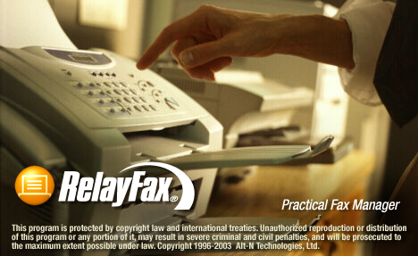

User Manual
Alt-N Technologies, LTD.
RelayFax® Version 6.7 – User Manual

Alt-N Technologies, Ltd.
2550 S.W. Grapevine Parkway, Suite 150
Grapevine, Texas 76051
817.601.3222
Fax: 817.601.3223
http://www.relayfax.com/

Copyright © 1996 - 2006 Alt-N Technologies, Ltd. All Rights Reserved.
RelayFax, MDaemon, and WorldClient are registered trademarks of Alt-N Technologies®.
Portions Copyright © 2000 NSN Software, All Rights Reserved
Portions Copyright © 1995 Daniel Berman, All Rights Reserved

LICENSE AGREEMENT
Please read this entire agreement. If you do not agree to the terms of this agreement promptly return your distribution materials to the place you obtained them for a full refund or delete your trial package.

ALT-N TECHNOLOGIES END-USER LICENSE AGREEMENT
This End-User License Agreement ("EULA") is a legal agreement between you ("Customer" or "Sub Licensee") and Alt-N Technologies ("Licensee") for the Alt-N software product(s) you are installing which include(s) computer software, "online" or electronic documentation, and may include associated media and printed materials ("SOFTWARE PRODUCT" or "SOFTWARE").

By installing, copying, or otherwise using the SOFTWARE PRODUCT, you agree to be bound by the terms of this EULA. If you do not agree to the terms of this EULA, promptly return the entire unused SOFTWARE PRODUCT, including all subscription UPDATES that you may have received as part of the SOFTWARE PRODUCT, to the place from which you obtained it for a full refund and/or delete all files related to your trial demonstration version of the SOFTWARE PRODUCT.

ALT-N TECHNOLOGIES SOFTWARE LICENSE
This SOFTWARE PRODUCT is protected by copyright laws and international copyright treaties, as well as other intellectual property laws and treaties. The SOFTWARE PRODUCT is licensed, not sold. The SOFTWARE PRODUCT consists of product documentation, a server application, and support files individually identified as "COMPONENT" and collectively referred to herein as "SOFTWARE".

GRANT OF LICENSE.
Alt-N Technologies grants to you as an individual, a personal, non-exclusive, non-transferable license to install and execute a single instance of the SOFTWARE on a single computer or on multiple computers provided that there is no chance of concurrently running two or more distinct instances of the SOFTWARE simultaneously for the purposes of evaluating the performance of the SOFTWARE PRODUCT for a period of no more than 30 days. If after that time continued use of the SOFTWARE PRODUCT is desired then the SOFTWARE PRODUCT must be registered with Alt-N Technologies subject to the terms as laid out in the registration information which can be found in the documentation accompanying the SOFTWARE PRODUCT. If you are an entity Alt-N Technologies grants you the right to appoint an individual within your organization to use and administer the SOFTWARE subject to the same restrictions enforced on individual users.

COPYRIGHT
All title and copyrights in and to the SOFTWARE PRODUCT are owned by Alt-N Technologies, its suppliers, or component vendors. The SOFTWARE PRODUCT is protected by copyright laws and international treaty provisions. Therefore, you must treat the SOFTWARE PRODUCT like any other copyrighted material except that you may either (a) make one copy of the SOFTWARE PRODUCT solely for backup or archival purposes, or (b) install the SOFTWARE PRODUCT on a single computer provided you keep the original solely for backup or archival purposes. You may not copy the printed materials accompanying the SOFTWARE PRODUCT.

THIRD PARTY COMPONENT LICENSING TERMS
Third party utilities, application programs, and/or components designed to integrate with the SOFTWARE PRODUCT are subject to the license terms governing those products.

You may not reverse-engineer, decompile, or disassemble the SOFTWARE PRODUCT, except and only to the extent that such activity is expressly permitted by applicable law, notwithstanding this limitation.

DISCLAIMER OF WARRANTY
NO WARRANTIES. THE SOFTWARE PRODUCT IS PROVIDED "AS IS" WITHOUT WARRANTY OF ANY KIND. TO THE MAXIMUM EXTENT PERMITTED BY APPLICABLE LAW, ALT-N TECHNOLOGIES DISCLAIMS ALL WARRANTIES, EITHER EXPRESS OR IMPLIED, INCLUDING, BUT NOT LIMITED TO, IMPLIED WARRANTIES OF MERCHANTABILITY AND FITNESS FOR A PARTICULAR PURPOSE AND ANY WARRANTY AGAINST INFRINGEMENT, WITH REGARD TO THE SOFTWARE PRODUCT. THIS LIMITED WARRANTY GIVES YOU SPECIFIC LEGAL RIGHTS. YOU MAY HAVE OTHERS WHICH VARY FROM STATE TO STATE.

CUSTOMER REMEDIES.
ALT-N TECHNOLOGIES ENTIRE LIABILITY AND YOUR EXCLUSIVE REMEDY SHALL NOT EXCEED THE PRICE PAID FOR THE SOFTWARE. NO LIABILITY FOR CONSEQUENTIAL DAMAGES. TO THE MAXIMUM EXTENT PERMITTED BY APPLICABLE LAW, IN NO EVENT SHALL ALT-N TECHNOLOGIES BE LIABLE FOR ANY DAMAGES WHATSOEVER (INCLUDING, WITHOUT LIMITATION, DAMAGES FOR LOSS OF BUSINESS PROFITS, BUSINESS INTERRUPTION, LOSS OF BUSINESS INFORMATION, OR ANY OTHER PECUNIARY LOSS) ARISING OUT OF THE USE OF OR INABILITY TO USE THIS SOFTWARE PRODUCT, EVEN IF ALT-N TECHNOLOGIES HAS BEEN ADVISED OF THE POSSIBILITY OF SUCH DAMAGES. BECAUSE SOME STATES DO NOT ALLOW THE EXCLUSION OR LIMITATION OF LIABILITY FOR CONSEQUENTIAL OR INCIDENTAL DAMAGES, THE ABOVE LIMITATION MAY NOT APPLY TO YOU.

Table of Contents

Part I - Administering the RelayFax Fax Server
Chapter 1
RelayFax® v6.7 11
Introduction 11
RelayFax Feature Summary 12
New Features in RelayFax 6.7 12
New Features in RelayFax 6.6 13
New Features in RelayFax 6.5 13
New Features in RelayFax 6.0.2 14
New Features in RelayFax 6.0 14
Sending Faxes 15
Receiving Faxes 16
Illustration of RelayFax’s method of operation: 17
Installation 18
Chapter 2
RelayFax’s Main Display 20
Menu Bar 20
Toolbar 21
Tool Window 22
Fax and Event Log Window 23
Shortcut Menu 24
Status Bar 26
Rescan Ports 26
Modem Manual Add 26
Modem Properties 29
Fax Device 29
Modem Profile 31
Options 33
Dialing 35
Log 36
Chapter 3
RelayFax Properties Dialog 37
Fax Server 37
Banner Text & Formatting Characters 39
Mail Server 40
Client Updates 42
Options 44
Service 47
Logs 49
Debug Logging 50
Chapter 4
Printer Selection 51
Printer Selection 51
Options 52
Network Resource Access 53
Chapter 5
MDaemon Server 55
MDaemon Properties 56
Chapter 6
Fax Mechanisms & Reporting 57
Attachment Faxing 57
Converting color and grayscale TIF images 60
Exporting 61
Export File Format 63
Imaging Options 67
OCR Options 70
Text Options 73
TWAIN Device Support 74
Chapter 7
Mail Sources and Rules 75
Mail Sources 75
Adding New Mail Host Entries 76
Editing Existing Mail Host Entries 76
Default Rules 77
Outbound Fax Rules 79
Inbound Fax Rules 85
Calling Number Display (Caller ID) Fax Routing 89
Junk Faxes 91
Chapter 8
Event Scheduler & Dialup 92
Event Scheduler 92
Dialup Settings 95
Chapter 9
Cover Pages 97
Cover Pages 97
Creating and Editing Cover Pages 98
Creating a New Cover Page 98
New Cover Page Properties 99
Editing Cover Pages 100
Chapter 10
Contact Manager 101
Fax Contact Manager 101
Importing Contacts from Other Address Books 102
Support for Outlook and Other Third Party Address Book Products 102
Chapter 11
Account Settings 103
Accounts 103
Options/Password 106
Chapter 12
Fax Templates and Billing Codes 108
Creating and Editing Fax Templates 108
Fax Templates 109
Fax Template Editor 111
Template Description 111
Template Properties 112
Template Options 114
Billing Codes 116
Chapter 13
Fax Broadcasting Wizard 117
Broadcast Fax Support in the RelayFax SMTP Client 117
Sending a Broadcast Fax 118
Step 1—Prepare the recipient list 118
Step 2—Open the Broadcast Fax Wizard 118
Step 3—Choose the recipient list or build it from a database 119
Step 4—Choose the fax image or document that will be sent 120
Step 5—Choose the cover page 121
Step 6—Choose the fax template 122
Step 7—Enter the sender information 123
Step 8—Begin the broadcast 124
Pausing a Fax Broadcast 124
Canceling a Fax Broadcast 124
ODBC Selector Wizard 125
Step 1—Prepare your database 125
Step 2—Open the Broadcast Fax Wizard 125
Step 3-Open the ODBC Selector Wizard 125
Step 4—Choose the data source 125
Step 5—Select the table containing the recipient information 127
Step 6—Select the columns to use 128
Step 7—Continue in the Broadcast Fax Wizard 128
Part II - RelayFax SMTP Client
Chapter 14
RelayFax SMTP Client 130
Introduction 130
RelayFax SMTP Client Features 130
Using the RelayFax SMTP Client 132
Starting the Client 132
Using the Client 132
Chapter 15
RelayFax Client Properties 134
Server Settings 134
Dialup Settings 136
Personal Settings 138
Client Settings 140
Scanner Settings 142
Contact List 143
Support for Outlook and Other Third Party Address Book Products 144
Chapter 16
Compose Fax Dialog 146
Compose Fax 146
Fax Properties 147
Client Could Not Deliver Image 148
Cover Pages 149
Send Schedule 151
Scan Image 152
Scanning options 154
Attached Documents 156
Advanced Options 158
Chapter 17
Working with Faxes 160
RelayFax Printer Driver 160
Sending a Fax via an Email Client 162
Attaching Documents to Fax Messages 162
Viewing, Printing, and Editing Faxes 163
Sending Faxes Programmatically 164
Using the Broadcast Fax Wizard 165
Sending a Broadcast Fax 166
Step 1—Prepare the recipient list 166
Step 2—Open the Broadcast Fax Wizard 166
Step 3—Choose the recipient list or build it from a database 167
Step 4—Choose the fax image or document that will be sent 168
Step 5—Choose the cover page 169
Step 6—Enter the sender information 170
Step 7—Begin the broadcast 171
ODBC Selector Wizard 172
Step 1—Prepare your database 172
Step 2—Open the Broadcast Fax Wizard 172
Step 3-Open the ODBC Selector Wizard 172
Step 4—Choose the data source 172
Step 5—Select the table containing the recipient information 174
Step 6—Select the columns to use 175
Step 7—Continue in the Broadcast Fax Wizard 175
Appendices
Appendix A – Macros and Files 176
Email Macros 176
DAT File Processing Macros 180
RelayFax Data Files 181
Appendix B – Modem Compatibility 184
Modem Compatibility 184
Flow Control 184
Appendix C – Regular Expression Matching 185
General Rules 185
One-Character Regular Expressions 185
Multiple-Character Regular Expressions 186
Matching at the Beginning and End of a Line 186
Appendix D – Troubleshooting 187
Troubleshooting 187
Index 189

Part i
RelayFax® Version 6.7
Administering the RelayFax
Fax Server

Chapter
1

RelayFax® v6.7
Practical Fax Manager for Windows

Introduction
RelayFax is a powerful fax server that automates sending, receiving and managing network faxes, and that integrates full faxing capabilities directly into your existing email system. RelayFax will monitor any number of POP accessible mailboxes on one or more mail servers, connect to those servers at scheduled intervals, collect all waiting email messages it finds, and then fax, email, or print them based upon a user defined set of fax rules. RelayFax can also dial your Internet Service Provider (ISP) to collect mail periodically instead of being forced to remain online continuously.
Printer drivers for Windows 9x/NT/2000/XP enable you to print directly from any Windows application and have the resulting document faxed to anyone anywhere. The RelayFax SMTP Client component enables you to print from a Windows application at home or on the road and have the resulting document faxed from your RelayFax server at the office. Full drag and drop support also makes it possible for you to fax a document by simply dragging it onto the tray icon or open client dialog.
RelayFax also contains support for TWAIN devices such as digital cameras and scanners. With RelayFax’s one-touch scanning features, documents can be scanned and faxed as easily as from a typical fax machine. In addition, scanner support in the client provides this same functionality to both local and remote users.
Faxing from remote and local locations is not limited to just users of the RelayFax SMTP Client—users can also use their favorite email client to send faxes. By including special macros in their messages and then sending them to RelayFax’s email address, they can emulate the client’s functionality. Documents and other files attached to email messages can also be extracted automatically by RelayFax, converted to a faxable image format, and faxed immediately.
RelayFax is also equipped with the latest Optical Character Recognition (OCR) technology. OCR makes it possible for RelayFax to “read” incoming faxes and route them based upon their contents. Faxes can be searched for specific names and phrases and then compared to special Fax Rules that determine what action should be taken when a rule is matched. Further, OCR files can be saved in a large number of the most common document formats. This makes it possible for you to instantly convert a fax to an editable and usable format instead of it simply remaining a static document.
Through the application of administrator-defined Inbound and Outbound Fax Rules, delivering fax and email messages to their proper recipients has never been easier. Users need not even know the fax number of the recipient—outbound messages can be delivered to their correct destination by several alternative routing methods defined in the Outbound Fax Rules. Inbound Fax Rules can also be created that will cause incoming faxes to be delivered to specific locations and users. OCR routing and the sending fax device’s Fax ID can be compared to the rules to determine the fax’s destination. Finally, there are several other actions made possible by the Fax Rules such as: automatic printing to specific printers, assigning alternate cover pages, attaching Fax Templates which provide various functions, and others. Even fax broadcasting, which sends the same fax to multiple different numbers, is supported by the RelayFax rules system.
RelayFax is truly the “practical fax messenger”.

RelayFax Feature Summary
- Automatic extraction and faxing of documents attached to email messages sent to the server.
- Check any number of POP mailboxes on any number of mail servers for new mail to be faxed.
- Complete RAS/DUN dialup support for collecting mail from servers on the Internet.
- Fully schedulable mail collection capabilities.
- Automatic detection and use of all fax modems available to the server.
- Support for individually configuring each available modem for sending and receiving faxes.
- Runs as Windows NT/2000/XP or Windows 9x system service.
- Elaborate rules based outbound faxing, which provides the ability to fax or email a message to one or more recipients, fax a message without knowing the fax number, attach an alternate cover page, and much more.
- Fax Broadcasting capability.
- Integrated support for the Microsoft™ Cover Page Editor.
- Least-cost routing support using SMTP sends some mail to other servers over the Internet for faxing.
- Rules based inbound fax routing using the ID of the foreign fax device. This makes it possible to route faxes to specific users or printers.
- Automatic printing of inbound and/or outbound faxes.
- Printer drivers for Windows 9x/NT/2000/XP supports printing to RelayFax from any application.
- Fax client software sends output from printer driver to RelayFax’s mail server account for pickup.
- Shared network-wide fax contacts/address book capability.

New Features in RelayFax 6.7
- Native Brooktrout Engine—RelayFax can now be equipped with a native Brooktrout engine for all Brooktrout boards. You can add this functionality to RelayFax by installing rfbt670_en.exe and following the instructions presented during installation. This will install both the native Brooktrout engine and the latest Brooktrout drivers.
- Global Scheduling for Normal and Broadcast Faxes—The Event Scheduler is now equipped with options for scheduling a daily window of time in which faxes may or may not be sent by RelayFax. You can specify a separate time-period for both normal and broadcast faxes, whether the period is to allow or disallow sending faxes, and whether or not it will be applied every day or just weekdays (Monday thru Friday).
- Expanded Contacts Options in Fax Client—The GroupWare option under the Contacts button of the Fax Client was renamed to MDaemon/Outlook Contacts and has been expanded. Using that option you can access either your WorldClient contacts stored online in your MDaemon/WorldClient email account, or you can access your Outlook contacts stored locally under an Outlook profile, when Outlook is your default email client. Under the WorldClient section, there is a new option to get all of your WorldClient contact folders (requires MDaemon 9.0).
- New Export File Column—The comma delimited export file now contains a column listing the durations, in seconds, of each fax transfer retry attempt. For example, if there were three attempts to deliver a particular fax, then the entry might look like this: “30,20,40.” This would indicate three retry attempts with durations of 30, 20, and 40 seconds respectively.

New Features in RelayFax 6.6
- Resend Only Unsent Pages—By default, RelayFax will now only attempt to resend unsent pages during retries of partially completed faxes. If you wish to configure RelayFax to attempt to resend the entire fax instead, then you can disable this option from the ResendPartialFaxes parameter under the [FaxServer] section of RelayFax.ini.
- DTMF Detection for Voice Modems and CAPI Devices—RelayFax now supports routing through the use of DTMF (Duel Tone Multi-frequency, also known as “Touch Tone”) signals when answering calls with fax modems that support voice features, or with CAPI devices in voice mode. For voice modems, any DTMF digits received will be treated as DID by RelayFax for the purpose of routing incoming faxes. The same is true for CAPI devices if no called party number is received—the DTMF digits will be used as DID. Otherwise, the DTMF digits will be added to the fax number, separated by “x”, and that combination will be treated as DID. In that case an account’s DID setting would have to look something like, “1234567x1234” in order for the fax to be routed properly.
When using the Black Ice engine, you must specify the number of DTMF digits to listen for on the Modem Properties dialog. When using the Alt-N fax engine or CAPI devices, instead of specifying the number of digits, the line will be monitored for ten seconds or until a fax tone is received. You can adjust the timeout value by editing the VoiceAnswerTimeout parameter located under the [FaxServer] section of the RelayFax.ini file.
To send DTMF digits with voice modems or CAPI devices, use the “x” or “@” character to separate the fax number from the DTMF digits. For example, “FAXNUMBER:1234567@1234” will dial “1234567” and wait for silence (lack of ringback), transmit the DTMF digits “1234”, and then start the fax transmission. Using “x” instead of “@” allows for the format: “1234567x1234@fax.domain”. Note, however, that although RelayFax displays DTMF digits after “x”, it actually sends “@” to the modem. The modem-specific parameters of the “@” character should be documented in your modem’s manual under the “D” command. For CAPI devices, there are several DTMF options in the [CAPI] section of RelayFax.ini to control the delay before and after sending DTMF digits, the length of each digit, and the gap between digits in milliseconds.

New Features in RelayFax 6.5
- OCR Printer Driver—You can now install the RelayFax OCR Printer Driver during installation of the RelayFax Server or Fax Client. The RelayFax OCR Printer Driver can be used for automatic fax number extraction from documents. Simply print a document or file containing the identifiers specified on the Client Properties dialog to the RelayFax OCR Printer Driver and the client will use those identifiers during the OCR scan to determine the fax number, recipient’s name, subject of the fax, and so on. When using the RelayFax OCR Printer Driver the client will not be opened because the fax info is taken from the document itself.
- Windows Dialing Rules Support—RelayFax now supports Windows Dialing Rules through options located on the new Dialing tab of the Modem Properties dialog. Windows Dialing Rules provide options for handling area and country codes that cannot be implemented using the Outbound Rules. Activating the Use Windows Dialing Rules option on the Dialing tab enables automatic processing of “canonical” numbers in the form “+<country code> (area code) <number>” (e.g. +1 (616) 555 1212). The “+” is automatically converted into “011” if the call is international, and it prefixes a “1” if the call is domestic long distance. The “+<country code>” is optional but the parentheses are required, and the default country code is automatically prepended if the number does not start with a “+”. Note that the outbound and prefix rules are applied before the Windows Location rules are processed. Fax numbers that are not in the correct format will be dialed unmodified.
- 33.6 kbps Faxing in Open Source Fax Engine—RelayFax now contains a new Class 1.0 V.34 (up to 33,600 bps) faxing engine for MultiTech MT5634ZBA modems.
- New Email Address Format—RelayFax 6.5 supports a new fax email address format:
“name,company” <faxnumber@domain.com>
To use this with MDaemon, create a mail gateway (for example, “fax.domain.com”) and route all email to the RelayFax account. Examples of the traditional format and the new format are below:
“5551212,John,Acme” <relayfax@fax.domain.com>
“John,Acme” <5551212@fax.domain.com>
- New Printer Options Including Fax Transmission Report—The Printer Selection dialog now contains an Options tab used for configuring your desired settings for the given printer. You can select a paper size and source, the number of fax images that you wish to print per page, the maximum number of pages to print per fax, and other settings. You can also designate whether or not to print a Transmission Report along with each printed fax, or to print a report only instead of the fax.
- Assign Fax Modem Priority—You can now right-click your installed fax devices and adjust their order in the list. Pending faxes are assigned to available fax devices in the order in which the devices are listed.

New Features in RelayFax 6.0.2
- RelayFax Engine Goes Open Source—The engine that RelayFax uses to send and receive faxes has been released by Alt-N Technologies to the open source community. The home for the project is located at:
http://sourceforge.net/projects/relayfaxosproj/
The goal of the project is to enhance the fax engine development and give something back to the open source community, which has been so good to us. Note: RelayFax itself will continue to be a commercial product—only the underlying fax engine source code is open source.
- Improved Address Book—RelayFax’s address book can now access WorldClient and Outlook Connector/MDaemon Groupware contacts from the client. Outlook and Exchange contacts can also be used.

New Features in RelayFax 6.0
- New Fax Engine—RelayFax is equipped with a new fax engine that supports many more fax modems, Error Correcting Mode (ECM), and more. Along with increased modem support is a completely redesigned Modem Configuration interface that provides new options for controlling COM port baud rate, flow control, fax baud rate, speaker activation and volume, and more.
- Support for CAPI 2.0—you can now use your CAPI 2.0 (ISDN) devices with RelayFax. RelayFax has been tested with both single and dual channel ISDN cards.
- Direct Inward Dialing (DID) Support—with support for DID routing, you can now associate DID fax numbers with users via new controls in the account editor, and configure RelayFax to automatically route faxes to specific users based on the DID information received. Additionally, a new inbound routing rule allows you to define actions based on DID information received. Finally, a new option makes it possible for you to configure RelayFax to accept calls only when they are directed to valid DID numbers—incoming calls to any other numbers will be ignored. These features require DID capable hardware.
- New Printer Drivers—RelayFax includes new printer drivers for converting documents into faxes by simply printing the document. The new printer drivers are much more configurable and have many new options. You can right click from the Windows printer manager and see the properties of the new drivers.
- Terminal Services Support—you can now run RelayFax in a Terminal Services environment. The administration interface, SMTP client, and printer drivers all support operating under Terminal Services.
- Support for a wide range of fax boards—RelayFax now supports faxing via Brooktrout, Gammalink, Bicom, Dialogic, and NMS fax boards. Not all models of all boards have been tested, but preliminary testing has been very successful.
- Improved Cover Page Editing—you can now edit *.COV cover pages under Windows 2000/XP using the Microsoft Cover Page Editor included with Windows 2000/XP. The older Windows 9x style cover page format (*.CPE) is still supported.
- Distinctive Ring Support—RelayFax now contains direct support for distinctive ring recognition. The Modem Properties dialog contains options for specifying which distinctive RING codes you want each device to answer. For each modem you can specify RING1, RING2, and/or RING3.
- Fast and Flexible Fax Database—information about incoming and outgoing faxes is now stored using XML, which is much more efficient and faster.
- Embedded Fax Parameter Extraction—documents can now be scanned via OCR for specific fax parameters such as fax numbers, recipient names, company names, and more. You designate specific identifying text to search for (for example, “FAXTO:” for a fax number) and then RelayFax will look for the appropriate text strings immediately following those identifiers. A text file can also be referenced for inclusion in the comments field of the cover page.
- PDF and PNG Document Support—incoming faxes can now be sent to their recipients in PDF and PNG formats.
- Improved TIF Image File Processing—you can now choose the compression format (Group 3 1D or 2D and Group 4 2D) to use for all faxes and TIF files. Further you can designate the default page size, which controls the size of TIF images generated from text, and you can force other page sizes as well.
- Improved Logging—log files can be now be rotated daily or weekly, and each service can be logged into a separate file instead of combined into single one. Further, log files are now created in the \Logs\ subfolder rather than \App\. Finally, special debug logging is also available. See Logs (page 59) for more information.
For a complete list of all changes and fixes included in RelayFax 6.5, see RelNotes.txt located in the \RelayFax\Docs\ subfolder.

Sending Faxes
With RelayFax sending a fax has never been easier. You can send a fax by using any of the following methods:
- Drag a document onto the Client’s tray icon, or onto an open Client dialog.
- Compose an email message and place the recipient’s fax number anywhere on the TO: line.
- Compose an email message and let RelayFax’s Fax Rules system determine where to fax it.
- Print to the RelayFax Printer Driver from any Windows application.
- Send only a cover page with a brief message on it through a single click of the RelayFax SMTP Client.

Receiving Faxes
Receiving a fax is also easy because RelayFax will detect and enable all of your fax modems when it is started. In addition, you can selectively configure modems that you may wish to use only for inbound or outbound faxing.
When a fax is received the transmitting fax device’s identifier (CSID) is compared to your Inbound Fax Rules. Then, the fax is folded into an email message using MIME techniques and is sent to any number of recipients determined by the Fax Rules, or to a default address if no rules are applied. Incoming faxes can also be routed based upon the COM port of the receiving modem, and upon the results of optical character recognition (OCR). Rules can be set up to search for specific words or phrases in the faxed document and then routed based on the results of the search.

Illustration of RelayFax’s method of operation:
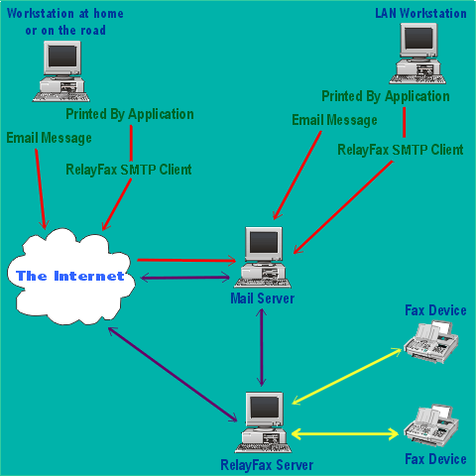

Installation
There are a few requirements for installing and running the RelayFax Server for Windows:
- A Microsoft Windows 9x or Windows NT4/2000/XP computer system with at least 256 MB of memory (512 recommended), and a Pentium II 450 MHz (or higher) processor. Typical hard drive space required is 30 MB plus whatever additional space you require for storing mail and fax images.
Note
The computer on which you install RelayFax does not need to be devoted exclusively to it – RelayFax may run concurrently with other programs (such as your mail server) if you so desire. In fact, if you are running MDaemon or WorldClient then this is recommended in order to utilize the built-in integration features more effectively.
- Access to a standard SMTP/POP3 mail server. This server does not need to be installed on your LAN. RelayFax’s dialup features make it possible to use your ISP’s mail server or any other server that you are allowed to use for collecting and sending email.
- One or more fax modems - preferably high quality and class 2.0 compatible. Although RelayFax does support class 2 modems, they are very limited in their capabilities and often prove to be unreliable. If possible, you should use either class 1 or class 2.0 modems for optimum performance.
Before You Begin
RelayFax’s installation program will ask you a number of questions during the installation process that are required to properly configure your server. While it is possible to enter this information after installation, you can save time and end your installation with a fully configured server by knowing the answers to these questions before you begin. You will need to know:
- The drive and directory in which you wish to install RelayFax (the default is C:\RelayFax).
- The registered user’s name and company.
- Which components you will install at this time - the server application and support files, the cover page creation utility, the Windows 95/98 driver and client, and/or the Windows NT/2000 driver and client.
Server
You need to know:
- Your Company name.
- The Call Subscriber Identification (CSID) that you wish to assign to your fax device (this is usually the same as your company name). In some areas of the world this string is required.
- Your fax and voice numbers.
- The domain name or IP address of your mail server.
- The logon and password for the RelayFax account on your mail server.
Client
You need to know:
- The domain name or IP address of your mail server.
- Your email address.
- The email address of the RelayFax mail account.

RelayFax’s Main Display
Chapter
2
RelayFax’s main display provides easy access to all of the server functions, and logs each inbound and outbound fax event. This display consists of seven components which will be outlined in the sections that follow. These eight components include: the Menu Bar, Toolbar, Tool Window, Fax and Event Log Window, Rescan Ports control, Modem Properties dialog, and the Modem Manual Add dialog.
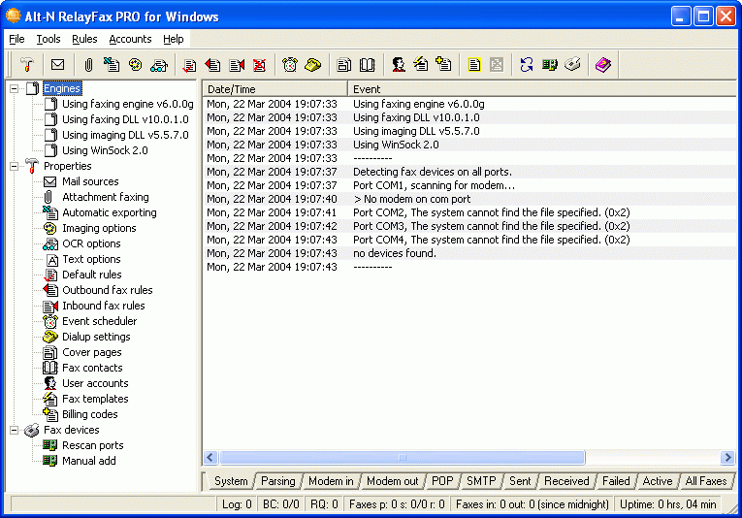

Menu Bar
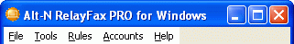
Directly beneath the title bar at the top of RelayFax’s Main Display is the Menu Bar. The Menu Bar contains several drop-down menus from which you can access the majority of RelayFax’s dialogs. Simply click on a menu item to make a desired selection.
Alternatively, you can access most of RelayFax’s features and quickly accomplish tasks you perform frequently by using shortcut keys. Shortcut keys are signified by the underlined letter in a menu title, corresponding drop-down list item, or control description in an individual dialog box. To use a keyboard shortcut simply press the ALT key followed by the underlined letter of the desired command. In the case of items on the drop-down list, there is no need to press the ALT key first.

Toolbar
RelayFax comes equipped with a movable toolbar that can be used to access most of the program dialogs. The Toolbar can be dragged from its default position beneath the menu bar and docked to any side of the main display window. Alternatively, it can be left in a detached state and it will float freely wherever it is placed on the display window or it can be dragged completely off the display and placed upon the Windows Desktop. To move the Toolbar simply click on it anywhere above or below its buttons and drag it to the desired position. In its free-floating state the RelayFax Toolbar can also be resized by moving the pointer over its edge and then dragging to the desired size.

Position the pointer over any of the Toolbar’s buttons and a tool tip will appear telling you its use.

Tool Window
The Tool Window contains a tree-view list of RelayFax features and dialogs. Double-click any listed item to open its corresponding dialog, or right-click an item and then choose Properties from the shortcut menu. You can collapse or expand each section of the list by clicking on its respective plus or minus sign located to the left of the section’s top item.
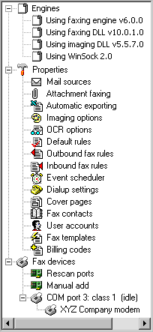
Note
The Modem Properties dialog and the Modem Manual Add dialog can only be reached through the Tool Window. Double-click on a listed modem to open its Modem Properties dialog. You can also right-click the listed modem to access its properties, reinitialize it, delete it from the list, or reorder its position in the list (pending faxes are assigned to available fax devices in the order in which they appear in the list),. If no modems are listed you may need to click the Rescan Ports button first to detect and list your installed modems. You can manually add modems that may not be listed by double-clicking the Manual Add icon and using the Manual Add dialog that will be opened.

Fax and Event Log Window
The Fax and Event Log Window displays a continually updated and highly detailed log of all Faxing Events and POP and SMTP Sessions occurring within RelayFax. This feature makes it possible to reference quickly any information regarding RelayFax’s recent activities that you may have questions about. It will also alert you to errors and problems that may occur during processing, thus aiding in diagnosing possible problems. The first six tabs in this window are the Event Log tabs. They log all system activity related to faxing and the fax engine, such as Modem behavior, parsing activities, email messages sent and received, and so on. The remaining five tabs (the Fax tabs) list the actual faxes that have been sent and received by RelayFax, those that are pending, and those that have failed to be sent for whatever reason. They display detailed information such as the sender and recipient, the time and date of the fax, the fax device’s ID, and a number of other facts. The All Faxes tab combines the contents of the other Fax tabs.
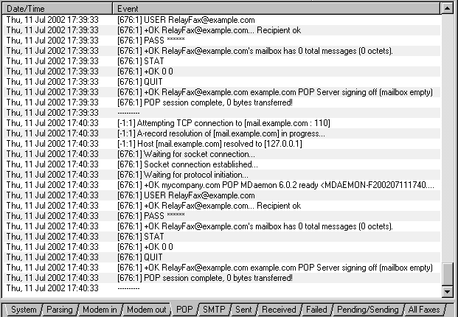

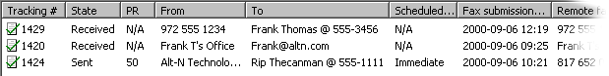
For each entry contained on the Fax tabs there is also a Shortcut Menu that can be used to perform various actions. The Shortcut Menu can be reached by right-clicking any entry. The menu’s controls will apply to any faxes selected in the window.
Note
The number of pending faxes that will be displayed is determined by the “MaxPendingFaxCount=” switch in the “[FaxServer]” section of the RelayFax.ini file. The default setting for this switch is “5”. If you have configured RelayFax to use multiple modems then we recommend increasing this number by 5 for each modem being used. In other words: 5 for one modem, 10 for two, 15 for three, and so on. This efficient setting keeps the queue balanced and processing smoothly.

Shortcut Menu
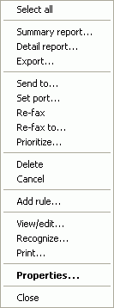
For the Fax tabs there is a Shortcut Menu that controls a number of tasks and features that can be applied to the entries on those tabs. To use the shortcut menu, right-click an entry and then click any available option that you wish to use. To select multiple entries, hold the Ctrl key down while clicking the desired entries and then right-click on any of those selected entries to bring up the shortcut menu. The menu’s controls will then apply to all of the selected entries. Note: Some of the shortcut menu’s options will not be available when multiple entries are selected.
There are seventeen listed commands on the Fax Window’s shortcut menu: Select all, Summary report, Detail report, Export, Send to, Set port, Re-fax, Re-fax to, Prioritize, Delete, Cancel, Add rule, View/edit, Recognize, Print, Properties, and Close.
The Select All command will cause all entries in the Fax Window to be selected. This makes it possible to Delete or create a report for all entries simultaneously.
Summary report builds a very brief report of all selected entries. It can be saved as a file and printed.
The Detail report command builds a highly detailed report of all selected entries, which includes information about the entries and the server activity related to them. This report can be saved as a file and printed.
We suggest that you periodically use the Detail report feature and then delete all entries from the Fax Window to maximize your computer’s resources.
The Export command exports the selected faxes to the export directory in TIF format and creates a comma-delimited export file detailing the information regarding the selected faxes. This export file can then be used with any database, spreadsheet, or other product which can import comma-delimited files.
For more information on exporting files and their format, see:
Automatic Fax Exporting—page 73
Export File Format—page 75
Send To will email the fax image to the address you specify. You will be prompted for the email address.
Use the Set port command to assign a specific port on which to send a pending fax.
The Re-fax command will resend a failed or previously sent fax.
The Re-fax to command is the same as Re-fax above except that you will be asked which number that you wish to send the fax to, plus you can optionally include different Company and Attention information than that which was in the original fax.
Prioritize opens a dialog from which you can change a pending message’s priority setting.
Note
Only those faxes with a status of “pending” can have their priority modified.
Click Delete to cause the selected entry or entries to be removed from the Fax Window and from the directory where the fax file is stored. Any fax image or work files that may be taking up disk space will also be deleted. You can also delete entries by selecting them and pressing the DELETE key.
The Cancel command is used to cancel faxes that are in progress. Click this option to cancel a fax in progress before deleting it.
The Add rule command, when selected on a received fax, will start the rule editor with the remote fax ID as the “match text”. This will save time when setting up rules for inbound fax routing.
The View/edit command will open the selected fax file for viewing in your default editor.

Click Recognize to OCR recognize the selected fax. A dialog will appear on which you can assign a filename and choose the format in which the OCR file will be saved.
Print will print the selected entries. The Select Printer dialog will open first so that you can choose which printer to use.
Click the Properties command to open the Fax Status property sheet for the selected fax entry. This sheet lists several facts and statistics about the fax in question. It also has a “View” button that can be used to view the fax to which it corresponds.
Note
Fax Status property sheets of inbound faxes will be limited in their scope. There is much more information available to RelayFax on outgoing faxes.
Click the Close command to close the shortcut menu without executing any other shortcut commands.
Note
If you have configured the Imaging Options dialog to delete faxes from the disk after they are sent then you will not be able to use some of these controls.

Status Bar
The status bar directly below the Fax and Event Log Window shows what the server is currently doing. It lists the number of entries present in the fax log (Log:), the status of any Broadcast Faxes (BC:), and the number of messages in the remote queue waiting to be uploaded to the mail server (RQ:). It also displays the number of faxes currently pending (p:), being sent (s:), and being received (r:). The two elements of the “s:” counter reflect the number of faxes in progress (the number to the left of the slash character) and the total number of modems available to send faxes (the number to the right of the slash). The next area on the status bar shows the number of faxes that have been received and transmitted since midnight. Finally, the total amount of time the server has been in uninterrupted operation is displayed at the far right.

Rescan Ports

Click either the button on the Toolbar or the icon listed under the Fax Devices section of the Tool Window to scan the local COM port to detect installed modems. RelayFax will attempt to detect automatically all fax devices accessible to the RelayFax Server. Occasionally you may need to rescan your ports after starting RelayFax, or in the event of some error. If the server is unable to detect your modem you can use the Manual Add feature to enter your modem’s information manually.

Modem Manual Add
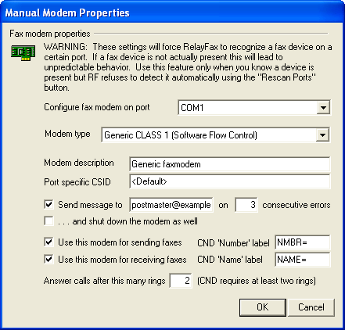
Use the Modem Manual Add dialog to manually identify modems that RelayFax is unable to detect by the Rescan Ports control. After manually creating an entry for a modem, you can configure it normally from the Modem Properties dialog (see page 31).
Note
The Modem Manual Add dialog can only be reached through the Tool Window. Under the Fax Devices section of the Tool Window, double-click on the Manual Add icon, or right-click the icon and then click Properties on the shortcut menu.
Fax Modem Properties
Configure fax modem on port
Select the port on which this device is installed.
Modem Type
Choose a device type from the drop-down list box.
Modem Description
Use this text box for listing a small description of the fax modem (e.g. “XYZ modem”, “Modem for receiving faxes”, and so on). This description will be displayed under the “Fax devices” heading in the Tool window of the RelayFax interface.
Port specific CSID
Each fax device must have a unique Call Subscriber Identification by which it identifies itself when connecting to other fax devices. It is common practice to use either your company name or fax number as your CSID. Use this option to enter a specific CSID for this modem, or leave it set to <Default> to use the CSID specified elsewhere in RelayFax’s settings. Note: If you enter a specific CSID in this control then it will be used for all incoming and outgoing faxes on this device and override any other CSIDs that you have specified elsewhere (for example, on the Fax Server tab of RelayFax Properties, or on a Fax Template). Thus, if you want to assign dynamic CSIDs based on templates and rules then you must leave this option set to <Default>.
Send message to [email address] on XX consecutive errors
Click this option and specify an email address and numeral in its text boxes if you want to send a warning message to someone whenever the specified number of connection errors occurs. This can be used for example to notify the administrator that the server is having a problem connecting to other devices and thus alert him that there could be a problem with your modem or phone line.
…and shut down the modem as well
Click this option if you want the modem to be taken offline if the number of connection errors specified in the above control occurs. If you are dividing your fax load across multiple modems then this could be a good way to cause a faulty modem to be shut down automatically and thus transfer the workload to your other modems until you can identify the problem.
Use this modem for sending faxes
Select this option if you wish this device to be configured for sending faxes.
Use this modem for receiving faxes
Select this option if you wish this device to be configured for receiving faxes.
CND ‘Number’ label
Enter the label that your modem appends to the Caller Number Display (CND) data which corresponds to the fax number from which the incoming call is originating (e.g. “NUMB=”, “CALLER NUMBER:”, and so on). You can identify the label by watching for it in the main display during an incoming call being processed by RelayFax. See Calling Number Display (Caller ID) Fax Routing (page 106) for more information.
CND ‘Name’ label
Enter the label that your modem appends to the Caller Number Display (CND) data which corresponds to the name attached to the fax number from which the incoming call is originating (e.g. “NAME=”, “CALLER NAME:”, and so on). You can identify the label by watching for it in the main display during an incoming call being processed by RelayFax. See Calling Number Display (Caller ID) Fax Routing (page 106) for more information.
Answer calls after thins many rings
Specify how many times the line must ring before RelayFax will answer it.
Note
When utilizing RelayFax’s CND features you must specify at least two rings in this control because CND data is transmitted between the first and second ring.

Modem Properties

Fax Device
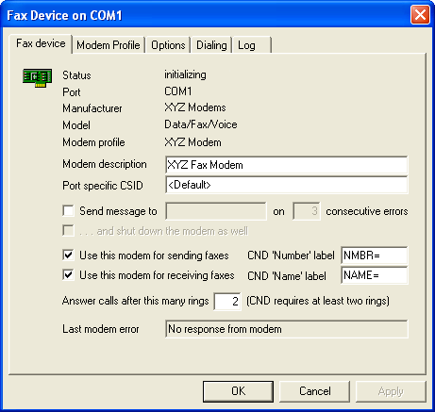
Use the Modem Properties dialog to configure each fax device installed on your system.
Note
The Modem Properties dialog can only be reached through the Tool Window. Under the Fax Devices section of the Tool Window, double-click on a listed modem to open its Modem Properties dialog, or right-click the listed modem and then click Properties on the shortcut menu. If no modems are listed then click the Rescan Ports button for RelayFax to detect and list your installed modems. If this does not detect your modems then you can use the Modem Manual Add feature to configure them manually.
The top area of this dialog displays information about the fax device, including its status, the port on which it resides, and the model and modem type.
Modem Description
Use this text box for listing a small description of the fax modem (e.g. “XYZ modem”, “Modem for receiving faxes”, and so on). This description will be displayed under the “Fax devices” heading in the Tool window of the RelayFax interface.
Port specific CSID
Each fax device must have a unique Call Subscriber Identification by which it identifies itself when connecting to other fax devices. It is common practice to use either your company name or fax number as your CSID. Use this option to enter a specific CSID for this modem, or leave it set to <Default> to use the CSID specified elsewhere in RelayFax’s settings. Note: If you enter a specific CSID in this control then it will be used for all incoming and outgoing faxes on this device and override any other CSIDs that you have specified elsewhere (for example, on the Fax Server tab of RelayFax Properties, or on a Fax Template). Thus, if you want to assign dynamic CSIDs based on templates and rules then you must leave this option set to <Default>.
Send message to [email address] on XX consecutive errors
Click this option and specify an email address and numeral in its text boxes if you want to send a warning message to someone whenever the specified number of connection errors occurs. This can be used for example to notify the administrator that the server is having a problem connecting to other devices and thus alert him that there could be a problem with your modem or phone line.
…and shut down the modem as well
Click this option if you want the modem to be taken offline if the number of connection errors specified in the above control occurs. If you are dividing your fax load across multiple modems then this could be a good way to cause a faulty modem to be shut down automatically and thus transfer the workload to your other modems until you can identify the problem.

Use this modem for sending faxes
Select this option if you wish this device to be configured for sending faxes.
Use this modem for receiving faxes
Select this option if you wish this device to be configured for receiving faxes.
CND ‘Number’ label
Enter the label that your modem appends to the Caller Number Display (CND) data which corresponds to the fax number from which the incoming call is originating (e.g. “NUMB=”, “CALLER NUMBER:”, and so on). You can identify the label by watching for it in the main display during an incoming call being processed by RelayFax. For more info, see Calling Number Display (Caller ID) Fax Routing (page 106).
CND ‘Name’ label
Enter the label that your modem appends to the Caller Number Display (CND) data which corresponds to the name attached to the fax number from which the incoming call is originating (e.g. “NAME=”, “CALLER NAME:”, and so on). You can identify the label by watching for it in the main display during an incoming call being processed by RelayFax. See Calling Number Display (Caller ID) Fax Routing (page 106) for more information.
Answer calls after this many rings
Specify how many times the line must ring before RelayFax will answer it. For CAPI devices, the length of each ring is defined in the [CAPI] section of the RelayFax.ini file. The default setting is 6 seconds.
Note
When utilizing RelayFax’s CND features you must specify at least two rings in this control because CND data is transmitted between the first and second ring.

Modem Profile
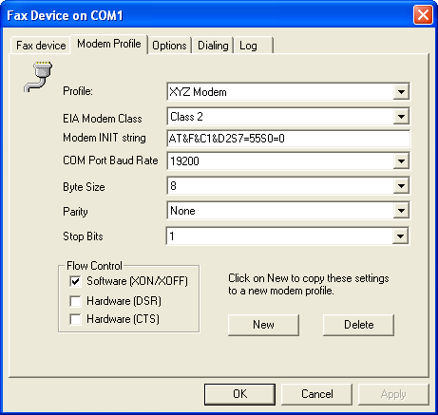

Profile:
This is your fax device’s profile. Choosing a different profile from the drop-down list may change the rest of the settings on this dialog. If the rest of the settings are dimmed or unavailable and you wish to edit them, click the New button to copy the settings to a new profile that you can edit.
EIA Modem CLASS
This control specifies the EIA modem standard that the device supports.
Modem INIT string…
Your modem’s initialization string is specified here. Normally, this string is detected when the fax device is queried by RelayFax. Changing your fax device’s profile may also alter the INIT string.
 Warning
Although RelayFax will allow you to edit the INIT value, do so with caution. Improper changes to modem INIT strings can cause your modem to stop working properly. See your modem documentation for more information on initialization strings.
COM Port Baud Rate
This is the maximum rate in bits per second (bps) that a program (e.g. RelayFax) may communicate with the fax device. This is not the rate at which the fax device communicates with other fax devices. That rate is specified on the Options tab.
Byte Size
This is the number of data bits used for each character that is transmitted and received by the modem. This setting must match the same setting in the modem with which you are communicating. Most fax devices use a value of 8, so you should not change it to another value unless you are certain it’s necessary.
Parity
Parity is a method of error correction. With parity correction enabled, an extra bit is transmitted with each character in order to make the number of bits sent either Odd or Even. There are also Mark and Space settings, which cause the parity bit to be either always set or always cleared, respectively. Both modems, whether sending or receiving, must have the same parity setting—it should typically be set to None because most connections use more sophisticated methods of error correction.
Stop Bits
This is the number of stop bits sent to indicate the end of each transmitted character. This is typically set to 1.
Flow Control
Flow Control is a method for compensating for the difference between the speed at which data reaches a device and the speed at which that device can process and transmit it. Because data might be sent faster than it can be processed, flow control can help prevent data from being lost by telling the sending device to pause while it catches up.
Software (XON/XOFF)
Click to enable this software-based method of flow control. This method transmits standard ASCII characters to pause and resume the flow of data. This software-based method is typically inferior to hardware flow control, but not all fax devices are equipped with a hardware-based method.
Hardware (DSR)
Click to enable DSR (Data Set Ready), a hardware-based method of flow control—it is used for controlling the flow of data between the modem and terminal or computer.
Hardware (CTS)
Click to enable CTS (Clear to Send), a hardware-based method of flow control—it is used for controlling the flow of data between the modem and terminal or computer.
New
If the settings on this tab are dimmed or unavailable and you wish to edit them, click New to copy the settings to a new profile that you can edit. After clicking New, designate a name for the new profile and click OK.
Delete
If the displayed profile is one that you have created, clicking this button will delete it and return this tab to its default settings.

Options
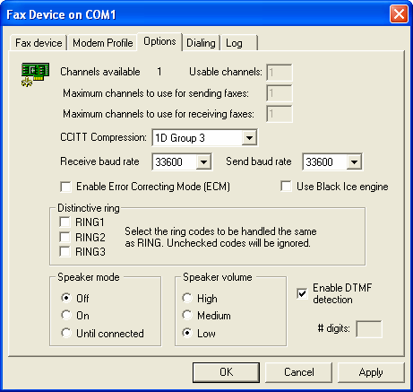
Channels
Displayed first on this tab are the number of telephony channels supported and the number of channels currently usable by the modem.
Send baud rate
This is the maximum rate in bits per second (bps) at which faxes can be sent by the fax device.
Receive baud rate
This is the maximum rate in bits per second (bps) at which faxes can be received by the fax device.
Enable Error Correcting Mode (ECM)
Click this check box to enable error correcting mode. Receiving devices that support ECM can request that portions of an image be resent if they are received with errors.
Distinctive Ring
If you are using a distinctive ring system, you can use these options to designate the RING patterns to which the fax device will respond. If in incoming call returns a ring code that is disabled here, RelayFax will ignore that call (i.e. the fax device will not answer it).
Speaker Mode
Use this option to designate whether or not the modem’s speaker will be activated when the modem is in use. You can choose to leave the speaker Off or On, or you can set it to be activated only Until Connected. The latter option will cause the speaker to be activated only until the modem successfully establishes a connection (for example, while dialing and attempting to connect to a fax number).
Speaker Volume
Use this option to designate the desired volume of your modem’s speaker.
Enable DTMF detection
Click this option to configure your modem that supports voice features to listen for DTMF (Duel Tone Multi-frequency, also known as “Touch Tone”) signals when answering calls. Any DTMF digits received will be treated as DID by RelayFax for the purpose of routing incoming faxes. RelayFax also is equipped with DTMF support for CAPI devices. As with DTMF support for voice modems, the DTMF digits will be used as DID, but only if no called party number is received. Otherwise, the DTMF digits will be added to the fax number, separated by “x”, and that combination will be treated as DID. In that case an account’s DID setting would have to look something like, “1234567x1234” in order for the fax to be routed properly.
# digits
When using the Black Ice engine, you must specify the number of DTMF digits to listen for on the Modem Properties dialog. When using the Alt-N fax engine or CAPI devices, instead of specifying the number of digits, the line will be monitored for ten seconds or until a fax tone is received. You can adjust the timeout value by editing the VoiceAnswerTimeout parameter located under the [FaxServer] section of the RelayFax.ini file.
Note
To send DTMF digits with voice modems or CAPI devices, use the “x” or “@” character to separate the fax number from the DTMF digits. For example, “FAXNUMBER:1234567@1234” will dial “1234567” and wait for silence (lack of ringback), transmit the DTMF digits “1234”, and then start the fax transmission. Using “x” instead of “@” allows for the format: “1234567x1234@fax.domain”. Note, however, that although RelayFax displays DTMF digits after “x”, it actually sends “@” to the modem. The modem-specific parameters of the “@” character should be documented in your modem’s manual under the “D” command. For CAPI devices, there are several DTMF options in the [CAPI] section of RelayFax.ini to control the delay before and after sending DTMF digits, the length of each digit, and the gap between digits in milliseconds.

Dialing
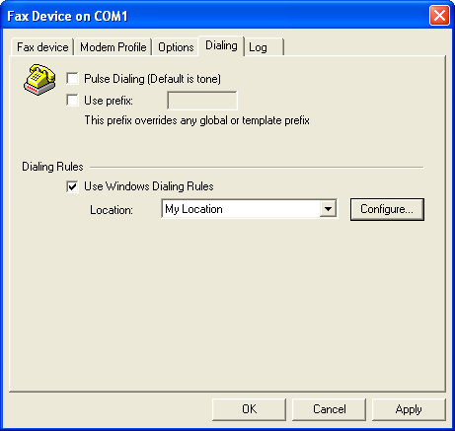
Dialing Rules
RelayFax supports Windows Dialing Rules. Windows Dialing Rules provide options for handling area and country codes that cannot be implemented using the Outbound Rules. Activating the Use Windows Dialing Rules option enables automatic processing of “canonical” numbers in the form “+<country code> (area code) <number>” (e.g. +1 (616) 555 1212). The “+” is automatically converted into “011” if the call is international, and it prefixes a “1” if the call is domestic long distance. The “+<country code>” is optional but the parentheses are required, and the default country code is automatically prepended if the number does not start with a “+”. The windows dialing rules will convert “canonical” numbers to a dialable string according to the options configured in the selected location. Note that the outbound and prefix rules are applied before the Windows Location rules are processed. Fax numbers that are not in the correct format will be dialed unmodified.

Log
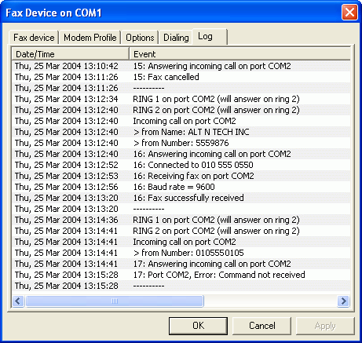
This tab displays the most recently logged activities of the fax device. A detailed log of incoming faxes, outgoing faxes, and any errors encountered, are all temporarily displayed here before they are combined with other logged events into the primary log files.

RelayFax Properties Dialog
Chapter
3

Fax Server
The Fax Server tab of the RelayFax Properties dialog is used to set up several default settings for your RelayFax Server. Here you will designate the default cover page, banner text, company name, fax device ID, and fax and voice numbers.
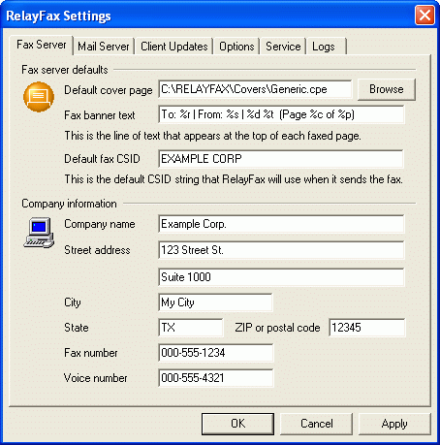

Fax Server Defaults
Default cover page
This is the path to the cover page that will be included with all outbound faxes that have not had an alternate cover page assigned to them by the Faxing Rules or Fax Templates.
Fax banner text
RelayFax will insert a line of text at the top of each faxed page. This line is called a Banner. With RelayFax it is possible to custom format your Banner by entering the desired text and formatting characters into the Banner Text control. The Banner may be formatted to automatically include various kinds of information such as the date and time, total pages, Recipient’s or Sender’s name, Fax ID, and other options.
Note
If the Banner control is left blank no fax banner will be sent. However, it is common practice to include a banner on outgoing faxes, and in some regions it is even required.
For a detailed discussion regarding your Banner Text and for a complete list and definition of available formatting characters, see:
Banner Text & Formatting Characters – page 45
Default fax CSID
Each fax device must have a unique Call Subscriber Identification. It is common practice to use either your company name or fax number as your CSID. When two fax devices are negotiating a connection, they make this information available to each another.
Note
In some regions, providing a CSID is required.
Company name
Enter the name of your company here. It is common practice to make this information available when sending and receiving faxes. This text will appear on outbound cover pages.
Street address, City, State, Zip or postal code
Enter your address information in these controls. This information will appear on any cover pages that have been set to include it.
Fax number
This is your fax number.
Voice number
This is your voice telephone number.
Note
Text entered into the Fax and Voice Number controls will appear on your cover pages.

Banner Text & Formatting Characters
RelayFax will insert a line of text at the top of each faxed page. This line is called a Banner. With RelayFax it is possible to custom format your Banner to automatically include various kinds of information such as the date and time, total pages, Recipient’s or Sender’s name, Fax ID, and various other options.
By inserting special formatting characters into the Banner, you may automatically include some information concerning the fax. See the list below for descriptions of these characters.
Although the Banner may be any length, only one line will appear at the top of a fax. This line may consist of up to three parts: a left-justified portion, a center-justified portion, and a right-justified portion. Each part is separated by “|”. Since none of these areas are limited in size, there is the potential that they may at times overwrite each another.
Note
If the Banner control is left blank, no fax banner will be sent. However, it is common practice to include a banner on outgoing faxes, and in some regions it is even required.

RelayFax Banner Formatting Characters
The following is a glossary of all valid formatting characters that may be used in the RelayFax Banner:
- %d = date in short format
- %D = date in long format
- %t = send time (24 hour format, e.g. 1:00pm = 13:00:00)
- %p = total number of pages in the fax
- %c = current page
_______
- %r = Recipient’s Name
- %y = Recipient’s Company
- %s = Sender’s Name
- %m = Sender’s Company
- %i = Sender’s Fax ID
- %u = Subject of Fax
- %f = Recipient’s Fax Number
- %o = Comments
- %x = Sender’s Fax Number
- %h = Sender’s Voice Number
- %T = Tracking Number

Mail Server
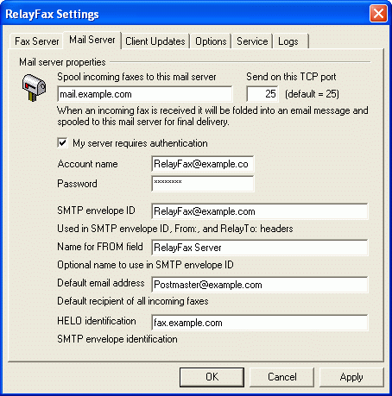

Use the Mail Server tab to specify the mail server that the RelayFax Server will connect to for delivering incoming faxes. Further, this mail server will be used by RelayFax for delivering fax confirmation and failure status messages. You will also specify a default email address and a few other parameters on this tab.

Mail Server Properties
Spool incoming faxes to this mail server
When an incoming fax is received it will be folded into an email message and spooled to this mail server for final delivery. Fax confirmation and failure status messages created by the RelayFax Server will also be spooled to this mail server.
Send on this TCP port
RelayFax will use this port when it sends data to your mail server. The default setting is port 25.
My server requires authentication
As an added security measure, some mail servers require you to authenticate yourself before you are allowed to use them to send or receive email. If such is the case with your mail server then click this box and enter your account name and password (login credentials) into the spaces provided below. This option provides support for ESMTP AUTH and the LOGIN and CRAM-MD5 protocols.
Account name
If your email server requires authentication before processing your messages then specify your account name or login name here.
Password
Enter the password that corresponds to the account name that you specified in the above control.
SMTP envelope ID
This is the address used in the SMTP “MAIL FROM” command when RelayFax spools an inbound fax or other message to your mail server. It is also used as the FROM and ReplyTo within RelayFax generated messages. Make sure that you specify an address in this field that RelayFax checks for email messages. If you do not specify a valid email address in this control then RelayFax will not receive messages from users when they are attempting to reply to a message that RelayFax sent to them (for example, to have RelayFax resend a failed fax). Thus, RelayFax will not be able to fulfill the commands contained in those messages.
Name for FROM field
Use this control if you want to an optional name to be entered into the name portion of the FROM field of RelayFax generated messages. The default value for this control is “RelayFax Server”.
Default email address
If RelayFax cannot determine to whom an incoming fax should be addressed then this default address will be used.
 Warning
This address must be different than that of your RelayFax email account (specified on the Mail Sources dialog) in order to prevent mail loops.
HELO identification
When spooling an inbound fax to your mail server RelayFax will identify itself as being a member of this domain.
Example:
HELO altn.com

Client Updates
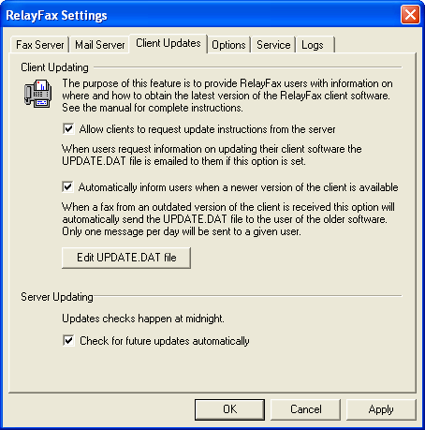
On the Shortcut menu of the RelayFax SMTP Client there is an option to “Update RelayFax Client”. When a user clicks that option, an update request message is sent to the RelayFax server. The Client Updates tab controls how RelayFax will respond to these update requests. If you have configured RelayFax to honor update requests it will email the contents of the UPDATE.DAT file to the user making the request. This file is located in the RelayFax\app\ subdirectory and can be edited with any plain text editor such as Notepad. To simplify the editing process you can click the Edit UPDATE.DAT file button to open it in your default text editor.
This tab also provides the option to automatically send the update message to any users who send a message to RelayFax from an older version of the client. This is a more “user friendly” method since they will not need to remember to check for updates; they will be informed automatically whenever the version they are using is out of date.

Client Updating
Allow clients to request update instructions form the server
Click this checkbox if you want RelayFax to email the contents of UPDATE.DAT to users who click Update RelayFax Client on their client’s shortcut menu.
Note
If this option is not checked then RelayFax will simply delete update requests without responding to them.
Automatically inform users when a newer version of the client is available
Enable this control if you want RelayFax to automatically send update information to users who send a message to RelayFax using an outdated version of the client.
Edit UPDATE.DAT file

Click this button to open UPDATE.DAT in your default text editor. You may utilize three macros in this file so that the contents of the response message will be specific to the recipient:

$CURRENTVERSION$ will be replaced by the current version number of the RelayFax SMTP Client.

$YOURVERSION$ will be replaced by the version number of the user’s client.

$ATTACHMENT<filepath>$ will attach a file to the update message being sent. For example: $ATTACHMENT<c:\RelayFax\App\rf300clnt.exe>$ would attach the client installation file to the response message.
Rather than attaching the latest version of the Client to the message, you can conserve bandwidth and resources by editing the UPDATE.DAT file to include a URL to a location from which the user can download it instead.

See the UPDATE.DAT file included with RelayFax for an example message.
Server Updating
Check for future updates automatically
Click this checkbox if you want RelayFax to check for updates automatically each day at midnight. When a RelayFax software update is available, a notification email will be dispatched to the Default email address designated on the Mail Server tab of the RelayFax Properties dialog (File→RelayFax properties…).
Note
This option will appear dimmed and not accessible if your update protection has expired. In order to restore automatic update functionality you will need to renew your RelayFax update protection.
You can manually check for updates at any time from an option on the Help menu (Help→Check for RelayFax updates…).

Options
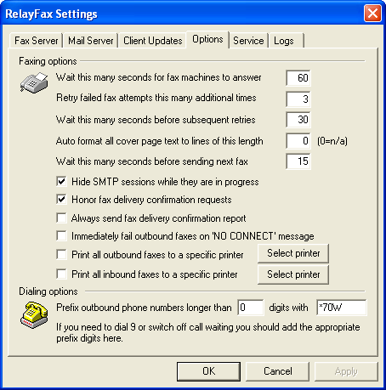
The Options tab of the RelayFax Properties dialog is used to specify several optional settings. These include the number of retry attempts for failed faxes, specifying whether all faxes should be printed or not, whether delivery confirmation requests should be honored, and several others.

Faxing Options
Wait this many seconds for fax machine to answer
If the Fax number to which RelayFax is trying to connect doesn’t answer within this many seconds, RelayFax will abort the attempt and try again later based upon the parameters outlined below.
Retry failed fax attempts this many times
If the initial fax attempt fails RelayFax will retry the attempt this many times. After this number of unsuccessful retry attempts RelayFax will give up permanently and inform the sender that the fax could not be sent.
Wait this many seconds before subsequent retries
This is the amount of time between subsequent delivery attempts.
Auto format all cover page text to lines of this length
Placing a value in this control will cause text placed in the cover page’s comments section to have line breaks inserted at the specified length. Setting this control to “0” will cause the text to appear exactly as it was typed by the user. If the text was composed without any line breaks, and it extended beyond the edge of the designated comments area, then it would be truncated.
Wait this many seconds before sending next fax
This is the number of seconds that RelayFax will wait after sending each fax before it will begin sending another.
Hide SMTP sessions while they are in progress
RelayFax can be configured to open a session window every time that a connection is made to another server. These session windows will display detailed information regarding each step of the connection and delivery process. By default these sessions are hidden. Disable this control if you want the session windows to be displayed.
Honor fax delivery confirmation requests
RelayFax is equipped with the ability to inform users of the status of their outgoing faxes. When RelayFax receives a message for faxing from the RelayFax SMTP Client or an email client requesting a Return Receipt, this feature may be used to email a short message back to the sender. This message will inform them when their fax has been successfully delivered.
Note
The confirmation message will only be returned when RelayFax receives a return receipt request from the sender’s RelayFax SMTP Client or when the Return-Receipt-To header is present in an email message.
Immediately fail outbound faxes on ‘NO CONNECT’ message
Click this option to cause RelayFax to immediately fail an outbound fax if a 'NO CONNECT' message is returned from the modem. This message is usually the result a person or answering machine answering rather than a fax device, thus it is likely that you have a wrong fax number for the recipient.
Print all outbound faxes to a specific printer
Enable this control if you want RelayFax to automatically print a copy of all documents that it receives for outbound faxing. These documents will be printed to whichever printer you have designated in the Select Printer dialog.
Print all inbound faxes to a specific printer
Click this option if you want a copy of all faxes that RelayFax receives to be printed to a specific printer. Click the Select printer button beside this control to choose the printer.
Select printer
Click this button to open the Select Printer dialog.
For a complete discussion on the Select Printer dialog and printing in general, see:

Select Printer – page 62

Dialing Options
Prefix outbound phone numbers longer than [xx] digits with…
If you need to dial a special prefix such as 9 to reach an outside line or switch off call waiting, then specify the minimum number of digits you wish to require in a number before the prefix will be added, and then specify the prefix codes or number in the space provided.
Note
When specifying phone numbers for RelayFax to dial you can use “w” or “W” to instruct RelayFax to wait for a subsequent dial tone. For example, “8w5551212” will dial 8, wait for the next dial tone, and then dial the remainder of the number. Similarly, the “%” character will insert a pause within the dialing process. For example, “8%5551212” will dial 8, pause, and then dial the rest of the number. The length of time during a pause is determined by modem S register settings.

Service
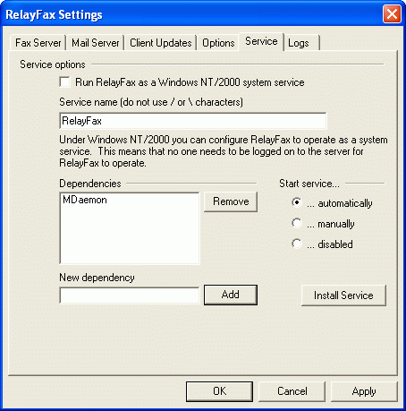

The Service tab of the RelayFax Properties dialog is used to control whether or not you wish to run RelayFax as a Windows system service. RelayFax can be configured to run as a system service under Windows NT/2000 and under Windows 95/98. Though more limited than services under Windows NT/2000, running RelayFax as a Windows 95/98 service will still allow it to operate when no users are logged on to the network on which it is running.

Service Options
Run RelayFax as a Windows 9x/NT/2000 system service
RelayFax may be configured to run as a system service under Windows NT/2000 and Windows 95/98. When RelayFax is configured to run as a service it will operate even when there are no users logged on to the network on which it is running.
Windows NT/2000 services have a number of configurable options such as Dependencies and Start-up choices. Windows 95/98 services are limited to simply providing the ability for the service to run when no users are logged on to the network. Due to this limitation the Service tab of the RelayFax Properties dialog will only contain the Run RelayFax as a Windows 95/98 System Service and Service Name options when installing the Windows 95/98 version of RelayFax.
Service name (do not use / or \ characters)
Enter the name of the RelayFax service here.

Dependencies
Dependencies
This list box displays the names of any services which must start before RelayFax does.
Note
For more information on Windows NT/2000 Services and Dependencies, consult your Windows NT/2000 help files and documentation.
Remove
Click this button to remove a selected Dependency from the Dependencies list box.
New dependency
Enter the name of a service upon which you wish the RelayFax service to be dependent and click the Add button to add it to the list of Dependencies.
Add
Click this button to add a service, which you have entered into the New Dependency text box, to the Dependencies list.

Start Service
This is the initial state of the service.

Automatically – starts the service at boot up.

Manually – starts the service only via user intervention.

Disabled – does not start the service at all.

Install service/remove service
Click this button to install or remove the RelayFax service.
Note
For more information on Windows NT/2000 system services, consult your Windows NT/2000 help files and documentation.

Logs
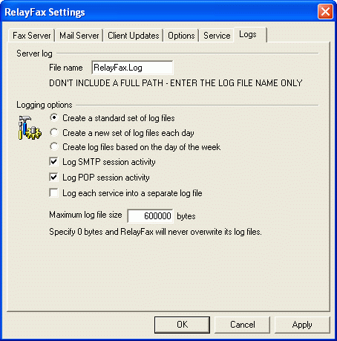

The RelayFax Server maintains a continually updated and highly detailed log of all Faxing Events and POP Sessions. Here you will assign a name and maximum size to that file.
Server Log
File name
You can name the log file here. It is called RELAYFAX.LOG by default.
Logging Options
Create a standard set of log files
Click this option to maintain a standard single set of log files.
Create a new set of log files each day
If this option is selected then separate log files will be generated each day. The names of the files will correspond to the date they were created.
Create log files based on the day of the week
If this option is selected, separate log files will be generated for each day of the week. The names of the log files will correspond to the day of the week on which they were created.
Log SMTP session activity
Click here if you wish the log to contain transcripts of SMTP session activity with your mail servers.
Log POP session activity
Click here if you wish the log to contain transcripts of POP session activity with your mail servers.
Log each service into a separate log file
Click this checkbox if you want RelayFax to maintain separate logs by service rather than in a single file. For example, RelayFax will log SMTP activity in a separate log file than other activity.
Maximum log file size [xx] bytes
Use this control to designate a maximum size (if any) for RelayFax’s log file. When the file reaches this size it will be saved with the file extension *.OLD. Then, a new RelayFax *.Log file will be created and maintained until it also reaches the maximum size. At that time the *.OLD log file will be overwritten by the new *.OLD file, and so on. If you do not wish to lose previously saved *.OLD files then you must save those files under a different name or extension before the RELAYFAX.LOG file reaches the maximum allowed size.
If you set Maximum log file size [xx] bytes to 0 the *.Log file will never be saved as *.OLD and reset. However, depending upon the volume of server use, this could result in a very large log file.

Debug Logging
RelayFax is equipped with special debug logging. To activate it, edit RelayFax.ini with notepad and set the following key:
[Special]
DebugLogging=Yes (default No)
Use FAXSPY.EXE to view these debug logs.

Chapter
4

Printer Selection

Printer Selection
The Select Printer dialog is used to choose the specific printer that you want to use when printing outbound or inbound faxes.

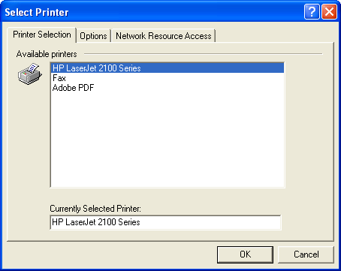

Available printers
This area will display all printers that are available for RelayFax to utilize when configured to print inbound or outbound faxes. To select a printer simply click on the desired entry in this list, and then click OK or press the ENTER key.
Currently selected printers:
This textbox displays the name of the printer that you have selected to be used by RelayFax.

Options

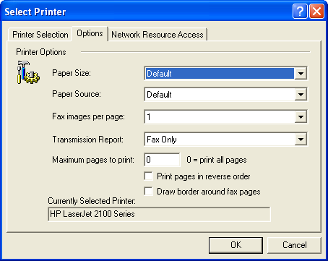

Use the options on this tab to specify your desired settings for the selected printer. You can select a paper size and source, the number of fax images that you wish to print per page, the maximum number of pages to print per fax, and other settings. In the Transmission Report drop-down list box you can designate whether or not to print a transmission report along with each printed fax. Alternatively, you can choose to print a transmission report only, instead of the fax.

Network Resource Access

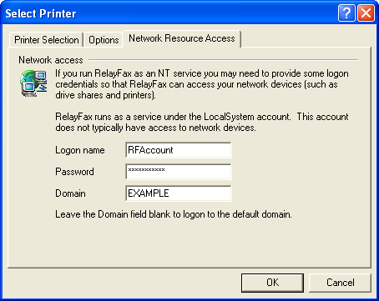

Note
This screen is only available when you are using Windows NT/2000/XP.
Click “File|Network resource access…” to open this dialog. If you run RelayFax as an NT/2000 service and you wish to print using printers attached to other computers across your network, you may have to provide RelayFax with some access credentials. Normally, RelayFax will run as a service using what is called the \”LocalSystem\” account. This account has no logon or password associated with it, therefore software running as \”LocalSystem\” may not be allowed to access network devices such as printers. To ensure that RelayFax can access a network printer you can provide the logon and password of an NT/2000 account that has access to it. When login credentials are included on this dialog RelayFax will log in as that account rather than the \”LocalSystem\” account.
Logon name
Enter the logon name of a valid NT/2000/XP account that has access to network printers.
Password
Enter the password to the above account.
Domain
Enter the optional NT/2000 domain upon which to authenticate the account. You can leave this field blank and RelayFax will authenticate the account using the default (current) domain.
Note
Printing under a windows network can be difficult to set up. You must take steps to make sure that the printer you are trying to access across your network has the correct permissions configured to allow RelayFax to access it. Sometimes printer access problems can be resolved by setting up the network printer to allow print access from any member of the “EVERYONE” group. This includes the \”LocalSystem\” account and therefore works when RelayFax is setup to run as an NT system service.

MDaemon Server
Chapter
5
Although RelayFax can be used with any email server, it has been designed to work exceptionally well with Alt-N Technologies’ MDaemon Server for Windows. Click “File|MDaemon properties…” to open the MDaemon Properties dialog. The controls on this dialog make it possible for RelayFax to be installed on the same machine as your MDaemon Server and share a single modem with MDaemon without causing any conflicts.
Immediately before MDaemon attempts a dialup connection it will create a file called PREDIAL.SEM. At the close of the connection, POSTDIAL.SEM will be created. RelayFax will look for these files before dialing and thus avoid attempting to use the modem when it is already in use by MDaemon.

 Attention
Within MDaemon you must specify at least 2 redial attempts in the RAS configuration screen in order for this feature to be utilized.
Note
This feature requires MDaemon 2.7.5.0 or later. Earlier versions of MDaemon do not utilize the PREDIAL/POSTDIAL files correctly. If you are using an earlier version of MDaemon, you may obtain a free upgrade to the latest 2.8x version by visiting http://www.mdaemon.com.

MDaemon Properties
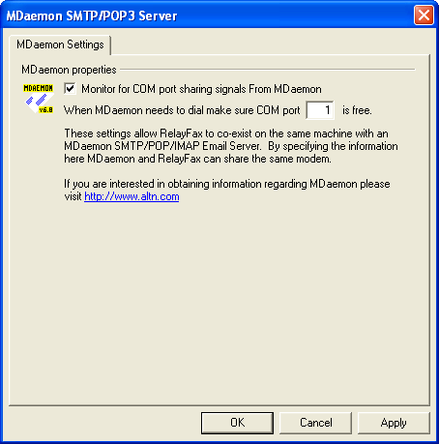

MDaemon Settings
Monitor for port sharing signals from MDaemon
Enable this switch if you want RelayFax to share a COM port with MDaemon.
When MDaemon needs to dial make sure COM port [xx] is free
When RelayFax detects that MDaemon needs to dial it will free this port for MDaemon’s use. If necessary, RelayFax will suspend listening for faxes while the port is in use by MDaemon.

Fax Mechanisms & Reporting
Chapter
6
Attachment Faxing, Automatic Fax Exporting, Imaging Options, and OCR Options

Attachment Faxing
RelayFax has the ability to extract attachments and fax them automatically. For example, it is possible for you to send an email message to the RelayFax Server which contains an Excel or Word document as an attachment. The RelayFax Server will extract the document, invoke the associated application to print it, close the application, and then fax the resulting image. Any number of separate attachments can be attached and faxed in this manner, and page breaks within any given document will be honored and cause multiple pages to be faxed. The settings on the Attachment Faxing tab allow you to control various aspects related to attachment faxing.
When the RelayFax Server extracts an attached document from an email message it must convert that document to a faxable image format. This is accomplished by invoking the application associated with the “print” shell command for the document in question. For example, Microsoft Word™ is associated with the “print” shell command for documents with the extension “.DOC”. When a “.DOC” file is extracted from an email message Microsoft Word™ is invoked and the attached document is printed to a special print driver called the RelayFax Print Redirector. The RelayFax Print Redirector is installed as part of the RelayFax Server package. This print driver converts printed documents to a faxable image format.
Note
The RelayFax Print Redirector must be set as the Default Printer because RelayFax invokes applications that will print to the Default Printer only.
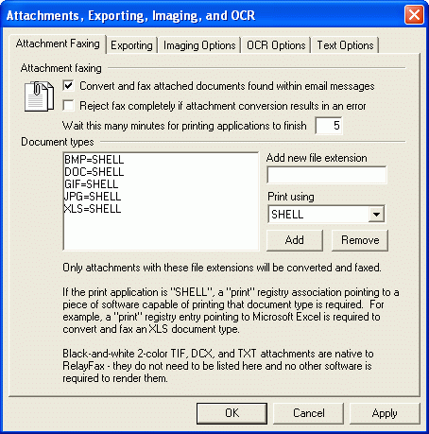

 Warning
All documents printed to the RelayFax Print Redirector must be printed in “Resolution: Fine Mode: 204 x 196 dpi”, located within the RelayFax Print Redirector properties. You should follow these steps to set this resolution as the default for the RelayFax Print Redirector:
(1) Select PRINTERS in the Windows control panel.
(2) Select the RelayFax Print Redirector icon.
(3) Windows 95/98: Edit the printer properties and select 204x196 dpi resolution. Windows NT/2000: Right click the RelayFax Print Redirector icon and select Document Defaults… Then select 204x196 resolution in the Graphic section of the Advanced tab.
During installation, the Print Redirector’s default setting will be set to the proper resolution. Exercise caution in changing this setting. Failure to properly set the Print Redirector to 204x196 dpi will result in improperly formatted fax images that appear out of scale or otherwise deformed.
For this feature to work you must have software associated with the “print” shell command for the document-type being faxed. Microsoft Word™ in the case of the above example. Without software capable of printing a specific document type RelayFax will be unable to convert and fax those types of attachments. If there is no “print” shell command for a particular document type then attachments of that type will simply be ignored by RelayFax. Installing Microsoft Office™ on the computer where the RelayFax Server is operating will provide all the proper shell associations and software required for converting all Office document types. RelayFax will invoke the associated application dynamically so there’s no need to leave memory intensive software like Word™ or Excel™ actively running in order to take advantage of this feature.
 Warning
Since it is possible to run macros via printing Microsoft Office™ and possibly other document types, the administrator must take care with the use of this feature. Security concerns are totally within the realm of the administrator and the software packages that RelayFax will invoke to print specific document types.
It is possible to attach URL and HTM files to a message and have RelayFax invoke Netscape or Explorer to render the URL or HTM and fax a completed document. This has been tested at Alt-N but the following bugs were encountered:
NETSCAPE: When Netscape Communicator 4 renders a URL it sends the completed HTML document to the print spool TWICE. The RelayFax Print Redirector cannot cope with this and will return an error if this occurs.
MICROSOFT: IE4 sometimes PROMPTS for the printer to use when an HTM file is passed to it. This is a serious problem since it forces RelayFax to wait for user input before continuing fax processing.
 Warning
When processing URL or HTM attachments, extreme care must be taken since HTML documents can contain Java applets, JavaScript, or the like, which will be executed when the URL or HTM is rendered by the web browser software. It is up to the administrator to determine if URL or HTM attachments should be processed through RelayFax. Processing URL or HTM documents could result in a security risk to some systems.
The “RelayFax Print Redirector” will log its activities into a file called REDIRECT.LOG which is kept in the RelayFax \app\ directory.
RelayFax will invoke the application associated with the “print” shell command for a specific document type. Extreme care must be taken to ensure that the application starts, prints to the RelayFax Print Redirector, and then cleanly exits without requiring any user input. This feature must run in an unattended fashion. Unattended operation is not possible if an application requires user interaction each time it is invoked. The rule is test test test! Send test messages to make sure each document type you wish to support has a compatible application associated with it.

Converting color and grayscale TIF images
Two color (black and white) TIF images are the native fax format and will therefore be handled appropriately by RelayFax without the need for any additional configuration or software. Color and grayscale TIF images can be faxed as well, but they must first be converted by RelayFax to two color images. If you want RelayFax to do this then you must enable attachment faxing and include the TIF file extension in the Document Types list.
Convert and fax attached documents found within email messages
Click this switch to turn on the attachment faxing feature. Without this switch set RelayFax will not fax documents attached to email messages.
Reject fax completely if attachment conversion results in an error
When RelayFax is configured to convert attachments to fax images, this control is used to cause them to be rejected when an attachment cannot be converted. Normally, any pages that are successfully converted will be sent, but when this switch is enabled a failure message will be returned to the sender whenever an error is encountered during the conversion process and no pages will be faxed.
Wait this many minutes for printing applications to finish
Use this option to force an application used for printing to be closed after the specified number of minutes. Sometimes certain applications will stop, waiting for user input, or for some other reason. After waiting the specified amount of time, if RelayFax finds that the application is still running it will be closed. Note: in such cases it is likely that the document will not have been printed (due to the application “hanging” or waiting for input) and therefore it will not have been faxed.
Document types
Only document types with extensions that match those listed here will be extracted, converted, and faxed. Black-and-white two color TIF, DCX, and TXT file attachments are native to RelayFax. Those document types do not need to be listed on this dialog, nor is any other software required for RelayFax to render them.
Remove
Click here to remove selected items from the Document Types list.
Add new file extension / add
Enter a new extension and click Add to insert it into the Document Types list.

Exporting
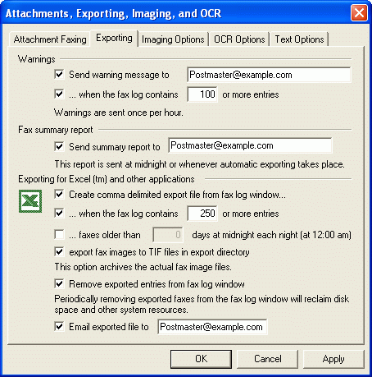

The act of making information about processed fax documents available in a format which other software can utilize for subsequent processing is known as fax exporting. Exporting creates an industry standard comma-delimited file containing detailed information about each faxed document processed by RelayFax. This file can easily be imported into applications such as Microsoft™ Excel™ or Access™ or any other software package that accepts comma-delimited files as input.
The export process itself also helps RelayFax better manage server resources. Since each entry in the fax log window consumes valuable server resources, older entries must periodically be removed from the fax log window to free up resources for new fax documents. Use of these export options will allow you to police the fax log window in an automated fashion. With these features you will be able to operate RelayFax in the most efficient manner possible while still maintaining a detailed database of information regarding faxing operations and a complete archive of all fax document image files.
RelayFax maintains the results of an export operation in the EXPORTS subdirectory. This subdirectory is located just below the RelayFax root directory. Each comma-delimited export file is given a name that corresponds to the date and time of the export event and it is placed in a subdirectory named for the date of the export event. For example, if an export event occurs on Jan 10, 1999 at 11:55:00 a subdirectory called 1999-01-10 will be created within the EXPORTS directory and an export file called 1999-01-10-11-55-00.CSV will be placed within it. Multiple exports can be performed on the same day and they will be placed in the same subdirectory but they will have slightly different file names.

Warnings
Send warning message to[ email address]
Click here and specify an email address where RelayFax should direct its warning messages. You can have multiple addresses specified here if you separate each with a comma.
… when the fax log contains [xx] or more entries
Click here and specify a threshold value. When the number of entries present in the fax log window meets or exceeds this value RelayFax will dispatch a warning message to the address specified above.

Fax Summary Report
Send summary report to…
Click this checkbox and fill in one or more addresses (separated by commas) and RelayFax will email to them a summary of all fax activity currently listed in the fax log window. This report is not as detailed as the file generated by the export process and is in a format typical of standard fax devices. It will be emailed to the addresses each time that automatic exporting occurs and just before midnight each day.

Exporting for Excel™ and other applications
Create comma delimited export file from fax log window
Click here if you wish RelayFax to automatically create export files.
… when the fax log contains [xx] or more entries
Click here and specify a threshold value. When the number of entries present in the fax log window meets or exceeds this value RelayFax will perform an export operation.
…faxes older than XX days at midnight each night (at 12:00 am)
Click this option to enable daily exporting. At midnight each night, all faxes older than the specified number of days will be exported. Thus, a value of 2 here would mean that faxes would remain in the fax log for two full days before being exported at midnight.
Export fax images to TIF files in export directory
When this option is active TIF images of each faxed document will be created and placed in the export directory along with the comma-delimited export file. This will allow you to keep archives of all fax images. Each fax has a unique tracking number associated with it. When the fax image is placed in the export directory it will be given the name of its tracking number with a .TIF extension. For example, 5254.TIF or 6523.TIF. You can match back an image to a record in the comma-delimited file by using this tracking number.
Remove exported entries from fax log window
Click this option and RelayFax will automatically remove exported faxes from the fax log window. In this way the fax log window can be automatically pruned of old faxes and server resources can be maximized. Periodic removal of old faxes from the fax log window is required to reclaim disk space and other resources devoted to an entry when it is present in the fax log window.
Note
If this control is disabled then the entries in the Fax Log Window will not be removed after an export file is created. Thus, when later export files are created these files will be exported again. If you do not won’t an entry to be included in future export files then it must be deleted from the fax log window—either manually or by enabling this control.
Email exported file to [xx]
Click here and specify an email address and the comma-delimited file created during an export event will be folded into an email message and dispatched to the specified address. You can specify more than one address by separating each with a comma.

Export File Format
The format of the comma-delimited export file is as follows:

TNUMBER | This field contains the unique identifier assigned to this fax. If image files were also exported then this value is used as the filename of the exported image file.
FSTATUS | 4 = SENT, 8 = FAILED, 16 = RECEIVED
PRIORITY | Indicates the priority value assigned to this fax. The default of 50 will be automatically assigned to incoming faxes. Outgoing faxes can be assigned any value between 0 and 100.
RNAME | This is the name of the recipient of the fax - if known.
FAXNUMBER | If this is a SENT fax, this is the number to which it was sent.
SUBJECT | This is the subject of the fax - if known.
FROMLINE | This is the name or email of the sender of the fax.
BANNER | This is the banner string that was used when sending the fax.
COVERPAGE | This is the path to the cover page that was used when sending the fax.
SCOMPANY | This is the sender’s company name setting (used in the template files).
RCOMPANY | This is the recipient’s company name – if known.
SFNUMBER | This is the sender’s fax number setting (used in the template files).
SVNUMBER | This is the sender’s voice telephone number (used in the template files).
LFAXID | This is the ID string of the local fax machine – if known.
STIMEOUT | This is the timeout value used when sending the fax.
MAXRETRIES | This is the maximum potential retries available when sending the fax.
RETRYDELAY | This is the delay in seconds between subsequent attempts to retry a failed fax.
SSCHFAXY | This is the year the fax was scheduled for transmission.
SSCHFAXMO | This is the month the fax was scheduled for transmission.
SSCHFAXD | This is the day the fax was scheduled for transmission.
SSCHFAXH | This is the hour the fax was scheduled for transmission.
SSCHFAXMI | This is the minute the fax was scheduled for transmission.
SSCHFAXS | This is the second the fax was scheduled for transmission.
SSENDFAXY | This is the year the fax was transmitted.
SSENDFAXMO | This is the month the fax was transmitted.
SSENDFAXD | This is the day the fax was transmitted.
SSENDFAXH | This is the hour the fax was transmitted.
SSENDFAXMI | This is the minute the fax was transmitted.
SSENDFAXS | This is the second the fax was transmitted.
SENDRES | This is the resolution the fax was sent with - 0=LOW, 1=HIGH
RFAXID | This is the fax ID of the remote site.
SPEED | This is the baud rate of the connection (ex: 9600, 14400, etc)
RCVRES | This is the resolution the fax was received with - 1=LOW, 2=HIGH
TOTPAGES | This is the total number of pages in the fax.
PAGESSENT | This is the total number of pages sent.
HANGCODE | This is the +FHNG result of a fax transfer. The meaning of this field can depend on the type of modem you are using.
PORT | This is the port that was used during a fax transfer.
RETRIESUSED | This is the actual number of retries attempted when sending a fax.
DURATION | This is the number of seconds it took to complete the fax transfer. This number is cumulative for faxes sent over multiple tries.
CLASS | This is the fax class used – 1=CLASS 1, 2=CLASS 2, 3=CLASS 2.0
ERRORCODE | This is the error or result code of the fax transfer.  0 = NO ERROR  1 = COMMAND WAS NOT ACKNOWLEDGED WITH AN OK  2 = MODEM DOESN’T SUPPORT FAX LEVEL OPERATIONS  3 = ERROR INITIALIZING FAX MODEM  4 = BAD FDIS SETTINGS  5 = ERROR SETTING LOCAL FAX ID  6 = ERROR DIALING  7 = ERROR TRYING TO CONNECT TO REMOTE FAX MACHINE  8 = BAD FCSI STRING  9 = ERROR RECEIVING NEGOCIATED +FDIS  10 = TRIED TO DO SOMETHING AT THE WRONG TIME  11 = LINE IS BUSY  12 = NO DIALTONE FOUND WHEN DIALING  13 = DIDN’T GET EXPECTED “CONNECT” MESSAGE  14 = USER CANCEL  15 = BAD OR NO FPTS WHEN EXPECTED  16 = BAD FHNG EXIT CODE OR NO FHNG WHEN EXPECTED  17 = +FDCS NOT FOUND WHEN EXPECTED  18 = GENERAL UNSPECIFIC ERROR WITH FAX MODEM  19 = INVALID FAX FILE OR FILES SPECIFIED  20 = INCOMPATIBLE DLL/SERVER VERSIONS  21 = COMMAND TIMED OUT  22 = NO RESPONSE TO MPS REPEATED 3 TIMES  23 = NO RESPONSE TO EOP REPEATED 3 TIMES  24 = COULD NOT TRAIN THE REMOTE SYSTEM
STREET1 | The sender’s street address.
STREET2 | The sender’s secondary address, or second line of their street address.
CITY | The sender’s city.
STATE | The sender’s state or province.
ZIP | Sender’s zip or postal code.
HOMEPHONE | This is the sender’s home telephone number.
HOMEFAX | This is the sender’s home fax number.
BUSPHONE | The sender’s business phone number.
BUSFAX | Sender’s business fax number.
BILLINGCODE | The billing code of the sender.
IMAGESIZE | This field contains the size (in bytes) of the fax image disk file.
COUNTER | Always contains a value of “1”.
EXPORTIMAGE | Was fax image exported?  0 = FAX IMAGE NOT EXPORTED  1 = FAX IMAGE EXPORTED
DID | This is the Direct Inward Dial number.
ERRORSTRING | If ERRORCODE=0, this column is empty, otherwise it contains a description of the error.
RETRYDURATIONS | Contains the duration, in seconds, of each fax retry attempt. For example, if there were three attempts to deliver a particular fax, then the entry might look like this: “30,20,40.” This would indicate three retry attempts with durations of 30, 20, and 40 seconds respectively. The export file’s DURATION column defined above is the sum of all attempts, or the total time to transfer the fax.

Imaging Options
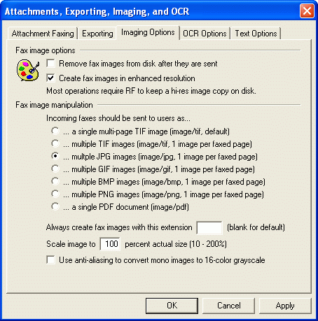

The Imaging Options tab is used for configuring several settings that govern RelayFax’s handling of fax images. It controls whether or not images will be stored after they have been sent, whether to use enhanced resolution when creating them, and the image format that will be used when emailing faxes to your users.

Fax Image Options
Remove fax images from disk after they are sent
Enable this control if you want RelayFax to delete fax image files from disk after they have been delivered to their final destination. Since fax image files can be somewhat large, this feature should be used to conserve storage space if that is of concern to you.
 Warning
Several features require the fax image to be present on disk (for example: viewing the image from the Fax Window on the main interface). Consequently, if you are removing images from the disk not all features will be available.
Create fax images in enhanced resolution
Use this switch if you wish to send high-resolution images when a document is faxed. Selecting this switch provides superior fax image quality but consumes a bit more disk space and transmission time.

Fax Image Manipulation
Incoming faxes should be sent to users as…
Note
Only one of the following options may be chosen. It is the image format that will be used when sending incoming faxes to your users in the form of email attachments.
A single multi-page TIF image (image/tif, default)
This is the default setting. When selected it will cause a single multi-page Tag Image File Format (TIFF) image of the incoming fax to be attached to the message. This file will have the TIF extension.
Multiple TIF images (image/tif, 1 image per faxed page)
This option will cause a separate TIFF image to be attached for every page that the fax contained. This can be useful since some TIFF viewers do not support multiple pages.
Multiple JPG images (image/jpg, 1 image per faxed page)
Causes one JPEG image to be attached per faxed page.
Multiple GIF images (image/gif, 1 image per faxed page)
When this option is selected, RelayFax will attach a single Graphic Interchange Format (GIF) image for each page that the fax contained.
Multiple BMP images (image/bmp, 1 image per faxed page)
Multiple Bitmap (BMP) images will be attached when this option is chosen.
Multiple PNG images (image/png, 1 image per faxed page)
Multiple Portable Network Graphic (PNG) images will be attached when this option is chosen.
A single PDF document (image/pdf)
This option sends incoming faxes to users as a single multi-page Portable Document Format (PDF) file.
RelayFax also supports PDF encryption. To create encrypted PDF files, choose this imaging option and add the following to your RelayFax.ini file:
[PDF]
Encrypt=Yes
OwnerPassword= (Recommended) An owner password gives full access to the document. No owner password means that anyone can change the permissions.
UserPassword= Designating a user password means that it will be required to open the document.
Permissions=-44 “-64” disallows all…no printing, editing, copying, and so on. “-44” permits printing and copying but disallows modifying the contents and annotations. -4 allows all. For more on encryption and permissions, see Chapter 3 of the Adobe PDF Specification at http://partners.adobe.com/public/developer/pdf/index_reference.html.
Note
The following controls will not be available when you choose the Single Multi-page TIF Images option above.
Always create fax images with this extension [xxx]
If you want the file attachments to have an extension other than the given format’s default setting, specify that extension here.
Scale image to [xxx] percent actual size
Specify a percentage in this control if you want the attached image file to be scaled to a different size than the original fax image. You may specify any value from 10% to 200%.
Use anti-aliasing to convert mono images to 16-color Grayscale
Use this feature to cause 2-color mono images to be converted to 16-color Grayscale.
Note
Use of this feature can greatly enhance the quality of fax images, especially when using the “Scale image…” feature to change their size.

OCR Options
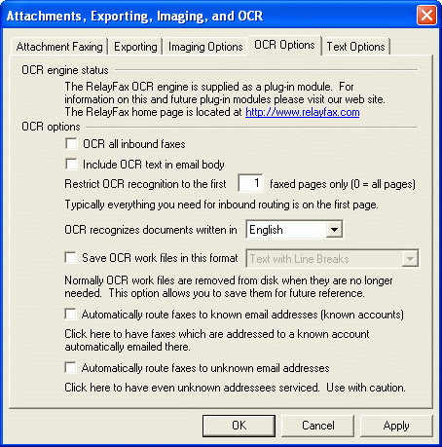

RelayFax is equipped with Optical Character Recognition (OCR) technology that can be used to route incoming faxes based upon their contents rather than just the sender’s fax ID or the port on which faxes arrive. RelayFax’s OCR engine will scan the incoming fax and recognize any typewritten text that it contains. By using the Inbound Fax Rules (page 101) you can specify the text that you want RelayFax to search for and then route the fax based upon the results.
The OCR Options dialog is used to configure the various options associated with RelayFax’s OCR capabilities. You can specify the number of pages that will be read, the language that you want OCR to recognize, whether or not you want the OCR files to be saved and the format in which to save them, and whether or not RelayFax should automatically route the fax to your users when if finds one of their names in the fax.
Document recognition is not just limited to incoming faxes. You can also recognize a document manually by clicking “File|Recognize…” and then specifying both the file that you want to be recognized and the format in which you want it to be saved.
Note
OCR is only effective for typewritten documents; it cannot recognize handwriting.

OCR engine status
RelayFax’s OCR engine is supplied as a plug-in module. If you have not yet installed it then this section will contain a message informing you that it needs to be installed. It also contains a hyperlink to the RelayFax web site from which the module can be downloaded. If the OCR module is not installed then the controls below this section will be dimmed. They will not be accessible until it is installed.

OCR options
OCR all inbound faxes
Click this check box if you want to OCR scan all incoming faxes.
Include OCR text in email body
Click this check box if you want to include the resulting text of OCR scans in the body of email messages. This option is independent of the $ATTACHOCRFILE$ macro (see Appendix A)—if you are using this option and that macro, the OCR files will still be attached to the email.
Restrict OCR recognition to the first [xx] faxed pages only
By default, only the first page of incoming faxes will be recognized. If you want RelayFax to recognize more than the first page then you can use this control to specify an alternate number. If you want all pages to be recognized then enter “0”.
OCR recognizes documents written in …
There are ten different languages that the OCR engine is capable of recognizing. From the drop-down list box choose the language that you want it to look for when recognizing the documents.
Save OCR work files in this format…
By default, the results of the OCR process will be used for routing purposes and then deleted. However, RelayFax provides the option to save these files for your use. This is a highly useful feature because the files can be saved in the most commonly used document formats, including: Microsoft Word, Microsoft Excel, WordPerfect, Adobe Acrobat, HTML, Lotus, plain text, text with line breaks, and others. If you want to save these files then click this checkbox and choose the desired format from the drop-down list box. Each file will be saved in RelayFax’s \Faxfile\ subdirectory along with the TIFF file to which it corresponds. OCR files will be saved with the extension “.ocr” regardless of the format in which they were saved. Some software products may not support files without certain specific file extensions so in some cases it may be necessary to rename the *.ocr file before it can be viewed by your product. When you have configured a rule to email an OCR document to someone, the file extension will be renamed to match the appropriate document format. Manually recognizing a document (File|Recognize…) will cause it to be saved with the chosen format’s file extension as well.
Note
OCR technology isn’t foolproof. Characters with similar shapes, unusual fonts, and fuzzy or unclear text may cause some mistakes in the documents resulting from the OCR process. However, in most cases only a moderate amount of editing will be required to correct these mistakes.
Automatically route faxes to known email addresses (known accounts)
Click this option if you want RelayFax to automatically route incoming faxes to your users when the OCR engine finds an account holder’s real name in a document. For example, if Frank Thomas had a fax account on your RelayFax server, enabling this option would cause any fax containing “Frank Thomas” to be routed to him automatically without the need to create a specific fax rule to do so.
Automatically route faxes to unknown email addresses
When this switch is enabled, the OCR engine will scan the fax for the first email address that it contains and then automatically route the fax to that address, even if it is otherwise unknown to RelayFax (not a known account). RelayFax will use Regular Expression Matching to determine what portion of the recognized text constitutes an email address. The Regular Expression syntax that RelayFax uses to extract addresses is located in the RelayFax.ini file and appears as follows:
[OCR]
LinePattern=[Tt][Oo]?:[a-zA-Z0-9\.]+@[a-zA-Z0-9\.]+
EmailPattern=[a-zA-Z0-9\.]+@[a-zA-Z0-9\.]+
RelayFax first uses LinePattern= to extract the line that contains an email address. Then the address is extracted from that line by using EmailPattern=, which almost assures a reliable result. If you need to adjust either of these values due to your particular situation, you can easily do so by editing their corresponding INI entries. See Appendix C – Regular Expression Matching (page 218) for an explanation of regular expression syntax.
 Warning
Enabling this feature will in effect cause RelayFax to become an open fax gateway for any user. That is, of course, the goal of this feature, but it may violate your local network policy.

Text Options
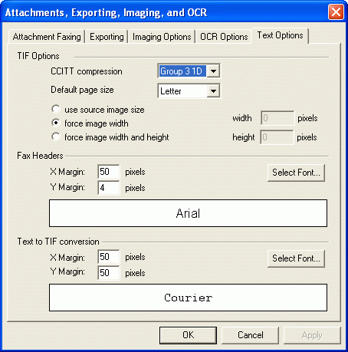

TIF Options
CCITT compression
This is the type of compression that RelayFax applies to all faxes and TIF files it creates. For most people, leaving it set to Group 3 1D will be sufficient, but a drop-down list of other options is provided for those who desire to change it. Note: some modems do not support all of the compression types, though many do.
Default page size
Use this option to designate the default dimensions of the TIF image RelayFax will create when converting a document or other image to a fax image. This is one of the options that can be set during installation.
Use source image size
When this option is selected, RelayFax will not resize the image. It will be converted to faxed as is.
Force image width
Choose this option to restrict images to the current width setting. RelayFax will force all converted document to that width. The document width is determined by the Default page size setting above.
Force image width and height
Choose this option and specify a height in the box provided. RelayFax will scale all converted documents to this width and height setting.
Fax Headers
X Margin: [XX] pixels
This is the amount of blank space (in pixels) that will appear on the left and right side of the fax header.
Y Margin: [XX] pixels
This is the amount of blank space (in pixels) that will appear above the fax header.
Select Font
Use this option to choose the font in which your header will appear.
Text to TIF conversion
X Margin: [XX] pixels
When converting a document into a TIF image for faxing, this is the amount of blank space that RelayFax will leave on the left and right side of the image.
Y Margin: [XX] pixels
When converting a document into a TIF image for faxing, this is the amount of blank space that RelayFax will leave at the top and bottom of the image.
Select Font
Use this setting to designate the font that RelayFax will use when converting text into a fax image.

TWAIN Device Support
RelayFax supports TWAIN compatible devices such as digital cameras and scanners. Documents can be scanned directly into RelayFax and then faxed to their proper destinations at the touch of a button. From the RelayFax server’s interface, you can acquire a document from a scanner by clicking “File|Select source…”, choosing the device that you wish to use, and then clicking “File|Acquire…”.
Because the scanner features are primarily accessed from within the RelayFax SMTP Client, you will find a more thorough discussion of them in the Client section of this manual.
See:
Scan Image—page 184
Scanning Options—page 186

Mail Sources and Rules
Chapter
7

Mail Sources
On the Mail Sources tab you will specify the POP3 mail hosts from which the RelayFax Server is to collect mail to be processed and faxed. RelayFax will connect to each one of these hosts to collect any waiting messages which need to be converted and faxed.
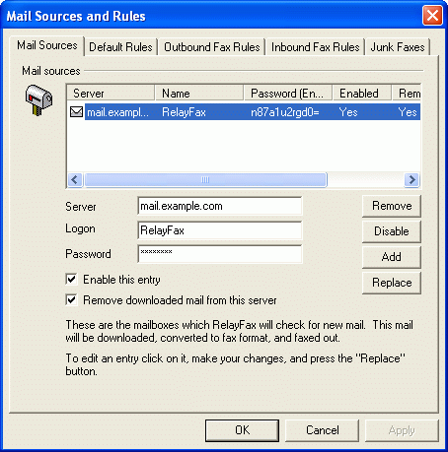

Mail Sources
Here you can specify as many mail server accounts as you wish. RelayFax will collect email from each of them, convert the emails to faxes, and then send them.
Server
Enter the server from which RelayFax’s mail will be collected.
Logon
Enter the username or login that accesses RelayFax’s account on the server.
Password
Enter the password required to access RelayFax’s account on the server.
Remove
Click this button to remove the selected mail hosts entries from the list.
Enable/Disable
Clicking this button toggles the state of the selected POP3 Mail Hosts entries. This switch gives you control over whether RelayFax will collect mail for this entry or skip over it when it performs the mail collection process.
Add
Press this button to add the values to the list of mail hosts from which RelayFax will collect mail.
Replace
When an entry is selected from the list it will be presented for editing. After any desired changes are made, click this button to apply the changes.
Remove downloaded mail from this server
You can use this setting to govern whether RelayFax should remove the mail that it collects from the remote host.

Adding New Mail Host Entries
To add a new mail host to the current list, fill in the various controls on this dialog and then click the Add button. At designated processing intervals RelayFax will check all enabled entries for new mail messages.

Editing Existing Mail Host Entries
To edit an existing mail host entry click the desired entry in list. When the entry is selected, its current settings will be displayed for editing in the various controls on this dialog. Make any desired changes to these control settings and then click the Replace button. The old settings for this entry will then be replaced by the new.
Note
Do not click the Add button when editing existing entries. Click the Replace Entry button to save any changes to existing entries.

Default Rules
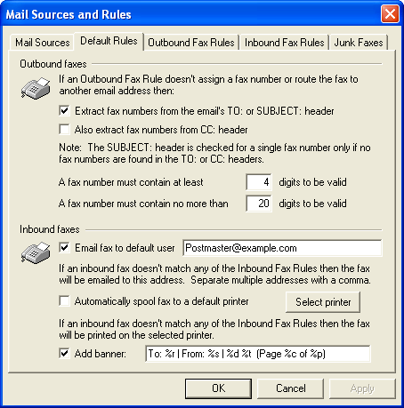
When RelayFax receives a document for faxing, or if it receives an incoming fax, it will first attempt to apply the Outbound or Inbound Fax Rules specified on their respective tabs. If no rule can be applied to the document or fax then RelayFax will act according to the default rules specified here.

Outbound Faxes
Extract fax numbers from the email’s TO: or SUBJECT: header
If an Outbound Fax Rule doesn’t assign a fax number or route the fax message to an email address, then RelayFax will attempt to extract a fax number from the message’s TO: header if this checkbox is enabled. If no numeric data is present in the TO: header (or CC: if enabled) then the SUBJECT: header will be scanned. If no rule can be applied to the message, and this control is disabled (or the headers contain no fax numbers), RelayFax will send a message to the Sender informing them that it cannot be sent.
Also extract fax numbers from CC: header
If you have RelayFax configured to extract fax numbers from TO: headers, click this checkbox if you wish to extract them from CC: headers as well.
A fax number must contain at least [xx] digits to be valid
Type the minimum number of digits that any extracted numbers must contain.
A fax number must contain no more than [xx] digits to be valid
Type the maximum number of digits that you wish to allow extracted numbers to contain. This is useful if you wish to prohibit your users from sending faxes to long distance numbers.

Inbound Faxes
Email fax to default user [address]
When RelayFax receives an inbound fax that does not match any of the Inbound Fax Rules, it will be emailed to this address. If entering multiple addresses they must be separated by commas.
Automatically spool fax to a default printer
This control makes it possible to automatically print all inbound faxes that do not match any Inbound Fax Rules. Enable this control and then click the Select Printer button. Next, the Select Printer dialog will open displaying a list from which you can choose a printer.
Select printer
Click this button to open the Select Printer dialog from which you can choose a printer for printing inbound faxes.
For more information on the Select Printer dialog and printing in general, see:

Select Printer – page 62

Outbound Fax Rules
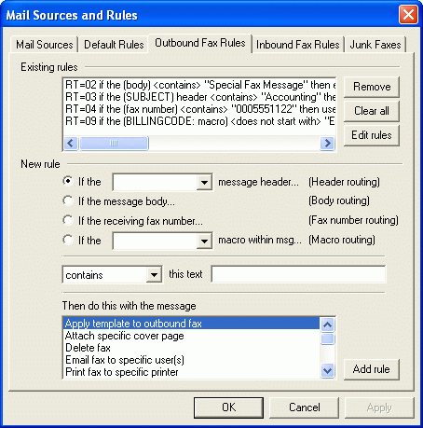
With the Outbound Fax Rules feature, you can setup rules that RelayFax will use to determine what to do with each email message that it receives. Careful utilization of the rules system will allow you to setup a very flexible and robust fax server system.
Fax Rules are processed in order and are cumulative. For example, if RelayFax receives a message from User@RelayFax.com and you have a rule that states: “If [FROM] contains ‘User’ then fax to {555-5555}”, and you have a later rule that says “If [FROM] contains ‘RelayFax.com’ then fax to {555-1234}”, then both rules would be applied and the message would be faxed to both numbers.
Note
In some cases, you may not want all possible rules to be applied to a message. RelayFax provides the “Skip next rule” and “Stop processing rules” actions for such situations. In the example above, if you did not want messages containing “User” to have more than the first rule applied to them you could create a rule immediately following the first which would say “If [FROM] contains ‘User’ then stop processing rules”. Then the rule stating, “If [FROM] contains ‘RelayFax.com’ then send to…” would not be applied to the message.

Existing Rules
This list shows you the rules that have already been created.
Remove
Press this button and the selected rules in the Existing Rules list will be removed.
Clear all
This button removes all existing rules.
Edit rules
If this button is clicked the OUTRULES.DAT file will be opened in Windows Notepad for manual editing of Outbound Fax Rules.
 Warning
Take care not to violate the syntax of the OUTRULES.DAT file.

New Rule

Header routing
If the [HEADER] message header…
Choose this option if you want the rule to route messages based on the contents of one of the message headers.

Body routing
If the message body…
Click this option if you want the fax rule to route messages based on the text in the message body.

Fax number routing
If the receiving fax number
Click this option if you want the rule to be based on the fax number to which the fax is being sent.

Macro routing
If the [xx] macro within msg…
When this option is chosen, the fax rule’s routing will be based on the presence of certain email macros found within the message body. You can choose from the list of available macros by clicking the drop-down list box and then using the arrow keys, Page Up, or Page Down on your keyboard.
For more information regarding email macros, see:
Sending a Fax via an Email Client—page 194
Email Macros—page 209

Comparison type
Is equal to, is not equal to, contains, does not contain, starts with, does not start with
These options specify what relationship is to exist between the part of the message being searched and the “This Text:” value of each rule.
This text:
Here you specify the text that RelayFax should look for in order to trigger the rule.

Then do this with the message
This control lists the available actions that can be performed if a received message meets an Outbound Fax Rule’s criteria. Here is a list of actions and their functions:
Add text to end of fax number – Use this action if you want to add text to the end of a fax number when it meets the rule’s criteria. When you choose this option and click Add rule a box will open in which you will specify the text that you wish to add. This action is only available when you choose the Fax number routing method.
Add text to start of fax number – Use this action if you want to add text to the beginning of a fax number when it meets the rule’s criteria. When you choose this option and click Add rule a box will open in which you will specify the text that you wish to add. This action is only available when you choose the Fax number routing method.
Replace text within fax number – Use this action if you want to replace the specified text in a fax number with some other text when it meets the rule’s criteria. When you choose this option and click Add rule a box will open in which you will specify the new text. This action is only available when you choose the Fax number routing method.
Apply template to outbound fax – Use this option if you want a Fax Template to be applied to messages meeting an Outbound Fax Rule’s criteria. With Templates, you can designate alternate banners, cover pages, and other fax parameters. To create a rule that will take this action specify the header, relationship, and text to be tested. Then, click the Apply template to outbound fax action, click the Add Rule button, choose the template file (*.TP) that you want to assign to the rule, and then click OPEN.
Note
Before you can create a rule that will take this action you must first create the Template that you wish to assign to the rule.
For more information on Templates, see:
Fax Templates – page 131
Assign Billing Code – Use this action to assign a specific Billing Code to an outbound fax meeting the rule’s criteria. When you click the Add Rule button, a dialog will open from which you can choose the desired Billing Code or create a new one.
Attach specific cover page – Use this feature if you want an alternate Cover Page to be attached to messages that match the rule’s criteria. To create rules that will take this action specify the header, relationship, and text to be tested. Then click the Attach specific cover page action, click the Add Rule button, choose the cover page file that you want to assign to the rule, and then click OPEN.
Note
Before you can create a rule that will take this action you must first create the alternate Cover Page that you wish to assign to the rule.
For more information on cover pages, see:
Cover Pages – page 116
Do not attach cover page – Select this action if you wish to prevent a cover page from being attached to the outbound fax when the fax message matches the rule’s criteria.
Delete fax – Select this action if you want the message to be deleted if it matches the rule.
Email fax to sender – Using this rule will cause any outbound fax matching the rule’s criteria to be emailed to the sender of the fax message.
Email fax to specific user(s) – Select this action, click the Add Rule button, enter one or more Email addresses into the dialog that will open (clicking Add after each address entered), and then click OK. This will cause RelayFax to forward any message that meets the specified Rule’s requirements to the address(es) indicated in the Rule.
Several special formatting macros are available for use in specifying these email addresses. See the Outbound Fax Rule Macros (page 212) for a complete listing.
Print fax to specific printer – Select this action, click the Add Rule button, and then the Select Print dialog will be opened. Choose a printer from the Available Printers list and then click OK. This will cause all outbound faxes that meet the rule's criteria to be sent to the selected printer.
For more information on the Select Printer dialog and printing in general, see:
Select Printer – page 62
Send fax at specific day and time – Select this action, click the Add Rule button, and then choose the date and time that you want a fax matching the rule to be sent.
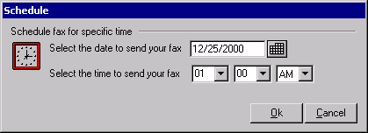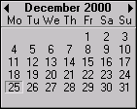
Click to open the graphical calendar from which you can choose the date to send the fax.
Send fax to numbers found in text file – Select this action, click the Add Rule button, and then pick the text file that contains your list of fax numbers. When this rule is triggered RelayFax will fax the message to each number specified in the file. The file must contain no more than one fax number per line but each line can also contain the recipient’s name and company information. Lines beginning with “#” or “;” are ignored to allow you to put comments throughout the file as necessary. Here are some examples:
555-1212  555-1212, Arvel Hathcock  555-1212, Arvel Hathcock, Alt-N Technologies  555-1212, Arvel Hathcock, “Alt-N Tech, LTD.”  555-1212, , Alt-N Technologies | ; only the fax number is specified  ; fax number and recipient name specified  ; fax number, name, and company specified  ; fax parms may contain commas it quoted  ; only fax number and company specified
Note
There is no theoretical limit to the quantity of fax numbers that such a file can contain. However, RelayFax sets an arbitrary limit of 100 numbers to keep from draining the computer of too many resources. If this limit is too low it can be adjusted by manually editing the RelayFax.ini file under the following key:
[Special]
MaxNumbersFromFile=100
Setting the value of this control to “0” will prevent any limit from being imposed.
Send fax to specific number(s) – Select this action, click the Add Rule button, and then enter one or more fax numbers into the dialog that opens (click Add after each fax number), and then click OK. This will cause RelayFax to fax any message that meets the specified Rule’s requirements to the fax number(s) indicated in the rule. Further, you can also specify the intended recipient’s name and company when creating the rule.
Set the priority level for this fax – Select this action, click the Add Rule button, and then specify the priority value (0-100) that you want to be assigned to faxes matching this rule. “0” is the highest priority and “100” is the lowest. Faxes are always sent in the order of their priority setting.
Send fax using a specific fax port – Select this action, click the Add Rule button, and select a port value from the dialog that will open. This will cause RelayFax to send any fax that meets the specified Rule’s criteria through a certain COM port.
Strip text from fax number(s) – This action is only available in rules using Fax Number Routing. It will cause the specified text to be stripped from the recipient fax number before RelayFax attempts to send the fax. Choosing the “contains” qualifier will cause the text to be stripped from the number anywhere that it occurs. Use the “starts with” qualifier if you want to strip this text from only the beginning of fax numbers. For example, you could use this action combined with the “starts with” qualifier to cause a certain unnecessary area code to be removed from the beginning of any fax number in which it appears.
Skip next rule – Use this rule to skip over the next rule.
For example,
Suppose you have two rules which read:
“If From contains ‘RelayFax.com’ then send to UserA@mdaemon.com”
“If Subject contains ‘Private’ then send to UserB@mdaemon.com”
If a message arrives from “Someone@RelayFax.com” it will match to the first rule. If it has the word “Private” in the subject it will also match the second rule. This will result in the fax being emailed to two different people (UserA and UserB).
But suppose you inserted a new rule between the first two like this:
“If From contains ‘RelayFax.com’ then send to UserA@mdaemon.com”
“If From contains ‘RelayFax.com’ then skip next rule”
“If Subject contains ‘Private’ then send to UserB@mdaemon.com”
This would prevent the message from being sent to UserB if it was from someone at RelayFax.com.
Stop processing rules – Use this rule to cause further rule processing to stop.
Note
You must double-click a selection from this list, or make a selection and then click the Add Rule button, to proceed with the rule creation process.
Add rule
After selecting an option from the Then do this with the message list, click the Add rule button to proceed with the rule creation process.

Inbound Fax Rules
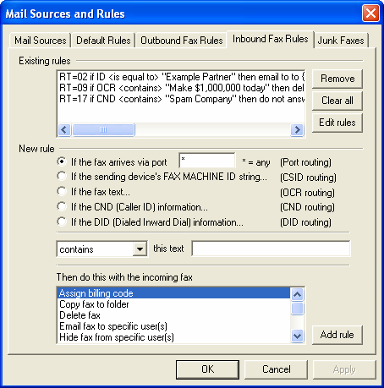
Inbound Fax Rules are used to tell RelayFax how to handle incoming faxes. When a fax is received, the transmitting fax device’s ID, the port on which the fax arrived, and the OCR results of its contents are compared to the current list of Inbound Fax Rules. If a match to one or more Inbound Fax Rules is made then the fax will be routed accordingly. Otherwise, the fax will be handled according to the settings on the Default Rules tab.

Existing Rules
The Existing Rules list box shows you a list of all rules that are currently in use.
Remove
Press this button and it will cause any rules that you have selected in the Existing Rules list box to be removed.
Clear all
This button removes all existing rules.
Edit rules
If this button is clicked the INRULES.DAT file will be opened in Windows Notepad for manual editing of Inbound Fax Rules.
 Warning
Take care not to violate the syntax of the INRULES.DAT file.
New Rule
Port routing
If the fax arrives via port xx
Click here and specify a port if you wish to base your rule on the COM port on which the fax arrives. Use the “ * ” wildcard in this space if you wish the rule to apply to all ports rather then a specific one.
CSID routing
If the sending device’s FAX MACHINE ID string…
Click here to base your rule on the Call Subscriber Identification of the fax device that is sending the incoming fax.
OCR routing
If the fax text…
Click this option if you want to base the rule on the results of the OCR process. RelayFax will recognize the document and then compare its contents to the inbound rules that you have created. For example: if you created a rule that said “…if OCR contains ‘Make money today!’ then delete fax”, then all incoming faxes in which RelayFax found the typewritten phrase ‘Make money today!’ would be deleted. See OCR Options (page 83) for more information on routing faxes automatically by using RelayFax’s OCR features.
CND routing
If the CND (Caller ID) information…
Click this option if you wish to base the rule on the incoming CND information. See Calling Number Display (Caller ID) Fax Routing (page 106) for more information on using CND routing.
DID routing
If the DID (Dialed number) information…
Click this option if your system supports Direct Inward Dialing (DID) and you wish to base the rule on the number that the sending fax device dialed.
Comparison type
Is equal to, is not equal to, contains, does not contain, starts with, does not start with
The options contained in the drop-down list box specify the relationship that is to exist between the results of the routing option search and the “This Text:” value of the rule. For example: If you chose the “If fax text…” (OCR routing) option, selected the “contains” option from this control, and then typed “Sales Report” into the “this text” box, then RelayFax would take the action specified in the “Then do this…” control whenever the OCR process revealed that the phrase “Sales Report” was contained within the incoming document.
This text:
Here you specify the text that RelayFax should look for in order to trigger the rule.
Then do this with the incoming fax
This control lists the available actions that can be performed if an inbound fax meets an Inbound Fax Rule’s criteria. Here is a list of actions and their functions:
Assign billing code – This action will assign a specified billing code to Inbound Faxes matching the rule’s criteria.
Copy fax to folder – This action will cause the fax to be copied to a specific folder.
Delete Fax – This action will simply delete the incoming fax.
Email fax to specific user(s) – Select this action, click the Add Rule button, enter one or more Email addresses into the dialog that will open (clicking Add after each address entered), and then click OK. This will cause RelayFax to email any inbound fax that meets the specified Rule’s requirements to the address(es) indicated in the Rule. A rule of this type will be created automatically when a user chooses the “To route future faxes from [sender] to someone else…” link that is included by default in fax messages that RelayFax directs to them. See the $INCLUDEURL$ Macro description in DAT File Processing Macros (page 213) for more information.
Hide fax from specific user(s) – This action will prevent a fax matching the rule from being delivered to the specified user. A rule of this type will be created automatically when a user chooses the “To ignore future faxes from [sender]…” link that is included by default in fax messages that RelayFax directs to them. See the $INCLUDEURL$ Macro description in DAT File Processing Macros (page 213) for more information.
Mark fax as SPAM (junk) – Marks the inbound fax as SPAM (a junk fax). Use the controls on the Junk Faxes tab to specify what should be done with messages that are marked as SPAM. A rule of this type will be created automatically when a user chooses the “To mark future faxes from [sender] as unwanted spam…” link that is included by default in fax messages that RelayFax directs to them. See the $INCLUDEURL$ Macro description in DAT File Processing Macros (page 213) for more information.
Print message to specific printer – Select this action, click the Add Rule button, and then the Select Printer dialog will be opened. Choose a printer from the Available Printers list and then click OK. This will cause all inbound faxes which meet the rule’s criteria to be sent to the selected printer.
For more information on the Select Printer dialog and printing in general, see:
Select Printer – page 62
Skip next rule – Use this option to skip over the next rule.
For example,
Suppose you have two rules which read:
“If ID contains ‘123’ then send to UserA@RelayFax.com”
“If ID contains ‘456’ then send to UserB@mdaemon.com”
If an inbound fax arrives from a device with the ID ‘123456’ then it will be routed to two different people (UserA and UserB).
But suppose you inserted a new rule between the first two like this:
“If ID contains ‘123’ then send to UserA@RelayFax.com”
“If ID contains ‘123’ then skip next rule”
“If ID contains ‘456’ then send to UserB@mdaemon.com”
This would prevent the fax from being sent to UserB if it was from ‘123456’.
Stop processing rules – Use this rule to cause further rule processing to stop.
Use specific OCR language – Use this action to designate a specific language for the OCR engine to use when the rule’s criteria is met. For example, you could use this rule to cause the OCR engine to use Swedish for all incoming faxes that you determine are coming from Sweden.
Note
You must double-click a selection from this list, or make a selection and then click the Add Rule button, to proceed with the rule creation process.
Add rule
After making a selection from the Then do this with the incoming fax list, click the Add rule button to proceed with the rule creation process.

Calling Number Display (Caller ID) Fax Routing
RelayFax is equipped with support for routing incoming faxes based upon Calling Number Display (commonly called Caller ID) data. As with other methods of routing inbound faxes, this is accomplished by using the Inbound Fax Rule editor. You will create rules specifying the text for which RelayFax will search and then the actions that will be taken when that text is or isn’t found.
There are a few requirements that must be met before you will be able to route faxes based upon Calling Number Display (CND) information. First, the CND service must be active on the telephone line on which you receive faxes. This service is provided by your telephone company, usually for a small extra monthly charge. Also, your receiving fax modem must have support for detecting and preserving CND data so that RelayFax can acquire it, and that support must be enabled. Since CND support is not normally enabled by default in most modems, it is likely that you will need to add the appropriate command to your modem’s INIT string within RelayFax. Consult your modem manual for the proper INIT string command that enables CND support. If you do not have documentation for your modem then we suggest visiting www.modemhelp.com. There you will find documentation and other resources available for most modems. See Modem Properties (page 31) for information about editing your INIT string.
Note
Most of the cheaper modems on the market today do not have CND capability.
CND data is transmitted from the telephone company to your fax modem in a packet of information between the first and second ring. Therefore, you must configure your modem to allow at least two rings before answering the call if you want to be able to route messages based on CND data. You can configure this setting on the Modem Properties dialog (page 31).
CND data can be provided to RelayFax in a variety of formats. It can be sent as a raw byte stream, in single-message format, or multi-message format. To make full use of RelayFax's CND routing capabilities you must configure your modem to provide CND data in multi-message format. Consult your modem manual for the proper INIT string settings required to achieve this (for example +VCID=1). In multi-message format most modems append “labels” to the raw CND data elements in order to make it easier to read, but there are no uniform standards governing what these labels should be. Therefore different modems use different labels for each piece of CND information. One modem, for example, might label the CND number as “NUMB=” while another would use “CALLER NUMBER:”. Because RelayFax needs to know which labels your modem uses so that it can parse the number and name elements from the CND data, you will need to determine them and then enter them into the controls found on the Modem Properties dialog. You can determine them by watching for the labels in the main display during an incoming call being processed by RelayFax. Technically, RelayFax should be able to acquire the CND data in raw format (which doesn't require any labels) but experimentation has discovered that some modems modify even the raw data before passing it to RelayFax. This makes parsing at the application level inevitable.
In addition to the normal actions that can be assigned to Inbound Rules, there is one special action available for use exclusively with CND routing. Since CND detection takes place prior to answering the call, you can use the “Do no answer incoming call” action. When an incoming call is ignored as a result of such a rule the call is not answered and will ring until the remote side gives up. While the phone is ringing you may see one or more error messages such as “unspecified modem error” or “timeout during fax send/recv”. These error messages are of no real concern. The presence of these error messages does not effect the performance of the software in any way.
See the “DAT File Processing Macros” section of Appendix A (page 213) for information regarding new CND related macros available for use within DAT files.

Junk Faxes
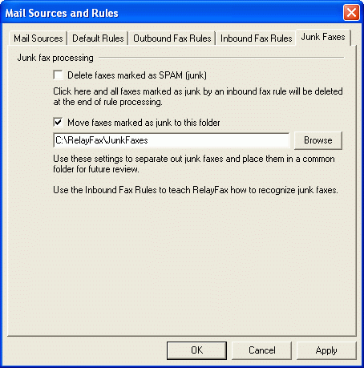
One of the available actions that can be specified in the Inbound Fax Rules is the “Mark as SPAM (junk)” action. The controls on the Junk Faxes dialog are used to designate what will happen to messages that have been marked as SPAM.

Junk fax processing
Delete faxes marked as SPAM (junk)
Click this checkbox if you want messages that are marked as SPAM to be deleted at the end of rule processing.
Move faxes marked as junk to this folder
Click this option and specify a folder if you want messages marked as junk to be moved to the folder for later review.

Event Scheduler & Dialup
Chapter
8

Event Scheduler
The scheduling system in RelayFax allows you to specify exactly when and how often you want new mail to be collected and waiting outbound mail to be forwarded.
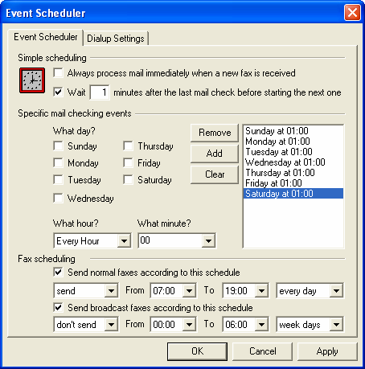

In RelayFax there are two ways that mail processing can be triggered: Simple Scheduling and Specific Mail Checking Events.
Simple Scheduling
Always process mail immediately when a new fax is received
Enable this check box and RelayFax will initiate a mail transaction with the server each time a new fax is received. This will allow fastest delivery of newly received faxes.
Wait [xx] minutes after the last mail check before initiating a new one
The Simple Scheduling feature allows you to configure RelayFax to begin processing every time the number of minutes that you have specified in this control has elapsed. This countdown begins at the conclusion of any mail processing event no matter what caused the event to be triggered.
Note
In order for Simple Scheduling to take effect during any given day at least one timed entry must exist for that day in the Scheduled Times list.
For example,
Suppose you want to schedule 45 minutes between dialup sessions but only on Monday through Friday. You will need to enable the Simple Scheduling option and enter 45 minutes into the control. Then, you must enter at least one scheduled time for each day (Monday, Tuesday, Wednesday, Thursday, and Friday). Since there wouldn’t be a scheduled time for Saturday or Sunday those days would be exempt and no mail processing event would be triggered by Simple Scheduling. The time you select when you setup your trigger days doesn’t matter. Simple Scheduling only checks whether or not an entry for any particular day exists.
Specific Mail Checking Events
Using this method you can designate exact times that you wish RelayFax to begin Mail Checking Events.
What day?
Select the days that you wish to schedule.
What hour?
Select the hour that you wish to schedule.
What minute?
Select the minute that you wish to schedule.
Remove
Clicking this button will remove the selected entries from the schedule listing.
Add
Once you’ve selected the day, hour, and minute click this button to add this time to the list of scheduled events.
Clear
This button removes all entries from the schedule listing.
Fax Scheduling
Use the options in this section to schedule a daily window of time in which faxes may or may not be sent by RelayFax. You can specify a separate time-period for both normal and broadcast faxes, whether the period is to allow or disallow sending faxes, and whether or not it will be applied every day or just weekdays (Monday thru Friday).
Send normal faxes according to this schedule
Click this option to set a time window for all normal (i.e. non-broadcast) faxes. Choose send in the first drop-down box if you wish to allow RelayFax to send faxes during the scheduled time. Choose don’t send if you wish to disallow the sending of faxes during that period. Designate the starting and ending hour next, and then choose every day if you wish the period to be enforced every day or week days if you wish the scheduled period to be enforced only Monday thru Friday.
Send broadcast faxes according to this schedule
Click this option to set a time window for all broadcast faxes. Choose send in the first drop-down box if you wish to allow RelayFax to send broadcast faxes during the scheduled time. Choose don’t send if you wish to disallow the sending of broadcast faxes during that period. Designate the starting and ending hour next, and then choose every day if you wish the period to be enforced every day or week days if you wish the scheduled period to be enforced only Monday thru Friday.

Dialup Settings
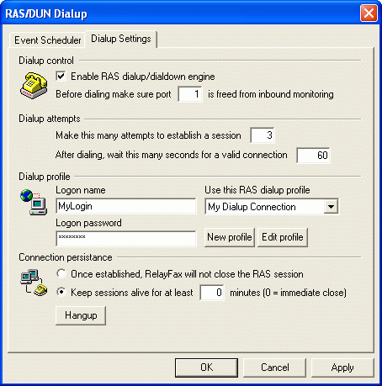
RelayFax can dial your ISP for you in order to collect mail from and post mail to remote mail servers. The Dialup Settings dialog controls this feature.

Dialup Control
Enable RAS dialup/dialdown engine
Click this checkbox to enable/disable the dialup feature.
Before dialing make sure that port [xx] is freed from inbound monitoring
By specifying the port on which you may have a fax device listening for incoming faxes, RelayFax can suspend listening temporarily in order to use that port for dialup. This aids in avoiding hardware conflicts.

Dialup Attempts
Make this many attempts to establish a session
RelayFax will attempt to connect to the remote host this many times before giving up.
After dialing, wait this many seconds for a valid connection
This value determines how long RelayFax will wait for the remote computer to answer and complete the RAS connection.

Dialup Profile
Logon name
The value specified here will be passed to the remote host during the authentication process.
Logon password
The value specified here will be passed to the remote host during the authentication process.
Use this RAS dialup profile
This drop down list box allows you to select a session profile that has been previously defined through Windows Dialup Networking or Remote Access Services Setup.
New profile
Click this button to create a new Dialup Networking or Remote Access Services profile.
Edit profile
Click this button to edit the currently selected Dialup Networking or Remote Access Services profile.

Connection Persistence
Once established, RelayFax will not close the RAS session
By default RelayFax will shut down a created connection immediately after all mail transactions have been completed and the session is no longer needed. Selecting this option will allow the session to remain active even after all mail has been transacted.
Keep sessions alive for at least xx minutes
This option will allow a RelayFax created RAS session to survive for the number of minutes specified. Placing a zero in this entry will cause the connection to be immediately closed after the transactions are completed.
Hang-up
This button will break the connection to the ISP. This button is active only if RelayFax has initiated the RAS session.

Cover Pages
Chapter
9

Cover Pages
RelayFax integrates with the Microsoft Cover Page Editor application that ships with Windows. This application provides a very high level of custom cover page design and creation capability. The Microsoft Cover Page Editor allows you to create and edit richly formatted cover pages, which are supported directly by RelayFax.
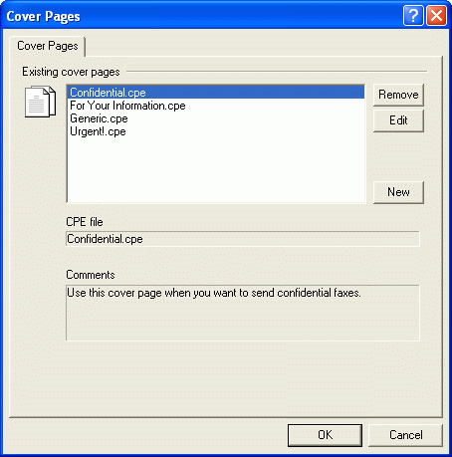
Note
The version of Microsoft Cover Page Editor included with Windows 2000/XP uses a different file format than the previous Windows 9x version. This new version uses the *.COV file format instead of the older *.CPE format, but RelayFax supports both formats. If the cover page editor is not installed or associated with these files then you may need to go to Add/Remove Programs in the control panel and install the Fax Services under Add/Remove Windows Components.
If you are using Windows NT, then you may need to obtain the old cover page editor from a Windows 9x installation disk. On a Windows 98 CD-ROM, the installer for this editor is located at the following path: \tools\oldwin95\message\us\AWFAX.EXE.
Otherwise, the following files are required:
FAXCOVER.EXE, MFC30.DLL, MFCO30.DLL, MFCUIA32.DLL, and MFCANS32.DLL.

Existing Cover Pages
This box displays all available cover pages that you have created.
Remove
You may delete a cover page by selecting it from the Existing Cover Pages list and then clicking the Remove button. RelayFax will ask you to confirm your decision to delete the cover page before proceeding.
Edit
To edit a previously created cover page select it from the Existing Cover Pages list and then click the Edit button. The cover page will be loaded into the Microsoft Cover Page Editor.
New
To create a new cover page click the New button. This will open the New Cover Page Properties dialog which you will use to assign a name for your cover page and include any desired comments or notes about this page for your reference.
CPE file:
This is the actual path to the cover page file itself.
Comments:
When you create a cover page you will have the opportunity to include some comments or a description of the page for your personal reference. These comments will appear in this area when a cover page is selected from the Existing Cover Pages list. This text will not appear on the cover page itself.

Creating and Editing Cover Pages
Whenever a fax is sent RelayFax may attach a cover page to it. This cover page might be the default cover page or it could be a custom one created by you. To create or edit a cover page open the Cover Pages dialog from the Tools menu or Toolbar within RelayFax.

Creating a New Cover Page
To create a new cover page click the New button located on the Cover Pages dialog. After clicking this button the New Cover Page Properties dialog will appear (see illustration and descriptions). On this dialog you will assign a name to your cover page and include any desired comments or notes about this page for your reference. After you have entered this information, click OK. Next, a program information box will appear informing you that the cover page has been created and is about to be loaded into the Microsoft Cover Page Editor for customization. The new cover page will start as a copy of GENERIC.CPE but you can add or subtract anything from it that you wish.

New Cover Page Properties
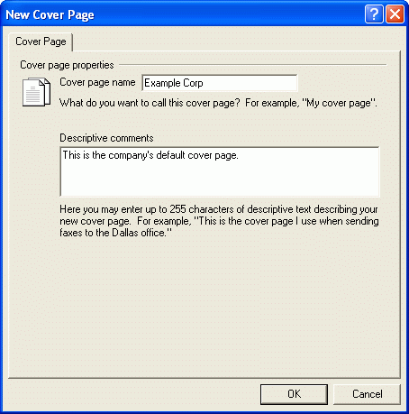

Cover Page Description
Cover page name
Type a name for your cover page into this text box. This may be a descriptive name such as “The Frank Thomas cover page”.
Descriptive comments
Here you may enter up to 255 characters of descriptive text or comments regarding this cover page. This can be used for reference to easily identify a specific cover page. This is helpful when creating Outbound Fax Rules to assign alternate cover pages. For example, “This is the cover page that Frank Thomas uses when sending faxes about his many heroic exploits.” When this particular cover page is selected from the Existing Cover Pages list this text will appear in the Comments section of the Cover Pages dialog.
Note
These comments are saved in your cover page folder as the file “CoverPageName.cmt”.

Editing Cover Pages
Note
Editing a cover page requires the Microsoft Cover Page Editor. This application ships with Windows 95 and Windows 98. Unfortunately Microsoft has declined to allow Alt-N to provide the files associated with this application in our installation archives. This means that if you are a Windows NT/2000 user or are otherwise unable to find this application on your system you will be missing the following files:
FAXCOVER.EXE, MFC30.DLL, MFCO30.DLL, MFCUIA32.DLL, and MFCANS32.DLL.
You can find an installation archive for these files on the Windows 98 CD-ROM. The path is \tools\oldwin95\message\us\AWFAX.EXE.
The new cover page editing tool included with Windows 2000 is not compatible with RelayFax. However, the previous version mentioned above still works very well. Therefore installing the old version will be necessary in order to edit your cover pages in Windows 2000.
To edit a previously created cover page select it from the Existing Cover Pages list on the Cover Pages dialog and then click the Edit button.

Contact Manager
Chapter
10

Fax Contact Manager
RelayFax and the RelayFax SMTP Client are each equipped with a complete fax contact and address book management system. It can be used to manage all of your contacts, and supports storing a large amount of information for each one them. You can add up to 50 fields for each contact, assign contacts to groups, add notes for them, sort by any field, launch your web browser, phone dialer, or email program, and a host of other features. For more information regarding the various features and options available within the Contact Manager, see its online Help system.
Because any number of the Contact Manager’s data files can be managed at once, and because they can be shared and viewed simultaneously by multiple users, the Contact Manager can be used effectively as both a global and personal address book for the users on your local network. Users can simply click the Open button in their Contact Manager and then navigate to the *.adx file on the network that contains the shared address book entries. That file will then be incorporated into their local Contact Manager. For remote users, the *.adx files can easily be emailed to their remote location so that they can have access to the shared contacts as well.
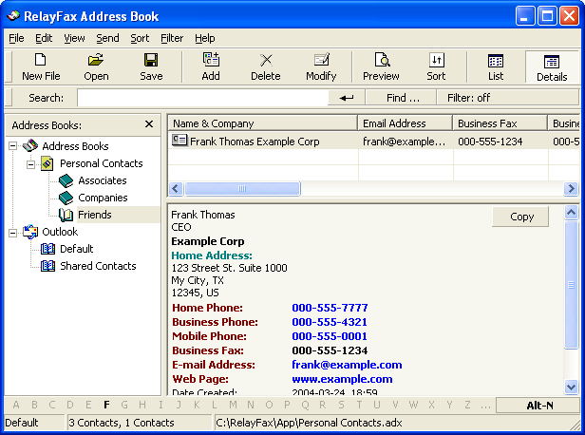

Importing Contacts from Other Address Books
The Contact Manager can import address book files from other applications by using the File→Import menu selection. If it is not an address book file format that the Contact Manager natively recognizes, then you must first export the address book from within your application to either a Comma Separated Values (CSV) file or Tab Separated Values (TSV) file. Most address book and contact management software supports this kind of export file. After you have exported the file from your application then you can import it into the Contact Manager. To import a CSV or TSV file into the Contact Manager:
- Open the Contact Manager by clicking “Tools→Fax contacts…” on the menu bar, or by clicking the Fax Contacts toolbar icon.
- In the Contact Manager, click “File→Import→Text File”
- Browse to the file that you want to import and click “Open”.
- Click “Next”.
- Uncheck any of the fields that you do not wish to import.
- Click “Check for duplicates” if you want to be notified if any of the imported entries match an already existing entry.
- Click “Next”
- Click OK on the message box informing you of the results of the import.

Support for Outlook and Other Third Party Address Book Products
The Contact Manager in RelayFax supports direct access to many third party address book products, such as Microsoft Outlook, without having to import them. To access these files:
- Open the Contact Manager by clicking “Tools|Fax contacts…” on the menu bar, or by clicking the Fax Contacts toolbar icon.
- The Contact Manager will be opened and the address book files to which the Contact Manager has access will be displayed in the left pane.
- If you want to access a file other than one that is displayed by default (for example, a Windows address book file on another computer on your network) right-click the address book type in the left pane and then click the Open options. Browse to the desired file and then click Open.

Account Settings
Chapter
11

Accounts
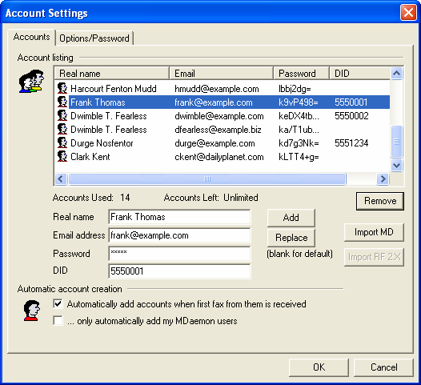

Account Listing
This display lists the names and email addresses of every user that has been granted permission to send faxes via RelayFax. It also displays an encrypted version of each user’s fax password or “<Default>” if a specific password hasn’t been assigned. The number of entries allowed in the listing is determined by the particular license that you have purchased for RelayFax. The listing can also be sorted by any of the three available fields: Real name, Email, Password. To sort the list, click the heading that you want it to be sorted by. Clicking the same heading again will cause the list to alternate between an ascending or descending sort order.
Accounts used:
This is the number of addresses that currently have permission to use the RelayFax server.
Accounts left:
This is the number of addresses still available before your RelayFax license key reaches its limit.
Remove
To delete an entry from the Account Listing, first click the desired entry and then click this button.
Real name
Type the user’s real name into this field.
Email address
Type the user’s email address. The user’s message must be sent from this address or RelayFax will not fax it.
Password
If you specify a password in this field then the user must include it in his message for RelayFax to fax the message. In the RelayFax SMTP Client there is a specific control used for including the user’s password, but if they send their message via a regular email client then they must include the “FAXPASSWORD:pass” macro in the body of their message. Leaving the Password field blank will set the user’s password to “<default>”. If no default password has been designated on the Options/Password tab then no password will be required in their messages. If there has been a password designated then they must include it in their message in the same way that a user-specific password would be included.
DID
If you are using a Direct Inward Dialing (DID) system, and the user has a DID fax number assigned to him or her, enter that number here.
Add
Click this button to add the user to the list after entering their information.
Replace
When you click an entry in the list of accounts its information will be displayed in the fields below the listing. If you edit that information then click this button to update the entry in the listing.
Import MD 3/4
If your local mail server is MDaemon 3 or later then you may click this button to automatically import your MDaemon users into RelayFax.
Import RF 2.X
RelayFax 3 and later uses a different format for its user listing than previous versions. Click this button to import the user listing from a 2.X version of RelayFax.

Options
Automatically add accounts when first fax from them is received
When this switch is enabled RelayFax will automatically add a new address to the list of accounts in the Address Listing whenever the first fax from them is received. This makes it possible to dynamically build your list of users.
 Warning
When using this feature RelayFax will accept messages from anyone who sends them until the maximum number of accounts has been reached. If you wish to limit or control permissions to your RelayFax Server do not use this feature. Disable this checkbox and then manually enter those addresses that you wish to permit to use your RelayFax Server.
Note
This feature can be enabled/disabled in only the first 60 days of a RelayFax Server’s lifespan; after that time this feature is permanently disabled. Below this control is a counter that states how many days you have left. Only in unlimited user license versions will this feature be permanently usable.
… only automatically add my MDaemon users
If you are using MDaemon as your local email server then click this checkbox if you want the Automatically add accounts… feature to apply only to your MDaemon users. Non-MDaemon users will not be added. New installations will not have to duplicate your MDaemon users. RelayFax will use MDaemon’s account database up to the maximum number of users allowed by your RelayFax license.

Options/Password
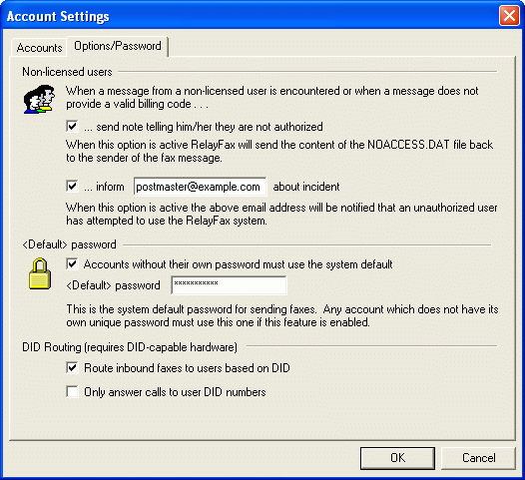
On the Options/Password tab of the Account Settings dialog, you can designate what RelayFax will do when it encounters a message that originates from an address other than those listed on the Accounts tab. These actions will also be taken when you are requiring your users to provide a password in their messages and an invalid one is given, or a password is omitted altogether.
Note
These options are not applied unless the Automatically add accounts when first fax from them is received option (located on the Accounts tab) has been turned off or the maximum number of Accounts has already been reached.
Non-Licensed Users
When a message is processed that does not originate from one of the addresses listed on the Accounts tab or does not contain a valid password, RelayFax will delete the incoming message and then take two possible actions listed below. You may configure RelayFax to do one, both, or neither of these tasks.
Send note telling him/her they are not authorized
When this checkbox is enabled RelayFax will convert the contents of the NOACCESS.DAT file (located in the …\RelayFax\app directory) into an email message and send it to the non-licensed user.
Inform [address] about incident
When this checkbox is enabled RelayFax will send a message to the address informing them that an unauthorized user has attempted to use the RelayFax system. Additionally, the complete message of the unauthorized user will be included with this email notification as a file attachment.
Note
When neither of these options is enabled, RelayFax will simply delete unauthorized user messages and take no further actions.

<Default> password
When a password is required, messages that do not include the correct one will not be processed. This security measure is at your disposal if you are worried about non-authorized personal sending faxes through your server. Although you can set specific passwords for each of your users, you can also designate a default password for users that have not had one specifically assigned to them.
Accounts without their own password must use the system default
Enable this checkbox if you want all users to be required to include a password with their messages even when one hasn’t been specifically assigned to their account. Accounts without their own unique password must use the password defined in the <Default> password control.
<Default> password
Specify the password that you want to require of all users that haven’t been given one specific to their account.
DID Routing (requires DID-capable hardware)
Route inbound faxes to users based on DID
If you are using a Direct Inward Dialing (DID) system, then click this check box if you want RelayFax to automatically route incoming faxes to users based on the DID numbers assigned under their account settings.
Only answer calls to user DID numbers
Click this check box if you want RelayFax to only respond to incoming calls destined for DID numbers that have been specified under the individual user Accounts. Inbound calls to unknown DID numbers will not be answered by RelayFax.

Fax Templates and Billing Codes
Chapter
12
Fax Templates can be used to assign a large number of alternate variables to outbound faxes. Applied through the Outbound Fax Rules, templates make it possible to attach an alternate cover page, banner text, change the sender’s name, company, Fax ID, and fax or voice numbers, and/or assign alternate dialing and retry settings. With Fax Templates you can cause RelayFax to simultaneously support, behave, and appear as any number of different fax devices at different companies or departments.
Combined with the Fax Rules and Exporting features, billing codes can be used to track the fax expenses and RelayFax time usage for specific groups of users. Users can be forced to include a billing code before their faxes will be accepted, and rules can be configured that will cause specific actions to be taken when certain billing codes are encountered. The Export File includes a field for each fax’s billing code and can therefore be used as a field in a spreadsheet that you might wish to create in order to track usage.
See page 140 for more on Billing Codes.

Creating and Editing Fax Templates
To create or edit a Fax Template, click Tools→Fax templates… to open the Fax Templates and Billing Codes dialog.
Creating a New Fax Template
To create a new Fax Template click the New button on the Fax Templates tab of the Templates and Billing Codes dialog. This will cause the New Template Properties dialog to open. Fill in the relevant information on this tabbed dialog (illustrated and described below) and then click OK. This will complete the Template creation process.
Editing Fax Templates
To edit a previously created Fax Template select it from the Existing Templates list on the Templates tab of the Templates and Billing Codes dialog, and then click the Edit button. This will open the Template Properties dialog (illustrated and discussed below), whish will display the selected Template’s settings. Make any desired changes and then click OK to save the changes and close the dialog.

Fax Templates
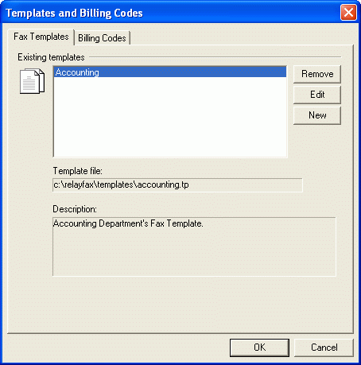

For more information on applying Fax Templates through Outbound Fax Rules, see:

Outbound Fax Rules – page 94

Existing Templates
All available Fax Templates are displayed in this area.
Remove
To remove a Fax Template from the Existing Templates list, click the desired template and then the Remove button.
Edit
To edit a previously created Fax Template, double-click the desired template in the Existing Templates list or click the template and then the Edit button. This will open the template’s Fax Template Properties dialog.
New
Click the New button to open the New Template Properties dialog used for creating new Fax Templates.
Template file:
Here you will find the file path to the currently selected Fax Template.
Description:
When you create a Fax Template you will have the opportunity to include some comments or a description of the template for your personal reference. Those comments or descriptions will appear in this area when a template is selected from the Existing Templates list. This text will not appear on any faxed or printed pages.

For a complete discussion on creating and editing Fax Templates, see:
Creating and Editing Templates – page 131
Note
Templates are applied by first defining and creating the template and then configuring a rule, which assigns a template based on whatever criteria the rule specifies.

For a complete discussion on using such rules, see:
Outbound Fax Rules – page 94

Fax Template Editor

Template Description
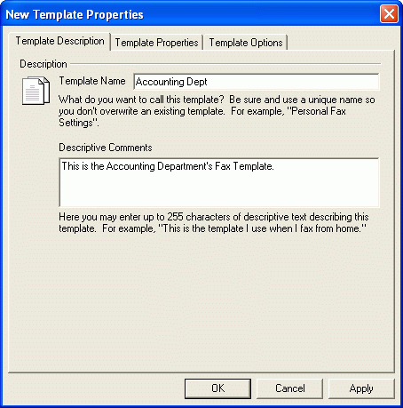

Description
Template name
Type a name for your Fax Template into this text box. This may be a descriptive name such as “The Frank Thomas Template”.
Descriptive comments
Here you may enter up to 255 characters of descriptive text or comments regarding this template. This can be used for reference to easily identify a specific template.

Template Properties
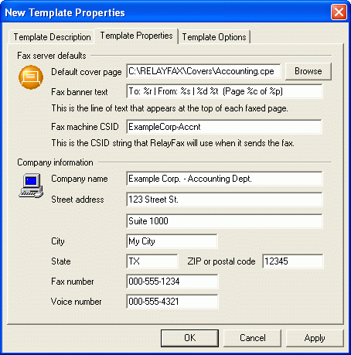

Use the Template Properties tab to assign alternate values to the controls located on the Fax Server tab of the RelayFax Settings dialog. All of the items listed here will appear on the cover page to which this Template is applied.

Properties
Default cover page
This is the path to the cover page that will be included with all faxes that match an Outbound Fax Rule that applies this Template.
For a complete discussion on cover pages, see:
Cover Pages – page 116
Fax banner text
RelayFax will insert this line of text – called a banner – at the top of each faxed page to which this Template applies. With RelayFax it is possible to custom format your Banner to automatically include various kinds of information such as the date and time, total pages, Recipient’s or Sender’s name, Fax ID, and various other options.
For a detailed discussion regarding the Banner Text and for a complete list and definition of available formatting characters, see:
Banner Text & Formatting Characters – page 45
Fax machine CSID
Each fax device must have a unique Call Subscriber Identification (CSID). It is common practice to use either your company name or fax number as your CSID. When two fax devices are negotiating a connection they make this information available to one another.
Note
In some geographical locations providing a CSID is required.
Company name
Enter the name of the company from which you wish the fax to appear to originate. It is common practice to make this information available when sending and receiving faxes.
Street address, City, State, Zip or postal code
Enter the company’s address information in these controls. This information will appear on any cover pages that have been set to include it.
Fax number
This is your fax number.
Voice number
This is your voice telephone number.

Template Options
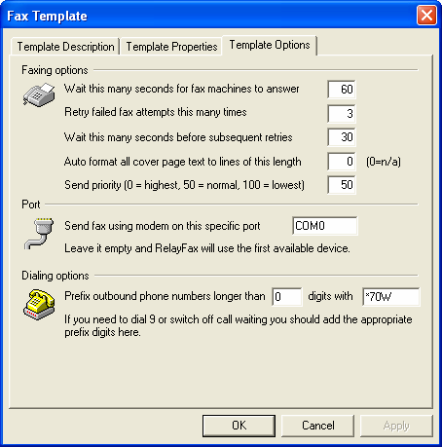

With the Template Options tab you can assign alternate values which will be applied to messages that match an Outbound Fax Rule assigning this Template.

Faxing options
Wait this many seconds for fax machine to answer
If the fax number to which RelayFax is trying to connect doesn’t answer within this many seconds, RelayFax will abort the attempt and try again later based upon the parameters outlined below.
Retry failed fax attempts this many times
After this number of unsuccessful attempts RelayFax will give up permanently and inform the sender that the fax could not be sent.
Wait this many seconds before subsequent retries
This is the amount of time that RelayFax will wait between subsequent delivery attempts.
Auto format all cover page text to lines of this length
Placing a value in this control will cause text placed in the cover page’s comments section to have line breaks inserted at the specified length in characters. Setting this control to “0” will cause the text to appear exactly as it was typed by the user. If the text was composed without any line breaks, and it extended beyond the edge of the designated comments area, then it would be truncated.
Send priority (0=highest, 50=normal, 100=lowest)
Specify the priority value that you want to be assigned to outbound faxes using this template.

Port
Send fax using modem on this specific COM port
Here you can restrict users of this template to one certain COM port.

Dialing Options
Prefix outbound phone numbers longer than [xx] digits with…
If you need to dial a special prefix such as 9 to reach an outside line or switch off call waiting, then specify the minimum number of digits you wish to require in a number before the prefix will be added, and then specify the prefix codes or number in the space provided.
Note
When specifying phone numbers for RelayFax to dial, you can use “w” or “W” to instruct RelayFax to wait for a subsequent dial tone. For example, “8w5551212” will dial 8, wait for the next dial tone, and then dial the remainder of the number. Similarly the “%” character will insert a pause within the dialing process. For example, “8%5551212” will dial 8, pause, and then dial the rest of the number. The length of time during a pause is determined by modem S register settings.

Billing Codes
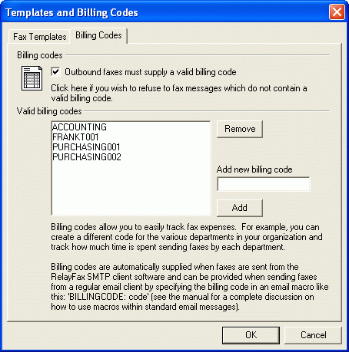
Combined with the Fax Rules and Exporting features, billing codes can be used to track the fax expenses and RelayFax time usage of specific groups of users. Users can be forced to include a billing code before their fax will be accepted, and rules can be configured that will cause specific actions to be taken when certain billing codes are encountered. The Export File includes a field for each fax’s billing code and can therefore be used as a field in a spreadsheet that you might wish to create in order to track this usage.

Billing Codes
Outbound faxes must supply a valid billing code
Click this option if you want to require all users to supply a billing code in their fax messages before they will be accepted.

Valid Billing Codes
This box displays all valid billing codes that you have created.
Remove
To remove a code from the list, click the code and then click this button.
Add new billing code
To add a billing code to list, enter it here and then click the Add button.

Fax Broadcasting Wizard
Chapter
13
Sending a single fax to multiple recipients by using a distribution list or database.
RelayFax’s broadcasting wizard makes sending a fax to multiple recipients or a distribution list simple. By stepping through the wizard one screen at a time and providing a few pieces of information, you can send a fax to any number of recipients—listed either in a text file that you have created or by acquiring them directly from the Contact Manager or an ODBC accessible database.
In the wizard you will choose: The text file containing the fax recipients, whether or not you want the fax to be “cover page only”, the fax image to send, the cover page to use, the template to use, some sender information. If you want to build the recipient list from an ODBC accessible database instead of a text file, you can step through an additional wizard in the middle of this process that will enable you to do so.
Once the broadcast fax begins, RelayFax will queue some of the faxes into the Fax Log Window so that you can see its status at any time. As the broadcast continues, RelayFax will constantly monitor the progress—remembering where it is in the list and which faxes have been completed. If the broadcast is interrupted due to a power failure or shutting down the server, the broadcast fax will be continued from the point at which it was left off as soon as RelayFax is launched.
On additional note: When the broadcast if finished, you can utilize RelayFax’s exporting features coupled with your database or spreadsheet application to create a list of the numbers that failed to receive the fax. You could then use that information to update your database or resend the fax to only those numbers.

Broadcast Fax Support in the RelayFax SMTP Client
Broadcast faxes can now be submitted from the RelayFax SMTP Client. There is a new option on the client’s tray icon shortcut menu that will allow you to build and submit a broadcast fax to the RelayFax server.
You can control whether any client-submitted broadcast faxes will be honored by setting the following switch in the RelayFax.ini file:
[Special]
AllowClientBroadcasts=Yes
You must first set this switch before client-submitted broadcast faxes will be honored. Also, you can edit the BCastPerm.dat file, which lists the email addresses of those who can and cannot submit broadcast faxes.
Broadcast faxes submitted from the RelayFax SMTP client are not currently able to assign templates to the broadcast fax. This is because the client software does not know what templates exist on the server. Similarly, the client does not know the billing codes that exist on the server thus the billing codes will not be pre-populated in the broadcast fax wizard.

Sending a Broadcast Fax

Step 1—Prepare the recipient list
Prepare a text file, contact list, or database that contains the fax numbers and names to which you wish to send the fax. Remember where this file or database is located. The format of a text file must be as follows:
The file must contain no more than one fax number per line but each line can also contain the recipient’s name and company information. Lines beginning with a pound sign or semicolons (‘#’ or ‘;’) are ignored to allow you to put comments throughout the file as necessary. Here are some examples:
555-1212  555-1212, Arvel Hathcock  555-1212, Arvel Hathcock, Alt-N Technologies  555-1212, Arvel Hathcock, “Alt-N Tech, LTD.”  555-1212, , Alt-N Technologies | ; only the fax number is specified  ; fax number and recipient name specified  ; fax number, name, and company specified  ; fax parms may contain commas if quoted  ; only fax number and company specified

If you want to build the list automatically from a database then the database must first be included in your Windows ODBC Data Source Administrator. This is located in either the Control Panel or Administrative Tools under the Control Panel, depending upon which version of Windows you are using.
If building the list from your Fax Contacts or address book, you will choose the list of recipients in Step 3 below.

Step 2—Open the Broadcast Fax Wizard
In RelayFax, click “Create broadcast fax…” on the “Tools” menu, or click the Broadcast Fax icon on the toolbar. This will open the Broadcast Fax Wizard.

Step 3—Choose the recipient list or build it from a database
Click the “Browse” button and navigate to the text file containing the fax numbers. If you want to build the list from a database then click “Pull data from ODBC data source”, which will launch the ODBC Selector Wizard (see page 152). After this step is completed RelayFax will display the first several entries to which the broadcast fax will be sent. Click “Next”.
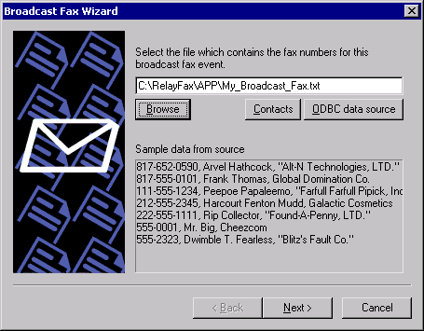

Step 4—Choose the fax image or document that will be sent
Click “Browse” and navigate to the fax image or document that you wish to send, or click the checkbox next to “This broadcast fax consists of a cover page only” if want to send a “cover page only” fax (the cover page will be chosen in the next step). Click “Next”.
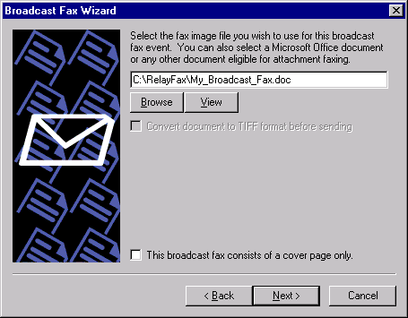

Step 5—Choose the cover page
Choose the cover page for the fax. If you need to create a new cover page or edit an existing one, click the Advanced button to open the Cover Page dialog (page 116). If you don’t want to include a cover page with the broadcast fax then click the checkbox next to “I do not wish to use a cover page”. Click “Next”.
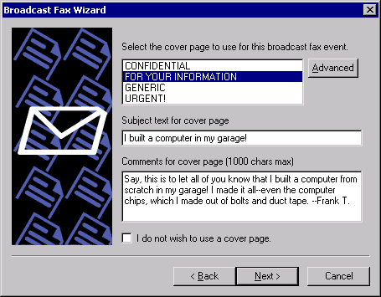

Step 6—Choose the fax template
Choose the fax template to use for the fax. If you need to create a new template or edit an existing one, click the Advanced button to open the Fax Templates dialog (page 133). If you don’t want to use a template with the broadcast fax then click the checkbox next to “I do not wish to use a fax template”. When you choose not to use a template RelayFax’s default settings will be used instead. Click “Next”.
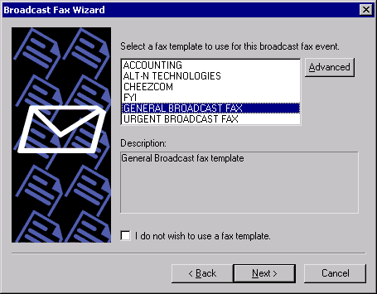

Step 7—Enter the sender information
- Enter the sender’s name.
- Enter the sender’s email address. RelayFax will send any system or error messages regarding the broadcast to this address.
- Choose a billing code for the broadcast (see page 140 for more information on Billing codes).
- Specify a priority value from “0” to “100” for this broadcast. The order in which faxes are sent is determined by their priority value—“0” being the highest priority and “100” being the lowest. The default value for normal faxes is “50”. The default value for broadcast faxes is “80”. If you want normal faxes to be sent before the broadcast fax then specify a number greater than 50 in this control. Further, if you do not want broadcast faxes to count against the “MaxPendingFaxCount=” value in the RelayFax.ini file, then you must designate a priority value between “80” and “100”.
- Click “Next”.
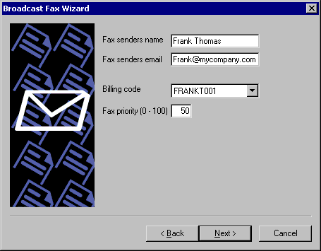

Step 8—Begin the broadcast
Click the “Finish” button to start broadcasting your fax.
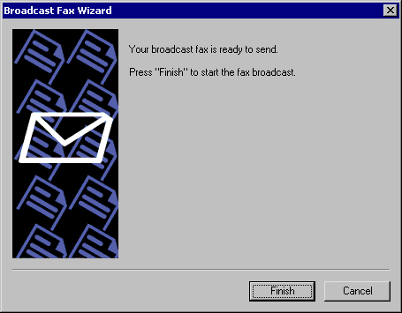

Pausing a Fax Broadcast
You can pause the fax broadcast at any time by clicking the “Disable send” button on the toolbar. If RelayFax is currently sending a fax when the button is pressed, it will complete the fax before pausing. As long as the button remains depressed RelayFax will not send any more faxes on any modems. Click the button again to resume faxing.

Canceling a Fax Broadcast
You can cancel the fax broadcast at any time by clicking the “Cancel broadcast fax” button on the toolbar. Clicking this button will prevent RelayFax from queuing any more faxes for the broadcast. However, any faxes that are pending in the Fax Log Window before the button is pressed will still be sent normally. This button will be dimmed on the toolbar when there is no broadcast fax in progress.
 Warning
Canceling a broadcast is a final decision. The broadcast cannot be resumed once it has been cancelled.

ODBC Selector Wizard
If you choose to build the Broadcast Fax recipient list from a database instead of a previously prepared text file, use the following steps to do so:

Step 1—Prepare your database
Prepare your database making sure that the table from which you wish to build the list contains fields for each recipient’s fax number, name, and company. Add the database to your Windows ODBC Data Source Administrator. ODBC Data Source is located in either the Control Panel or Administrative Tools under the Control Panel, depending upon which version of Windows you are using.

Step 2—Open the Broadcast Fax Wizard
In RelayFax, click “Create broadcast fax…” on the “Tools” menu, or click the Broadcast Fax icon on the toolbar.

Step 3-Open the ODBC Selector Wizard
Click “Pull data from ODBC data source” to open the ODBC Selector Wizard.

Step 4—Choose the data source
This dialog lists all data sources currently included in the ODBC Data Source Administrator. Click the data source that contains the table that will be used to build your list. If a logon and password is required to gain access to the data source then include that information on this dialog as well. Click “Next”.
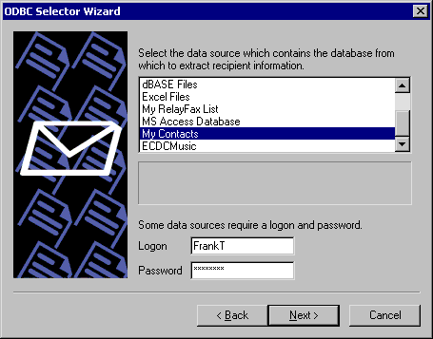

Step 5—Select the table containing the recipient information
This dialog lists the tables contained in the chosen database. Click the table that contains the fields that you wish to use to build your recipient list. Click “Next”.
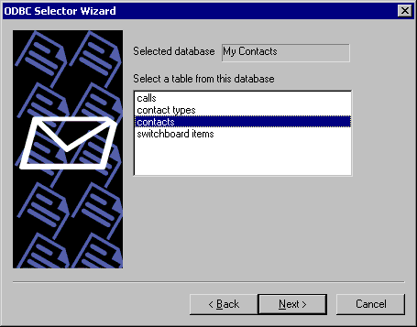

Step 6—Select the columns to use
Use the drop-down list boxes to select the database columns that you wish to use to build your list of recipients. Select columns that correspond to the recipient fax number, name, and company. Name fields 2 and 3 are optional. If your database contains a single column for Name then you can assign it to Name field 1 and leave the others blank. This dialog also contains an optional control that can be used to enter an SQL SELECT statement “WHERE” clause if necessary. Click “Next”. The recipient list will be built and you will be returned to the Broadcast Fax Wizard.
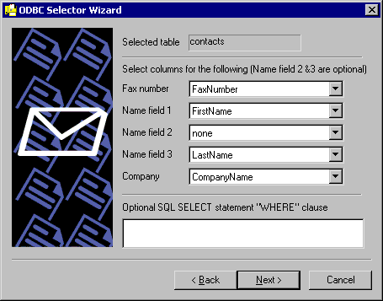

Step 7—Continue in the Broadcast Fax Wizard
Go to step 3 in “Sending a Broadcast Fax” (page 146) and continue normally from that point forward.

Part Ii
RelayFax® Version 6.7
RelayFax SMTP Client

RelayFax SMTP Client
Chapter
14

Introduction
RelayFax includes a special utility called the RelayFax SMTP Client. This client can be installed (along with the RelayFax Printer Driver) on each workstation on your LAN, and it can be installed at any remote location as well.
The RelayFax SMTP Client, and the accompanying RelayFax Printer Driver and RelayFax OCR (Optical Character Recognition) Printer Driver, make it possible to fax anything that you can scan or print. The client will attach the relevant document to an email message and then send it to the RelayFax server. Then, based upon the contents of the message or the fax rules configured on the server, RelayFax will route the fax to its appropriate destination. The client also contains a “Cover page only” feature for sending short messages requiring only a cover page. Documents can be faxed by printing to the RelayFax Printer Drivers instead of your normal printer, scanning them using the client’s scanner and twain support, or attaching files with the client’s Attached Files tab.
Whenever you scan a document or print one to the RelayFax Printer Driver, the RelayFax SMTP Client will be opened automatically for completing your fax. You will enter the fax recipient information manually or with the Contact Manager, choose from several other options such as alternate cover pages and scheduling, and then click the Send Fax button. The client will then email the document to your RelayFax server’s mailbox (dialing into the Internet if necessary) where it will be collected and faxed to its final destination.
When faxing documents via the RelayFax OCR Printer Driver, the documents will be scanned for specific identifiers to determine the recipient’s fax number and name, the subject of the fax, and so on. It will then be sent to your RelayFax server normally, just like when sending manually or printing to the RelayFax Printer Driver. The Fax Client, however, will not be opened because the recipient and other information will be taken from the document itself.
The RelayFax SMTP Client and RelayFax Printer Drivers can also be accessed by custom applications in order to automatically fax documents. For more information on using this functionality, see:

Sending Faxes Programmatically – page 196

RelayFax SMTP Client Features
- Immediate faxing from within any application by printing a document to the RelayFax Printer Driver.
- A cover page comment feature allows quick and easy faxing of a brief “cover page only” message.
- Full twain device support for faxing from scanners and digital cameras.
- Quick-Scan features make it possible to scan and fax documents by simply clicking a shortcut menu option or pressing the button on your scanner.
- Contact Manager that can be used to share contacts over a network.
- Confirmation Request feature that will cause RelayFax to inform the sender when their fax has been successfully transmitted.
- RAS Dialup controls make it possible for the Client to automatically dial into the Internet when being used remotely.
- Support for including extra information on the cover page such as: recipient’s name and company, sender’s name and contact information, billing codes, and more.
- Client may be used to email messages directly to users instead of to RelayFax for faxing.
- Scheduling feature so that you can designate a specific date and time to send the fax.
- By setting the parameters in the FAXCLNT.INI file, the RelayFax SMTP Client and RelayFax Printer Driver can be accessed programmatically by other applications, which enables them to send faxes automatically.
- Client contains a personal cover page manager and can utilize custom cover pages.
- Client allows attachment of documents to outgoing faxes.

Using the RelayFax SMTP Client

Starting the Client
To start the RelayFax SMTP Client click the icon on the desktop, or click the Windows START button and navigate to the client’s icon in the RelayFax program group. The client starts automatically when you print to the RelayFax Printer Driver from within a Windows application, or when you click the scan button on your scanner.

Using the Client
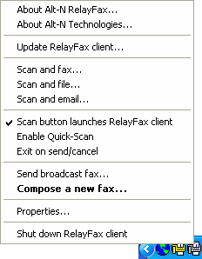
When the client is running, an icon will be displayed in the system tray. Right-click this icon to display a shortcut menu from which you can access various client features.
The following items are available on the shortcut menu:
About Alt-N RelayFax – Click this option to display copyright and developer information about RelayFax.
About Alt-N Technologies – Displays information about RelayFax’s developer, Alt-N Technologies.
Update RelayFax Client – Click this option to find out if there is a more recent version of the RelayFax SMTP Client than the one you are currently using. This will cause a Client Update Request to be sent to your RelayFax server. Be sure that you have entered your information into the Mail Server and Dialup Settings tabs of the Properties dialog before attempting to send an update request. Without this information the client won’t be able to send your request correctly. NOTE: Some RelayFax servers might not be configured to accept requests for client update information. Consequently, some users may not receive a response to their update requests.
Scan and fax – If your machine has a scanner installed then you can click this option to have the RelayFax SMTP Client scan a document and then open the Compose Fax dialog to fax it.
Scan and file – Click this option to scan and save a document to your hard disk. You will be prompted to choose the folder in which you want the file to be saved.
Scan and email – Click this option to scan a document and then email it to someone. First, type the recipient’s email address into the dialog that will open (or click the Contacts button on it and then choose the recipient). Next, click OK and type a subject for the email on the Compose Fax dialog. Click Send Fax when you are ready to send the email.
Scan button launches RelayFax client – Some scanners have a button that can be used for “one-touch” scanning. Enable this shortcut option if you want your scanner button to automatically launch the RelayFax Client in addition to activating your scanner.
Enable Quick-Scan – When this option is enabled and you attempt to use your scanner to acquire a document, the RelayFax Client will immediately scan the document using the scanner’s current default settings rather than present you with a Scanner Options dialog first. A checkmark will appear beside this option when it is enabled.
Exit on send/cancel – Activate this option if you want the RelayFax SMTP Client to shut down after a fax is sent or the Cancel button inside the client is clicked – the client will close and the tray icon will disappear. When this control is not enabled, the Compose Fax dialog will close but the tray icon will still be accessible.
Send broadcast fax… – Click this option to launch the Broadcast Fax Wizard.
Compose a new fax… – Click this option to open the client’s Compose Fax dialog.
Shut down RelayFax client – Click this option to shut down the RelayFax SMTP Client. The tray icon will disappear and all client dialogs will close.
Properties – This control will open the client’s Properties dialog.

RelayFax Client Properties
Chapter
15

Server Settings
This dialog is used to configure various settings that the RelayFax SMTP Client needs in order to process your faxes.
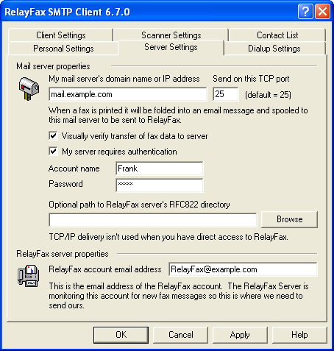

Mail Server Properties
My mail server’s domain name or IP address
This is the name or IP address of your mail server. When sending a fax the RelayFax SMTP Client will fold it into an email message and then send that message to this mail server for delivery to the RelayFax Server mailbox.
Send on this TCP port
The client will send your messages on this port.
Visually verify transfer of fax data to server
Normally the client transfers fax data in the background. Click this switch to interactively monitor transactions as they occur.
My server requires authentication
As an added security measure, some mail servers require you to authenticate yourself before you are allowed to use them to send or receive email. If such is the case with your mail server then click this box and enter your account name and password (login credentials) into the spaces provided below. This option provides support for ESMTP AUTH and the LOGIN and CRAM-MD5 protocols.
Account name
If your email server requires authentication before processing your messages then specify your account name or login name here.
Password
Enter the password that corresponds to the account name that you specified in the above control.
Optional path to RelayFax server’s RFC822 directory
If your RelayFax SMTP Client is installed on the same machine as your RelayFax server, or one that is accessible via your local area network, then you can specify the path to its RFC822 directory here (e.g. “C:\RelayFax\Rfc822”). This will deliver your outbound faxes directly to RelayFax instead of having to go through your mail server.

RelayFax Server Properties
RelayFax account email address
Your faxes are sent to this email address. It is the address of your RelayFax Server.

Dialup Settings
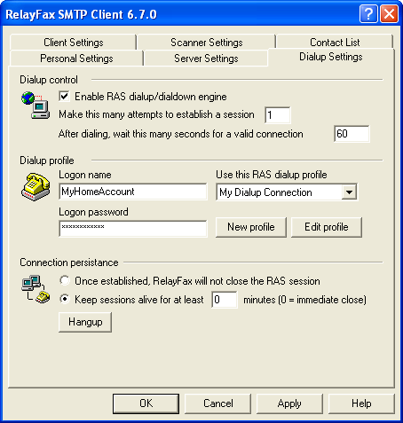

Dialup Control
Enable RAS dialup/dialdown engine
Click this checkbox to enable/disable the dialup feature.
Make this many attempts to establish a session
RelayFax will attempt to connect to the remote host this many times before giving up.
After dialing, wait this many seconds for a valid connection
This value determines how long RelayFax will wait for the remote computer to answer and complete the RAS connection.

Dialup Profile
Logon name
The value specified here will be passed to the remote host during the authentication process.
Logon password
The value specified here will be passed to the remote host during the authentication process.
Use this RAS dialup profile
This window allows you to select the session profile that has been previously defined through windows Dialup Networking or Remote Access Services Setup.
New profile
Click this button to create a new Dialup Networking or Remote Access Services profile.
Edit profile
Click this button to edit the currently selected Dialup Networking or Remote Access Services profile.

Connection Persistence
Once established, RelayFax will not close the RAS session
By default RelayFax will shut down a created connection immediately after all mail transactions have been completed and the session is no longer in use. Selecting this option will allow the session to remain active even after all mail has been transacted.
Keep sessions alive for at least [xx] minutes
If enabled this option will allow a RelayFax created RAS session to survive for at least the number of minutes specified. Placing a zero in this entry will cause the connection to be immediately closed after all transactions have been completed.
Hangup
This button will break the connection to the ISP. This button is active only if RelayFax has initiated the RAS session.

Personal Settings
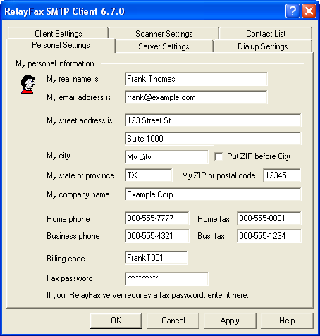
This tab is used to collect information about you so that the RelayFax Server can account for your fax activities. Providing this information may not be required, depending on your site security policies. If provided, this information may be used for cover page creation and accounting purposes.
Note
Filling in the fields on this dialog doesn’t necessarily mean they will all appear on the cover page. Cover pages will only display the information that they have been designed to display.

My Personal Information
My real name is
Enter your name here. This information may appear on the cover page of faxes that you send.
My email address is
Place your email address in this text box. RelayFax will send delivery confirmation notices and notifications of problems with your fax to this address.
Note
This address must match a valid user of the RelayFax system. For information on RelayFax User Accounts, see: User Accounts – page 124.
My street address is
Enter your street address here.
My city
This field is for your city.
My state or province
Enter your state or province here.
My ZIP or postal code
This field is for your ZIP or postal code.
My company name
Type the name of your company here.
Home phone
Your home telephone number.
Home fax
Your home fax number (if you have one).
Business phone
Enter the voice telephone number of your business.
Business fax
This is your business fax number.
Billing code
If you are required to provide a billing code or special identifier with your faxes enter it into this field.
Fax password
If you are required to include a password with your faxes then enter it here.

Client Settings
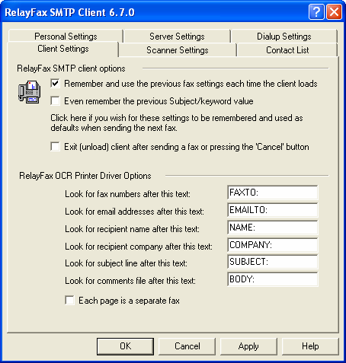
RelayFax SMTP Client options
Remember and use the previous fax settings each time the client loads
Click this checkbox if you want RelayFax to save the client’s current settings for the next time the client is opened. This will also save any recipient information that you have filled in on the Fax properties tab. However, the Recipient list will not be saved.
Even remember the previous Subject/keyword value
If you have enabled the “Remember and use the previous fax settings…” checkbox then click this control if you want the content of the “Subject/Keyword” field on the Fax Properties tab of the Compose a New Fax dialog to be saved as well.
Exit (unload) client after sending a fax or pressing the ‘Cancel’ button
Click this option if you want the Client to exit and the tray icon to disappear after sending a fax or clicking the ‘Cancel’ button on the dialog. If this control is not enabled then the tray icon will remain active but the dialog will still close.
RelayFax OCR Printer Driver Options
When sending a fax by printing a document to the RelayFax OCR Printer Driver, the settings in this section will be used during the Optical Character Recognition scan to determine the various parameters associated with the fax. Place these identifiers in your documents in order to designate the fax number, the recipient’s name, the subject of the fax, and so on.
Look for fax numbers after this text
When the RelayFax OCR Printer Driver encounters this text while scanning a document, the set of numbers immediately following this identifier will be treated as a fax number.
Look for email addresses after this text
When the RelayFax OCR Printer Driver scans a document, it will look for an email address immediately following this designated text. RelayFax will then email a copy of the fax to the address.
Look for recipient name after this text
This text denotes that there is a recipient name following.
Look for recipient company after this text
The fax client will treat text following this identifier as the recipient’s company name.
Look for subject line after this text
This text identifies the subject line of the fax.
Look for comments file after this text
After this text, the fax client will look for a reference to a text file; the contents of the file will be included in the comment section of the cover page. The text file must be contained in the \RelayFax\App\ subfolder.
Each page is a separate fax
Click this check box if you wish to treat each page of a document printed to the OCR Printer Driver as a separate fax. If using this option, be sure to include an identifier listed above such as FAXTO: or EMAILTO: on each page of the document.
Note
You can also use this feature to include multiple, consecutive pages of a document in a single fax. Any pages that do not include either a FAXTO: or EMAILTO: identifier will be appended to the fax delimited by the last page that did include one of those identifiers. For example, if page one and page six of a document included a FAXTO: identifier, then pages one thru five would be included with the first fax, and pages six and subsequent pages would be included with the second fax.

Scanner Settings
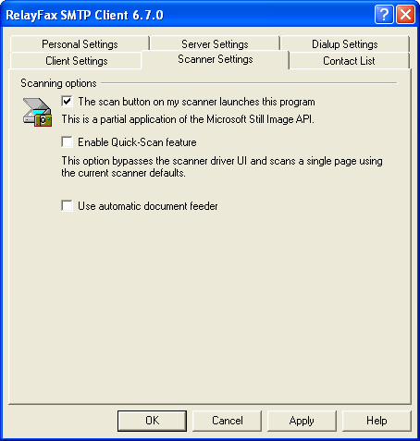

Scanning Options
The Scan button on my scanner launches this program
Click here if you want the RelayFax Client to respond when you press the scan button on your scanner.
Enable Quick-Scan feature
Click this control if you want the Scanning Options dialog and your scanner’s user interface to be bypassed whenever you scan a document. Scanning will begin immediately using the scanner’s current default settings. Uncheck this control if you want Scanning Options and your user interface to open before scanning.
Use automatic document feeder
If your scanner is equipped with an automatic document feeder, then click this check box if you wish to use it with RelayFax.

Contact List
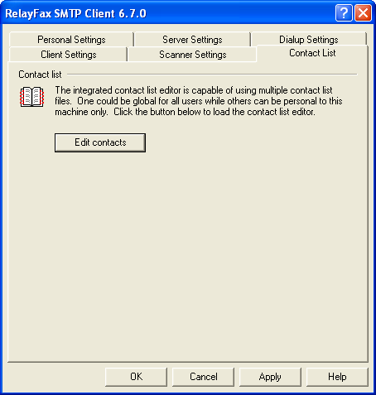
The RelayFax SMTP Client is equipped with a complete fax contact and address book management system. It can be used to manage all of your contacts and supports storing a large amount of information for each one. You can add up to 50 fields for each contact, assign contacts to groups, add notes for them, sort by any field, launch your web browser, phone dialer, or email program, and a host of other features. For more information regarding the various features and options available within the Contact Manager, see its online Help system.
Because any number of the Contact Manager’s data files can be managed at once, and because they can be shared and viewed simultaneously by multiple users, the Contact Manager can be used effectively as both a global and personal address book for your local network. You can simply click File|Open within your Contact Manager and then navigate to the *.adx file on the network that contains the shared address book entries. The file will then be incorporated into your local Contact Manager.

Support for Outlook and Other Third Party Address Book Products
The Contact Manager in RelayFax supports direct access to many third party address book products, such as Microsoft Outlook, without having to import them. To access these files:
- Open the RelayFax SMTP Client by clicking on its desktop icon or its icon within the RelayFax program group.
- Click the Contacts button on the Fax Properties tab.
- The Contact Manager will be opened and the address book files to which the Contact Manager has access will be displayed in the left pane.
- If you want to access a file other than ones that are displayed by default (for example, a Windows address book file on another computer on your network) click the address book type in the left pane and then click the Open icon. Browse to the desired file and then click Open.
For Example:
To open another Outlook address book file:
- Click the Outlook icon in the left pane of the Contact Manager.
- Click the Open icon on the toolbar.
- Click browse.
- Navigate to the alternative *.wab file.
- Click open.
- The new file will be listed under the Outlook icon in the left pane of the Contact Manager.

Compose Fax Dialog
Chapter
16
The Compose Fax dialog is used to enter information relevant to individual faxes. This dialog appears when you click “Compose a new fax…” or one of the scanning options on the RelayFax Client’s shortcut menu (page 160). It appears automatically each time that you print to the RelayFax Printer Driver.

Compose Fax
This dialog contains six tabs:
- Fax Properties – On this tab you will specify the number to which you want the fax to be sent, the subject of the fax, the recipient’s name and company, and any comments that you want to appear on the cover page.
- Cover Pages – This tab allows you to specify a cover page for an outbound fax.
- Send Schedule – Used for scheduling a specific date and time that the fax should be sent.
- Scan Image – Used to acquire a document from a scanner or twain device for faxing. For other options see the Scanner Settings tab on the client’s Properties dialog.
- Attached Documents – This tab enables you to attach documents to an outbound fax.
- Advanced Options – Used for designating a priority setting for your fax. This tab also contains a control that governs whether or not a confirmation will be returned to you when your fax is sent.

Fax Properties
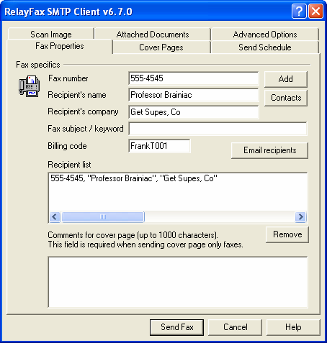

Fax Specifics
Fax number
Enter the fax number to which you want your fax to be sent and then click the Add button to add it to the recipient list. This will also add the contents of the other recipient information fields to the list.
Recipient’s name
Place the name of the fax recipient here.
Recipient’s company
Place the name of the fax recipient’s company here.
Fax subject/keyword
Enter the subject of the fax into this field. This field can also be used for entering keywords that the RelayFax server’s fax rules system may be configured to search for.
Billing code
This control will display the default billing code value that you have designated on the Personal Settings tab of the Client Properties dialog. You may enter an alternate value into this text field if you wish to override it for the current fax.
Add
Click this button to add the contents of Fax number, Recipient name, and Recipient company fields to the recipient list.
Contacts
Entries can also be added to the Recipient list by using the Contact Manager or the MDaemon/Outlook Contacts dialog. Click Contacts and then choose either the RelayFax Contacts or MDaemon/Outlook Contacts option to open the desired dialog. If using the Contact Manager, click any entry that you want to add to the list, and then click OK. If using the MDaemon/Outlook Contacts dialog, click the desired entry and then click either the Send Email or Send Fax icon. Note: In both dialogs you can select multiple entries by holding down the CTRL key as you click them.
Email Recipients
If you wish to email a copy of the fax to someone, click this button to specify the address.
Recipient list
This is the list of all the recipients that will receive a copy of this fax. This list must contain at least one recipient.
Remove
Click this button to remove selected entries from the Recipient List.
Comments for cover page
This area is for any comments that you want to appear on the cover page. Up to 1000 characters are allowed but there is no guarantee that they will all fit in the space reserved for them on the page. When more text is entered here than will fit on the cover page the remainder will be truncated.
Send fax
After you have filled in all areas relevant to your fax, click this button to send it. The RelayFax SMTP Client will fold the fax into an email message and dispatch it to the RelayFax Server. The Recipient List must contain at least one entry for this button to be enabled.

Client Could Not Deliver Image
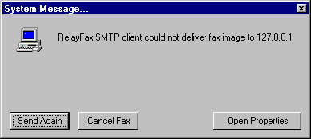
After clicking Send Fax on the Compose Fax dialog, a warning message may appear informing you that the client could not deliver your message to the IP address specified. This is usually due to an error in your Client Properties configuration. Click the Open Properties button to open the Client Properties dialog so that you can check your settings. The mail server and dialup settings information on this dialog must be entered properly in order for the client to be able to deliver messages. Make sure that the correct IP address or domain name of your mail server has been entered on the Server Settings tab and (if using the dialup features) that correct ISP account information has been entered on the Dialup Settings tab.

Cover Pages
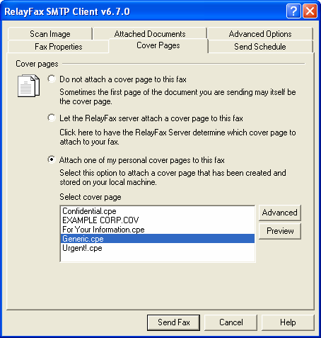

Do not attach a cover page for this fax
Click this checkbox if you do not want RelayFax to append a cover page. In such cases only the printed document will be faxed.
If you want to create a custom cover page and include it with your document (instead of the RelayFax formatted cover pages) you can use this feature to do so. Simply create your cover page (using whatever methods you wish) and then make it the first page of your document. Then, after printing the document to the RelayFax Printer Driver make sure that the Do not attach a cover page for this fax checkbox is enabled before sending the fax.
Note
The information that the RelayFax Server automatically includes on regular cover pages will not be included if this switch is selected. However, each page will still contain a banner at the top.
Note
This option is disabled when sending only a cover page.
Let the RelayFax server attach a cover page to this fax
Click here to have the RelayFax Server attach a cover page to this fax. The cover page that will be attached is determined by the template used and/or any Outbound Fax Rules matched by the fax.
Attach one of my personal cover pages to this fax
Click here and select a cover page from the list box and it will be used when the fax is sent.

Send Schedule
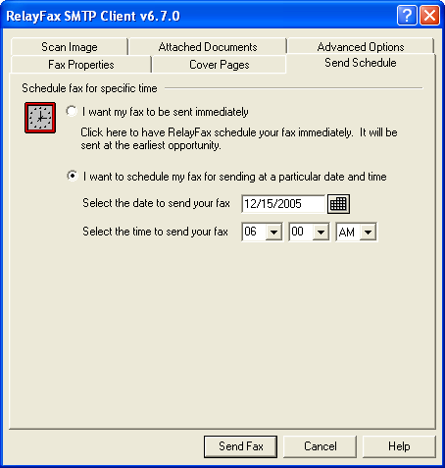

This tab makes it possible for you to specify a specific date and time that you want RelayFax to send your fax.

Schedule fax for specific time
I want my fax to be sent immediately
Click this option if you want RelayFax to send your fax at the earliest opportunity and on the first available fax modem.
I want to schedule my fax for sending at a particular date and time
Choose this option to cause RelayFax to send your fax at a specific date and time.
Select the date to send your fax
Type the date that you want your fax to be sent. The date must be in the format: mm/dd/yyyy. You can also click to open a calendar from which you can choose the date instead.
Select the time to send your fax
Use the drop-down list boxes to choose the hour, AM or PM, and minute to send the fax.

Scan Image
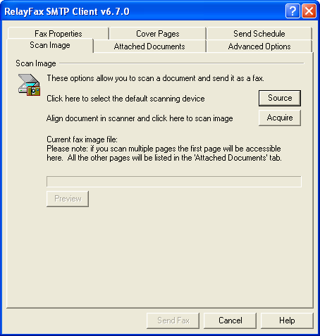
The RelayFax SMTP Client now supports TWAIN compatible devices such as scanners and digital cameras. In effect, scanner support makes it possible for you to use the client in the same manner that you would use a typical fax machine. You can scan a document at the touch of a button, type-in a fax number, and then click “Send Fax” to send it.

Scan Image
Source
Click the “Source” button to open the Select Source dialog, which lists all available TWAIN devices installed and properly configured for use with your computer. Next, choose the device that you wish to use and then click the “Select” button. The selected device will then become the default source from which the client will attempt to acquire documents.
Acquire
Click this button to acquire a document from the selected source. Before acquiring the document, the Scanning Options dialog will be opened unless you have enabled the Quick-Scan feature on the shortcut menu or Scanner Settings tab of the client’s Properties dialog.
Current fax image file
When you acquire a document from a TWAIN device, the path to the file will be displayed in this field.
Note
Only a single file can be displayed in this field. When scanning multiple pages, the first one will be listed here and the remainder will be listed on the Attached Documents tab.
View
Click View to open the file listed in the Current fax image file control.

Scanning options
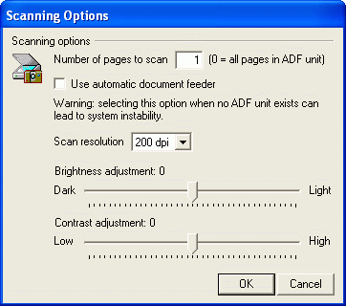

Scanning Options
Number of pages to scan [xx]
If you are sending a multi-page fax, use this control to enter the number of pages that it contains (including cover page). You will be prompted to ready each page before it is scanned. Depending upon your scanner, a product-specific user interface may or may not appear. If you are using an automatic document feeder (ADF) with your scanner then you may enter “0” to cause it to scan all loaded pages. Be sure to enable the Use automatic document feeder control if you are using one.
Use automatic document feeder
Click this checkbox if your scanner is equipped with an ADF unit.
 Warning
Do not enable this control if your scanner isn’t equipped with an automatic document feeder. Configuring the client to use an ADF unit when there isn’t one could lead to errors or system instability.
Scan resolution
Click the drop-down list box and choose the resolution setting that you want to be used when scanning the documents.
Brightness adjustment
Use the slider to adjust the brightness setting that will be used when scanning.
Contrast adjustment
Use the slider to adjust the contrast setting that will be used when scanning.
Note
Not all scanner device drivers will accept the Resolution, Brightness, and Contrast settings from RelayFax. You may have to replicate these settings once the scanner driver user interface has loaded.

Attached Documents
Use the settings on this tab to attach documents to your fax. If the RelayFax Server has Attachment Faxing support enabled, each attached documents will be converted to a faxable image format and sent as additional pages.
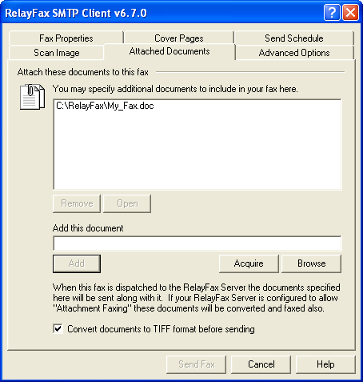

Attach these documents to this fax
This list box shows the currently attached documents.
Remove
Click this button to remove one or more selected documents from the list.
View
Select a file from the list and then click this button to open it.
Add this document
Type in the path to the document you wish to include with this fax.
Acquire
Click this button to acquire a document from your default TWAIN device.
Browse
Click here to select a document to include with this fax.
Add
Click here to add the specified document to the list box.
Convert documents to TIFF format before sending
Click this option if you want the client to convert the documents for you before sending rather than letting the fax server convert them.

Advanced Options
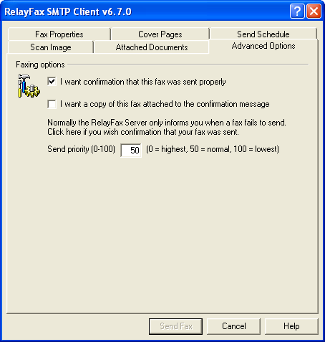

Faxing Options
I want confirmation that this fax was sent properly
Click this checkbox to request that RelayFax send you a confirmation notice when it has successfully transmitted your fax. Ordinarily RelayFax would only send a message to you if it could not send your fax.
Note
This feature will only work if the RelayFax Server has been configured to honor these requests.
I want a copy of this fax attached to the confirmation message
Click this option if you want the confirmation message to have a copy of your sent fax attached to it. This control will not be available when the “I want confirmation that this fax was sent properly” control is cleared.
Send priority (0-100)
This control if for designating a Priority value for your fax. The order in which RelayFax will send a fax is determined by its priority value – 0 is the highest priority and 100 is the lowest. Higher priority faxes will always be sent first. If this control is left blank then RelayFax will assign the “normal” priority value of 50.

Working with Faxes
Chapter
17

RelayFax Printer Driver
With the RelayFax Printer Driver you can fax documents directly from within the applications that you are use to create them. You can do this by printing the document to the RelayFax Printer Driver instead of to your usual printer. After setting the desired parameters, click OK and then the client’s Compose Fax dialog will be opened automatically for completing the fax.
For more information, see:
Compose Fax Dialog – page 176
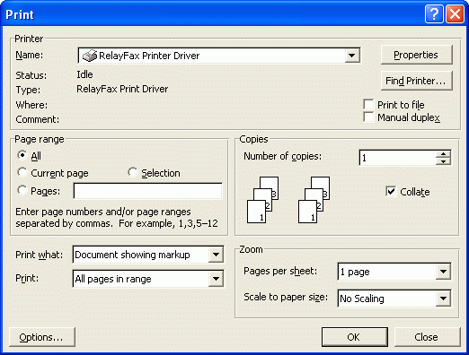

 Warning
During installation, the RelayFax Printer Driver’s default setting will be set to the proper resolution. Exercise caution in changing this setting. Failure to properly set the printer driver to 204x196 dpi will result in improperly formatted fax images that appear out of scale or otherwise deformed.
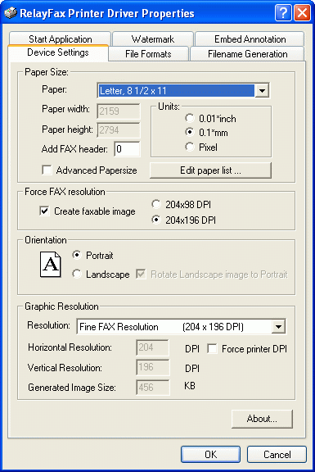

Sending a Fax via an Email Client
Most of the time a fax will be created by printing to the RelayFax Printer Driver from within a Windows application. However, it is possible and sometimes most effective to simply load up your email client and directly generate a message to be faxed. This is done by composing your email message and addressing it to one of the email accounts that you know RelayFax is monitoring. For example, if RelayFax is collecting all the email messages sent to FaxServer@mydomain.com then sending your message to that address will get it faxed. Several special considerations must be observed in order to use this method of faxing.
When you address your email message you can specify just a fax number on the TO: line like this:

“555-1212” <FaxServer@mydomain.com>
You can also specify the recipient’s name, company information, and fax number like this:
“555-1212, Jeff Boyd, Forest Park Lanes” <FaxServer@altn.com>
Note how each part within the quotations is separated by a comma. The format is like this:
[Open Quote]FAX NUMBER[Comma]PERSONAL NAME[Comma]COMPANY NAME[Close Quote]
Because each section is separated by a comma, you will need to enclose in quotation marks any field value that contains a comma. For example:
“555-1212, “Boyd, Jeff”, “Alt-N Tech, LTD.”” <FaxServer@altn.com>
Finally, you might specify just the recipient’s name and fax number like this:
“555-1212, , “Alt-N Tech, LTD.”” <FaxServer@mydomain.com>

Attaching Documents to Fax Messages
The RelayFax Server has the ability to extract attachments and fax them automatically. For example, it is possible for you to send an email message to the RelayFax Server which contains an Excel or Word document as an attachment. The RelayFax Server will extract the document, invoke the associated application to print it and then fax the resulting image. Any number of separate attachments can be attached and faxed in this manner. Page breaks within any given document will be honored and cause multiple pages to be faxed.
For more information, see:
Attachment Faxing – page 68

Note
When you send a fax through an email message and not through the printer driver, the text of your mail will be placed in the comments section of the cover page IF the cover page exists and the length of the text of your message is less than 1000 characters. However, page breaks within the body of the email message will be honored and cause RelayFax to generate multiple faxed pages rather than just a cover page.

Viewing, Printing, and Editing Faxes
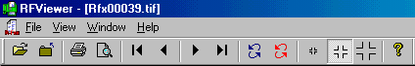
Installing the RelayFax SMTP Client on a workstation will also install RFViewer - a simple utility for viewing and printing a fax image file. This software utility will be associated with the proper extensions for opening and printing TIF documents. If an existing software package is found associated with the TIF extension, that registry entry will be saved under the “edit” shell command. Use the blue arrow keys to move from page to page in a multi-page fax.

Sending Faxes Programmatically
Your custom application can use the RelayFax system to send a fax by observing the following steps:
Set the following parameters in the FAXCLNT.INI file under the [FAXPARMS] section. The file can be found in the \Application Data\RelayFax\ subdirectory of the user’s profile (e.g. Documents and Settings in Windows 2000).
LastFaxNumber=555-1212 | Sets the fax number.
LastRecipientName=Arvel Hathcock | Sets the recipient’s name.
LastRecipientCompany=Alt-N Tech | Sets the recipient’s company.
LastFaxSubject=Sample Subject | Sets the subject of the fax message.
LastComments=This is%ea comment | Comments for cover page (%e = line break).
LastEmailAddress=FaxServer@mycompany.com | Address of RelayFax Server’s email account.
ConfirmSend=Yes(or No) | Request a send confirmation.
NoCoverPage=Yes(or No) | Use a cover page at all?
DefaultCoverPage=Yes(or No) | User server assigned cover page.
SpecificCoverPage=Yes(or No) | Use a specific cover page.
LastCoverPage=FILENAME | Filename of specific cover page to use.
VerifyTransfer=Yes(or No) | View mail sessions in progress.

When you have finished with the above parameters, set the following key to activate automatic faxing: AutoFax=Yes (or No)
If the AutoFax key is set to Yes, the RelayFax SMTP Client will create and spool the next printed document sent to the RelayFax Printer Driver automatically without prompting the user for any information. After doing so the RelayFax SMTP Client will reset the AutoFax key to No.
When setting the LastCoverPage key, use only the name of the cover page file – not the complete path to the file itself. The Client will assume the file is located in the Cover Page Directory.
Further, the NoCoverPage, DefaultCoverPage, and SpecificCoverPage keys work together. Only one can be set to Yes. The others must be set to No. An error will result if more than one of these keys is set to Yes at the same time.

Using the Broadcast Fax Wizard
The RelayFax SMTP Client contains the Broadcast Fax wizard, which makes sending a fax to multiple recipients or a distribution list simple. By stepping through the wizard one screen at a time and providing a few pieces of information, you can send a fax to any number of recipients—listed either in a text file that you have created, choosing them from your Contacts list, or by acquiring them directly from an ODBC accessible database.
In the wizard you will choose: The text file containing the fax recipients, whether or not you want the fax to be “cover page only”, the fax image to send, the cover page to use, the template to use, and some sender information. If you want to build the recipient list from an ODBC accessible database instead of a text file, you can step through an additional wizard in the middle of this process that will enable you to do so.
Note
This feature may not be available to all users. The administrator must grant your account permission before you will be able to use the client to send broadcast faxes.

Sending a Broadcast Fax

Step 1—Prepare the recipient list
Prepare a text file, contact list, or database that contains the fax numbers and names to which you wish to send the fax. Remember where this file or database is located. The format of a text file must be as follows:
The file must contain no more than one fax number per line but each line can also contain the recipient’s name and company information. Lines beginning with a pound sign or semicolons (‘#’ or ‘;’) are ignored to allow you to put comments throughout the file as necessary. Here are some examples:
555-1212  555-1212, Arvel Hathcock  555-1212, Arvel Hathcock, Alt-N Technologies  555-1212, Arvel Hathcock, “Alt-N Tech, LTD.”  555-1212, , Alt-N Technologies | ; only the fax number is specified  ; fax number and recipient name specified  ; fax number, name, and company specified  ; fax parms may contain commas if quoted  ; only fax number and company specified

If you want to build the list automatically from a database then the database must first be included in your Windows ODBC Data Source Administrator. This is located in either the Control Panel or Administrative Tools under the Control Panel, depending upon which version of Windows you are using.
If building the list from your Fax Contacts or address book, you will choose the list of recipients in Step 3 below.

Step 2—Open the Broadcast Fax Wizard
Right-click the RelayFax SMTP Client tray icon, and choose “Send broadcast fax…”.

Step 3—Choose the recipient list or build it from a database
Click the “Browse” button and navigate to the text file containing the fax numbers, or click Contacts to choose the recipients from the Contact Manager. If you want to build the list from a database then click “ODBC data source”, which will launch the ODBC Selector Wizard (see page 152). After this step is completed RelayFax will display the first several entries to which the broadcast fax will be sent. Click “Next”.

Step 4—Choose the fax image or document that will be sent
Click “Browse” and navigate to the fax image or document that you wish to send, or click the checkbox next to “This broadcast fax consists of a cover page only” if want to send a “cover page only” fax (the cover page will be chosen in the next step). If you have selected a file to send then you can click the “Convert document to TIFF format before sending” checkbox if you want the client to convert the document for you before sending it rather than letting the fax server convert it. Click “Next”.
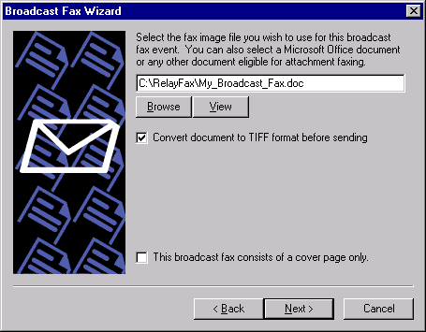

Step 5—Choose the cover page
Choose the cover page for the fax. If you need to create a new cover page or edit an existing one, click the Advanced button to open the Cover Page dialog (page 116). If you don’t want to include a cover page with the broadcast fax then click the checkbox next to “I do not wish to use a cover page”. Click “Next”.

Step 6—Enter the sender information
- Enter the sender’s name.
- Enter the sender’s email address. RelayFax will send any system or error messages regarding the broadcast to this address.
- Choose a billing code for the broadcast (see page 140 for more information on Billing codes).
- Specify a priority value from “0” to “100” for this broadcast. The order in which faxes are sent is determined by their priority value—“0” being the highest priority and “100” being the lowest. The default value for normal faxes is “50”. The default value for broadcast faxes is “80”. If you want normal faxes to be sent before the broadcast fax then specify a number greater than 50 in this control. Further, if you do not want broadcast faxes to count against the “MaxPendingFaxCount=” value in the RelayFax.ini file, then you must designate a priority value between “80” and “100”.
- Click “Next”.

Step 7—Begin the broadcast
Click the “Finish” button to start broadcasting your fax.

ODBC Selector Wizard
If you choose to build the Broadcast Fax recipient list from a database instead of a previously prepared text file, use the following steps to do so:

Step 1—Prepare your database
Prepare your database making sure that the table from which you wish to build the list contains fields for each recipient’s fax number, name, and company. Add the database to your Windows ODBC Data Source Administrator. ODBC Data Source is located in either the Control Panel or Administrative Tools under the Control Panel, depending upon which version of Windows you are using.

Step 2—Open the Broadcast Fax Wizard
Right-click the client’s tray icon, and choose “Send broadcast fax…”.

Step 3-Open the ODBC Selector Wizard
Click “ODBC data source” to open the ODBC Selector Wizard.

Step 4—Choose the data source
This dialog lists all data sources currently included in the ODBC Data Source Administrator. Click the data source that contains the table that will be used to build your list. If a logon and password is required to gain access to the data source then include that information on this dialog as well. Click “Next”.

Step 5—Select the table containing the recipient information
This dialog lists the tables contained in the chosen database. Click the table that contains the fields that you wish to use to build your recipient list. Click “Next”.

Step 6—Select the columns to use
Use the drop-down list boxes to select the database columns that you wish to use to build your list of recipients. Select columns that correspond to the recipient fax number, name, and company. Name fields 2 and 3 are optional. If your database contains a single column for Name then you can assign it to Name field 1 and leave the others blank. This dialog also contains an optional control that can be used to enter an SQL SELECT statement “WHERE” clause if necessary. Click “Next”. The recipient list will be built and you will be returned to the Broadcast Fax Wizard.

Step 7—Continue in the Broadcast Fax Wizard
Go to step 3 in “Sending a Broadcast Fax” (page 200) and continue normally from that point forward.

Appendix A – Macros and Files

Email Macros
When RelayFax processes an email message in preparation for faxing, it examines the message to determine where and to whom the fax should be sent. Most of the time this information will be specified on the TO: line, however it is possible to specify several key items within the email message itself. The following special macros can be placed within the body of an email message to achieve special results. Each macro must appear on its own line and at the top of the message body:
FAXPASSWORD: Password | Used for including your fax password within the message. If RelayFax is configured to require a password then you must use this macro to include it, when sending a fax via an email client.
FAXID: Text | Specifies the fax ID to use when sending the fax. This information is transmitted to the receiving fax machine.
FAXSUBJECT: Text | This macro specifies the subject of the fax. This information appears on the cover page.
FROMNAME: Text | This macro specifies the real name of the sender of the fax.
FROMLINE: Text -or-FROMADDRESS: Text | Either of these macros specifies the email address of the sender of the fax. The value must be an email address.
FAXNUMBER: Parms | This macro specifies the one fax recipient. ‘Parms’ can specify a fax number only or a fax number + recipient name + recipient company name.  Ex: 555-1212  Or 555-1212, Jerry Donald, Alt-N Tech  Or 555-1212, “Hathcock, Arvel”, “Alt-N Tech, LTD.”
CCNUMBER: Parms | Use this macro to specify additional fax recipients. You can use as many of these macros as you need. Specify a single recipient per macro. ‘Parms’ can specify a fax number only or a fax number + recipient name + recipient company name.  Ex: 555-1212  Or 555-1212, Jerry Donald, Alt-N Tech  Or 555-1212, “Hathcock, Arvel”, “Alt-N Tech, LTD.”
PORT: Number | This macro specifies the port that the fax should be sent on. Make sure that you specify a valid port.
FROMCOMPANY: Text | This macro specifies the company name of the sender of the fax.
FROMPHONE: Text | This macro specifies the voice telephone number of the sender of the fax. This is the voice number value that is used in RelayFax’s template files.
FROMFAX: Text | This macro specifies the fax number of the sender of the fax (typically the RelayFax Server’s fax number).
STREET1:Text | The sender’s street address.
STREET2:Text | The sender’s secondary address, or second line of their street address.
CITY:Text | The sender’s city.
STATE:Text | The sender’s state or province.
ZIP:Text | Sender’s zip or postal code.
HOMEPHONE:Text | This is the sender’s home telephone number.
HOMEFAX:Text | This is the sender’s home fax number.
BUSPHONE:Text | The sender’s business phone number.
BUSFAX:Text | Sender’s business fax number.
BILLINGCODE:Text | The billing code of the sender.
CONFIRMSEND: true | This macro specifies that the sender of the fax wishes to receive a confirmation message when the fax has been successfully sent. The value of this macro should be the word “true”.
ATTACHMENT: Path | Causes the attachment specified in the path to be included in the fax message. The file path must be accessible to the RelayFax server for it to be attached.
COVERPAGE: Path | This macro specifies the cover page that will be used for this fax. “Path” must specify a valid .CPE file accessible to the RelayFax Server.
PREFIX: Text | This macro specifies a prefix to the fax number such as “*70” or “9,”.
IGNOREBODY: | This macro prevents RelayFax from including the email body in the comments field. The body is still scanned for macros.
COMMENTS: Text | This macro specifies the text that will appear in the COMMENTS section of the cover page. You can specify more than one line of comment text by placing “%e” into the text where a line break should appear.
SCHEDULE: mm/dd/yyyy ##:## am/pm | Designates a specific date and time to send the fax.  Example: SCHEDULE: 01/01/2001 05:30 PM  NOTE: The day and date parameters must be two characters: 01, 02, etc. The year must be four. The hour must be 01-12 with AM or PM following the minutes.
PRIORITY: 00-100 | Sets a priority value for the fax. 00 is the highest priority and 100 is the lowest. Messages will always be faxed in the order of their priority setting. When no priority setting is present, they will be treated as “normal” with a setting of 50.
WAITFORANSWER: Number | This macro specifies how long RelayFax will wait for the receiving fax machine to answer. This is a value in seconds.
RETRYATTEMPTS: Number | This macro specifies how many times RelayFax will retry a failed fax attempt.
RETRYDELAY: Number | This macro specifies the number of seconds RelayFax will wait between subsequent fax attempts.
NOCOVERPAGE: true | This macro will prevent RelayFax from generating a dynamic cover page and sending it along with your fax. This is useful for situations in which you either do not want a cover page or the first printed page of your document is the cover page for the fax.
BANNERTEXT: Text | This macro specifies the text that appears at the top of each faxed page. You can use the special banner characters here. See Banner Text & Formatting Characters – page 45 for more information.

---Example Start---

From: Frank@Thomas.com
To: “555-1212, “Eddie Filewood”, “Forest Park Lanes, Front Desk” <RelayFax@domain.com>
Subject: This is a sample email message

FROMNAME: Frank Thomas
FROMCOMPANY: Forest Park Lanes, Inc.
NOCOVERPAGE: true
COMMENTS: Hit me in! %e Tell me I’m a lyin’.

Say, this is the fax I wanted to send to you.

Frank

---Example End---
Outbound Fax Rule Macros
The following macros can be used in Outbound Fax Rules:
 Warning
All of these macros must be in upper case.
$RECIPIENTNAME$ | This macro expands to the name of the fax recipient.
$RECIPIENTCOMPANY$ | This macro expands to the company name of the fax recipient.
$FAXNUMBER$ | This macro expands to the fax number the fax was sent to.
$FROMADDRESS$ | This macro expands to the email address of the sender of the fax.
$FROMMAILBOX$ | This macro expands to the mailbox of the fax sender. The mailbox is the part to the left of the @ sign in an email address.
$FROMDOMAIN$ | This macro expands to the domain of the fax sender. This is the part of the email address to the right of the @ sign.
$SUBJECT$ | This macro expands to the subject text of the email message.
$MESSAGEID$ | This macro expands to the message-id string of the email message.
$DATESTAMP$ | This macro expands to the date stamp of the email message.
$HEADER:VALUE$ | This macro expands to the value of the header specified to the right of the colon. For example, $HEADER: FROM$ would expand to the value of the email message’s FROM: header.

Example:

$FROMMAILBOX$@mycompany.com

For more information on Outbound Fax Rules, see:
Outbound Fax Rules – page 94

DAT File Processing Macros
The following macros are used within RelayFax’s *.DAT files. Some files can contain only certain macros. See RelayFax Data Files – page 214 for a list of the files in which these macros may be used.
$TRACKINGNUMBER$ | Every fax is assigned a unique tracking number. This macro returns that value and is useful for matching a fax event with the log files.
$RECIPIENTNAME$ | This macro expands to the name of the fax recipient.
$RECIPIENTCOMPANY$ | This macro expands to the company name of the fax recipient.
$RECIPIENTFAX$ | This macro expands to the fax number of the fax recipient.
$FAXNUMBER$ | This macro expands to the fax number the fax was sent to.
$FAXSUBJECT$ | This macro expands to the subject of the fax.
$FROMLINE$ -or-  $FROMADDRESS$ | This macro expands to the email address of the sender of the fax.
$FROMNAME$ | This macro expands to the name of the sender of the fax.
$FROMCOMPANY$ | This macro expands to the name of the company the fax was sent to.
$FROMFAX$ | This macro expands to the fax number of the sender of the fax (typically the RelayFax Server’s fax number).
$FROMPHONE$ | This macro expands to the telephone number of the sender of the fax. This macro corresponds to the voice number setting in RelayFax’s template files.
$STREET1$ | Expands to the sender’s street address.
$STREET2$ | Expands to the sender’s secondary address, or second line of their street address.
$CITY$ | Expands to the sender’s city.
$STATE$ | This macro expands to the sender’s state or province.
$ZIP$ | Expands to the sender’s zip or postal code.
$HOMEPHONE$ | The sender’s home telephone number.
$HOMEFAX$ | The sender’s home fax number.
$BUSPHONE$ | Expands to the sender’s business phone number.
$BUSFAX$ | Sender’s business fax number.
$BILLINGCODE$ | This macro expands to the billing code of the sender.
$REPLYLINE$ | When faxes are received and an email is generated to send the fax to its proper recipient(s) this macro will be used to generate the Reply-To header in that email. If the fax machine sending the fax transmits a fax ID to RelayFax then that fax ID will be used in the Reply-To field. This will allow the recipient of the fax to hit REPLY in their mail client and send the fax back to the person who originated it. If no fax ID is provided then this macro expands to a statement telling the recipient of the email not to generate replies. If the fax ID does not contain a fax number then a rule will have to be setup to make this feature work properly. This macro is valid in the NEWFAX.DAT and PARTFAX.DAT files only.
$LOCALID$ | This macro expands to the fax machine ID of the local fax device sending the fax.
$REMOTEID$ | This macro expands to the fax machine ID of the remote fax device accepting the fax.
$REASONSTRING$ | This macro expands to a text description detailing why a fax attempt failed. This macro is valid in the FAILURE.DAT file only.
$COVERPAGE$ | This macro expands to the path name of the cover page used on the fax.
$BANNERTEXT$ | This macro expands to the banner used on each fax page.
$COMMENTS$ | This macro expands to the comments used on the cover page.
$SPEED$ | This macro expands to the baud rate of the fax connection.
$PAGECOUNT$ | This macro expands to the total number of pages in the fax.
$PAGESSENT$ | This macro expands to the total number of pages actually faxed.
$RETRYCOUNT$ | This macro expands to the number of attempts taken to deliver the fax.
$RESOLUTION$ | This macro expands to 0 for low resolution or 1 for hi-resolution.
$FAXCLASS$ | This macro expands to CLASS_1, CLASS_2, or CLASS_20
$DURATION$ | This macro expands to the number of seconds taken while sending or receiving the fax.
$PORT$ | This macro expands to the port used to send the fax.
$SENDYEAR$ | This macro expands to the year that the fax was sent or received.
$SENDMONTH$ | This macro expands to the month that the fax was sent or received.
$SENDDAY$ | This macro expands to the day that the fax was sent or received.
$SENDHOUR$ | This macro expands to the hour that the fax was sent or received.
$SENDMINUTE$ | This macro expands to the minute that the fax was sent or received.
$SENDSECOND$ | This macro expands to the second that the fax was sent or received.
$TIMESTAMP$ | This macro expands to a formatted string displaying the date and time the fax was sent or received.
$CURRENTVERSION$ | Expands to RelayFax’s current version number.
$YOURVERSION$ | Expands to the version number of the user’s RelayFax SMTP Client.  NOTE: This macro can only be used in the UPDATE.DAT file.
$ATTACHMENT:path$ | Attaches the file specified in the path to a message.
$ATTACHFAXFILE$ | This macro causes RelayFax to attach the fax image file to whatever message is being generated.
$ATTACHOCRFILE$ | Attaches the OCR file corresponding to the fax.
$FAXFILE$ | This macro expands to the name of the fax image file stored on disk.
$INCLUDEURL$ | When this Macro is used in the NEWFAX.DAT or PARTFAX.DAT files, URLs will be included with messages that are built from these files that will make it possible for users to mark faxes originating from the same number as junk, prevent future faxes from being sent to them, and cause future faxes from the same source to be forwarded to an alternative email address.
$CNDDATA$ | Returns all of the CND information provided to RelayFax by your fax modem. The “|” character is used in place of line breaks.
$CNDNAME$ | Returns only the CND name element. This macro will only work properly when the CND name label is properly configured within the Modem Properties dialog.
$CNDNUMBER$ | Returns only the CND number element. This macro will only work properly when the CND number label is properly configured within the Modem Properties dialog.

RelayFax Data Files
The following files are used by RelayFax to perform various functions as described below. Other than ACCT3X.DAT, these files can be edited freely by using a text editor, and can be customized as required. For you convenience, many of these files can be opened for editing from directly from within RelayFax by clicking “File|Open” and then choosing the desired file.
FAILURE.DAT | This file is returned to the sender of a fax whenever RelayFax has an error sending it.  ANY DAT FILE PROCESSING MACRO.
CONFIRM.DAT | This file is sent back to people who request a confirmation of their fax being sent.  ANY DAT FILE PROCESSING MACRO.
NEWFAX.DAT | When an incoming fax is completely received it is sometimes folded into an email message and sent to one or more recipients. This file will be the body of that email message.  The following macros are valid for this file:  $TRACKINGNUMBER$, $REMOTEID$, $SPEED$, $REPLYLINE$, $PAGECOUNT$, $RESOLUTION$, $PORT$, $SENDYEAR$, $SENDMONTH$, $SENDDAY$, $SENDHOUR$, $SENDMINUTE$, $SENDSECOND$, $TIMESTAMP$, $DURATION$, $FAXCLASS$, $ATTACHFAXFILE$, $ATTACHOCRFILE$, and $INCLUDEURL$.
PARTFAX.DAT | When an incoming fax is only partially received it is sometimes folded into an email message and sent to one or more recipients. This file will be the body of that email message.  The following macros are valid for this file:  $TRACKINGNUMBER$, $REMOTEID$, $SPEED$, $REPLYLINE$, $PAGECOUNT$, $RESOLUTION$, $PORT$, $SENDYEAR$, $SENDMONTH$, $SENDDAY$, $SENDHOUR$, $SENDMINUTE$, $SENDSECOND$, $TIMESTAMP$, $DURATION$, $FAXCLASS$, $ATTACHFAXFILE$, and $INCLUDEURL$.
UPDATE.DAT | This contents of this file will be emailed to users making client update requests, and to users who sending messages from an outdated client – when RelayFax has been configured to send it.  The following macros are valid for this file:  $CURRENTVERSION$, $YOURVERSION$, $ATTACHMENT:path$
POPHOSTS.DAT | This file lists the pop servers and logon credentials of all the mail hosts RelayFax is configured to connect to and check for new mail to be faxed.  NO MACROS ARE USED IN THIS FILE.
NOTO.DAT | If RelayFax is asked to fax a message but no fax number can be determined then this message will be emailed back to the person trying to send the fax.  NO MACROS ARE USED IN THIS FILE.
NOCOVER.DAT | Returned when the prescribed cover page cannot be attached to the fax.  NO MACROS ARE USED IN THIS FILE.
EXT.DAT | Lists the file extensions that RelayFax will attempt to convert and fax when they are attached to a message.  NO MACROS ARE USED IN THIS FILE.
SMTPFAIL.DAT | This file will be sent when an email message cannot be delivered due to an SMTP failure.  NO MACROS ARE USED IN THIS FILE.
NOACCESS.DAT | If RelayFax determines that the sender of a fax is not a licensed user then this message will be returned to them and their fax will not be sent.  NO MACROS ARE USED IN THIS FILE.
OUTRULES.DAT | This file lists the rules for processing outgoing faxes.  NO MACROS ARE USED IN THIS FILE.
INRULES.DAT | This file lists the rules for processing incoming faxes.  NO MACROS ARE USED IN THIS FILE.
FAXBOOK.DAT | This file lists fax contacts. This file can be shared amongst all network users.  NO MACROS ARE USED IN THIS FILE.
ACCT3X.DAT | This file lists the email address, real name, and fax password, of each RelayFax user account The entries within this file are stored in an encrypted format for security.  NO MACROS ARE USED IN THIS FILE.
UIDL.DAT | This file lists the UIDL values of messages stored on mail servers. This file is used to make sure RelayFax does not duplicate faxes.  NO MACROS ARE USED IN THIS FILE.
MSGID.DAT | This file lists the Message-ID values of messages stored on mail servers. This file is used to make sure RelayFax does not duplicate faxes.  NO MACROS ARE USED IN THIS FILE.
SCHEDULE.DAT | This file lists the times and scheduling settings RelayFax uses to determine when it should connect and collect mail to fax out.  NO MACROS ARE USED IN THIS FILE.

Appendix B – Modem Compatibility

Modem Compatibility
RelayFax is compatible with most Class 1, Class 2, and Class 2.0 modems. However, although RelayFax supports Class 2 modem compatibility, we do not recommend them. If you are using a Class 2 modem, you can expect to experience problems with connection, completion of faxes, and other problems. The frequency of these problems will depend upon the quality of the connection, your particular modem, the length of the connection, and so on. This is not a problem with RelayFax but is caused by the inconsistent manner in which Class 2 modems were developed by modem manufactures. For the best performance, we recommend the use of high quality Class 2.0 modems. Even Class 1 modems, which could have connection problems of their own, are more consistent than Class 2.

Flow Control
To best ensure that RelayFax operates at optimum efficiency, we recommend that you add INIT string commands in the Modem Properties dialog (page 31) that enable both hardware and software flow control for your modem. Further, be sure to exercise caution when editing your INIT or RESET string values. RelayFax will allow you to edit them but improper changes can cause your modem to stop working properly. See your modem documentation for more information on initialization and reset strings. If you do not have documentation for your modem then we suggest visiting www.modemhelp.com. There you will find documentation and other resources available for most modems.

Appendix C – Regular Expression Matching
Regular expressions use these special characters:
. [ ] - ^ * ? + $

General Rules
Characters other than the special characters match themselves. For example, “yardbird” matches “yardbird”.
A backslash (\) followed by a special character, matches the special character itself. For example, “Pardon\?” matches “Pardon?”.
The following escape codes can be used to match control characters:
\b backspace
\e Esc
\f formfeed
\n newline
\r carriage return
\t tab
\xddd the literal hex number 0xddd
\^x where x matches some control-code (for example \^c, \^c)

One-Character Regular Expressions
The . special character matches any single character except a newline character. For example “.ive” would match “jive” or “five”.
The [ and ] special characters are used to denote one-character regular expressions that will match any of the characters within the brackets. For example, “[aeiou]” would match either “a”, “e”, “i”, “o”, or “u”.
The - special character is used within the [ ] special characters to denote a range of characters to match. For example, “[a-z]” would match on any lowercase alphabetic character between a and z.
The ^ special character is used to specify search for any character but those specified. For example, “[^g-v]” would match on any lowercase alphabetic character NOT between g and v.

Multiple-Character Regular Expressions
The * special character following a one-character regular expression matches zero or more occurrences of that regular expression. For example, “[a-z]*” matches zero or more occurrences of lowercase alphabetic characters.
The + special character following a one-character regular expression matches one or more occurrences of that regular expression. For example, “[0-9]+” matches one or more occurrences of lowercase alphabetic characters.
The ? special character specifies that the following character is optional. For example “xy?z” matches on “xy” or “xyz”.
Regular expressions can be concatenated. For example, “[A-Z][a-z]*” matches capitalized words.

Matching at the Beginning and End of a Line
If the ^ special character is at the beginning of a regular expression, then a match occurs only if the string is at the beginning of a line. For example, “^[A-Z][a-z]*” matches capitalized words at the beginning of a line.
If the $ special character is at the end of a regular expression, the then a match occurs only if the string is at the end of a line. For example, “[A-Z][a-z]*$” matches capitalized words at the end of a line.

Appendix D – Troubleshooting

Troubleshooting
This section lists some common problems and potential solutions.
I WANT TO MAKE CUSTOM COVER PAGES BUT MY COMPUTER DOES NOT HAVE THE MICROSOFT COVER PAGE EDITOR SOFTWARE INSTALLED. WHY DOESN’T MY COMPUTER HAVE THIS SOFTWARE AND WHERE CAN I OBTAIN IT?
Microsoft does not distribute their cover page creation and editing tool as a normal part of Windows NT/2000. Some older Windows 95 installations have also reported that this tool is not installed by default. We have been in contact with Microsoft on this issue and they have refused to allow us to distribute this application as part of the RelayFax installation. This is a shame because this is an excellent cover page tool and we are committed to using it as our native format. However we do know that this tool is available as part of the Microsoft fax tools system and is on the Windows 98 CD-ROM in the \tools\oldwin95\message\us directory as AWFAX.EXE.
MY PRINTER WON’T PRINT MY FAX.
This can be caused by a variety of reasons. If RelayFax fails to print a partially received fax it could be that not enough of the fax was received in order to be printed. If RelayFax fails to print a successfully received fax make sure your printer allows the EVERYONE group to have access to it, if it’s an NT share. In addition, if the printer is located on another computer on your network, make sure that RelayFax has access to that printer. Sharing restrictions could be preventing RelayFax from accessing the printer across the network. If RelayFax is running as a service then you may need to provide some logon credentials in order for RelayFax to access a network device such as a printer. See the SELECT PRINTER section of this manual for more details about doing this.
MY PRINTER DOESN’T SHOW UP IN THE PRINTER SELECTION BOX.
A driver for the printer must be installed locally. Only the printers listed in the CONTROL PANEL | PRINTERS screen are available for RelayFax use.
I HAVE A LOT OF PROBLEMS WITH MODEM TIMEOUTS AND MODEM PROBLEMS IN GENERAL.
RelayFax is compatible with most Class 1, Class 2, and Class 2.0 modems. However, although RelayFax supports Class 2 modem compatibility, we do not recommend them. If you are using a Class 2 modem, you can expect to experience problems with connection, completion of faxes, and other problems. The frequency of these problems will depend upon the quality of the connection, your particular modem, the length of the connection, and so on. This is not a problem with RelayFax but is caused by the inconsistent manner in which Class 2 modems were developed by modem manufactures. For the best performance, we recommend the use of high quality Class 2.0 modems. Even Class 1 modems, which could have connection problems of their own, are more consistent than Class 2.
Flow Control
To best ensure that RelayFax operates at optimum efficiency, we recommend that you add INIT string commands in the Modem Properties dialog (page 31) that enable both hardware and software flow control for your modem. Further, be sure to exercise caution when editing your INIT or RESET string values. RelayFax will allow you to edit them but improper changes can cause your modem to stop working properly. See your modem documentation for more information on initialization and reset strings. If you do not have documentation for your modem then we suggest visiting www.modemhelp.com. There you will find documentation and other resources available for most modems.

Index

A
Account Address 134
Account Settings
Accounts 103
Options 106
Templates 109
Accounts
Adding 103
Address Listing 103
Automatically creating 103
Creating 103
Importing from RelayFax 1.0 103
Number Left 103
Number Used 103
Removing 103
Settings 103
User 103
ACCTINFO.DAT 181
Add Rule 24
Adding
Accounts 103
Adding Mail Hosts 75
Address Listing 103
Apply template to outbound fax 81
Archiving fax image files 61
Attach specific cover page 82
Attached Documents 156
Attaching documents to fax messages 162
Attaching files to faxes 156
Attaching personal cover pages to faxes 149
Automatic Fax Exporting 61
Automatically Printing Faxes 77
Available Printers 51
B
Banner 37, 39
Banner Characters 39
banner text 37
Banner Text 112
Banner Text & Formatting Characters 39
Broadcast Fax 117, 165
C
Characters 39
Client 130
Advanced Options 158
Attached Documents 156
Attaching files to faxes 156
Attaching personal cover pages to faxes 149
Comments for cover page 147
Compose a new fax 146
Compose Fax 147
Compose Fax Dialog 146
Confirming fax was sent 158
Cover page comment 132
Cover Pages 149
Dialup Settings 136
Fax Properties 147
Features 130
Introduction 130
Mail Server 134
Options 158
Printer Driver 160
Properties 134, 147
Sending Faxes 146
Sending Faxes Programmatically 132
Server's domain name 134
Server's IP Address 134
Starting 132
Using the 132
Version 158
Collecting mail for faxing 75
Comma Delimited Export Files 61
Comments for cover page 147
Company 112
company name 37
Compose Fax Dialog 146
Advanced Options 158
Attached Documents 156
Cover Pages 149
Fax Properties 147
Overview 146
Scan Image 152
Send Schedule 151
Sending Faxes 146
Configuring Modems 26
Confirmation Requests 42, 44
Confirming fax was sent 158
Connection Persistance 95, 136
Cover Page 112
Cover Pages 149
Creating 98
Creating and Editing 98
Description 98
Editing 98
Properties 98
Create Report 24
Creating
Accounts 103
Creating and Editing Cover Pages 98
Creating Comma Delimited Export Files 61
Creating your Banner 39
D
DAT File Processing Macros 180
DAT Files 181
Data files 180
Data Files 181
Databases 117, 165
Default cover page 37
Default Email Address 40
Default Fax Rules 77
Definition of Formatting Characters 39
Delete Fax 87
Delivery Confirmation Requests 42, 44
Dependencies 47
Dialup
Closing sessions 95, 136
Connection Persistance 95, 136
Freeing ports for… 95
Hangup 95, 136
Keeping sessions alive 95, 136
Logon Name 95, 136
Logon Password 95, 136
Number of attempts 95, 136
Profiles 95, 136
RAS 95, 136
Settings 95, 136
Time to wait for a connection… 95, 136
dialup attempts 95
Dialup Settings 95, 136
Driver 130
E
Email Address 40
Email client
Sending faxes via 162
Email exported files to… 61
Email Fax Image to 158
Email Macros 176
Email message to specific user(s) 82, 87
Enabling RAS dialup/dialdown engine 95, 136
Enhanced Resolution 42, 44
Event Scheduler 92
Export 24
Exporting fax images to TIF files 61
Exporting Faxes 61
Extracting Numbers from TO or SUBJECT 77
F
Fax Broadcasting 117, 165
fax device ID 37
fax device's ID string 86
Fax Exporting 61
Fax Images
Removing from Disk 42, 44
Fax Machine ID 112
Fax Modem Settings 26
fax number 37
Fax Server 37
Fax Template Properties 111
Fax Templates 111, 112, 114
FAXCLNT.EXE file 132
FAXCLNT.INI file 132
Faxes
Automatically Printing 77
Default Rules 77
Emailing to default user 77
Inbound Rules 85, 91
Outbound Rules 79
Sending Programmatically 132
faxing a scanned image 152
FAXPARMS 132
Formatting Characters 39
H
Hangup 95, 136
HELO identification 40
Hiding SMTP Sessions 42, 44
Honor Confirmation Requests 42, 44
I
Importing Accounts from RelayFax 1.0 103
Inbound Default Rules 77
Inbound Fax Rules 85, 91
INIT String 26
Intallation 18
Introduction 11, 130
ISP Account Information 95, 136
K
Keywords 147
L
List of Formatting Characters 39
Log Options 49
Logging
Max Log Size 49
POP Session Activity 49
SMTP Session Activity 49
Logs 49
M
Macros
DAT file processing 180
Email 176
Mail Hosts 75
Adding 75
Collecting from 75
Editing 75
enabling/disabling 75
Removing 75
Mail Server 40
Mail Server Properties 40
Mail Sources 75
Mail Sources and Rules 75
Maximum number of pending faxes 117, 165
MDaemon
sharing ports with 55
using RelayFax with 55
MDaemon Settings 55
mdaemon.ini file 55
Menu Bar 20, 56
Modem Manual Add 22, 26
Modem Port 26
Modem Properties 22
Modem Settings 26
N
Network Access 53
Network Printer Access 53
Non-licensed users 106
Number Prefixes 42, 44
O
ODBC Databases 117, 165
Options 42, 44
Dialing 42, 44
Faxing 42, 44
Miscellaneous 42, 44
Outbound Default Rules 77
Outbound Fax Rules 79
Overview 11
P
POP3 Mail Hosts 75
Adding 75
Collecting from 75
Editing 75
enabling/disabling 75
Removing 75
POP3 servers 75
Port
freeing for MDaemon 55
Modem 26
TCP 40
Port sharing with MDaemon 55
Ports
Rescan 26
POSTDIAL.SEM file 55
Postmaster 106
PREDIAL.SEM file 55
Prefix 42, 44
Print message to specific printer 87
Printer 130
Selection 51
Printer Driver 160
Printing Outbound Faxes 42, 44
Processing mail immediately 92
Profiles
Dialup 95, 136
Properties 24
Fax Server 37
Logs 49
Mail Server 40
Options 42, 44
Service 47
Template 112
R
RAS/DUN Dialup 95
Recipient's Company 147
Recipient's Name 147
Re-Fax 24
RelayFax 11
Fax Server for Windows 11
RelayFax Data Files 180, 181
RelayFax Main Display 20, 56
RelayFax Printer Driver 160
RelayFax Settings 37
RelayFax SMTP Client 130
Advanced Options 158
Attached Documents 156
Attaching files to faxes 156
Attaching personal cover pages to faxes 149
Confirming fax was sent 158
Cover Pages 149
Options 158
Printer Driver 160
Version 158
Removing
Accounts 103
Removing exported fax log entries 61
Removing Fax Images from Disk 42, 44
Removing Mail Hosts 75
Rescan Ports 26
RESET String 26
Retry Attempts 42, 44
Rules
Default 77
Inbound Default 77
Inbound Fax 85, 91
Outbound Default 77
Outbound Fax 79
S
scanning 152
Schedule 151
Scheduling 92
Scheduling faxes 151
Security 106
Select All 24
Select Printer 42, 44, 51, 53
Selected Printers 51
Send fax to numbers found in text file 82, 83
Send fax to specific number 83
Send fax using a specific fax port 83
Send Schedule 151
Send To 24
Sending Faxes 147
Sending Faxes Programmatically 132
Sending faxes to multiple recipients 117, 165
Sending faxes via an email client 162
Sending Warning Messages 61
Server Log 49
Service 47
Settings 37
Fax Server 37
Logs 49
Mail Server 40
Options 42, 44
Service 47
Sharing ports with MDaemon 55
Shortcut Menu 24
Add Rule 24
Create Report 24
Delete 24
Export 24
Print 24
Properties 24
Re-Fax 24
Select All 24
Send To 24
View/Edit 24
Simple Scheduling 92
Skip next rule 84, 87
SMTP 130
SMTP Client 130
Advanced Options 158
Attached Documents 156
Attaching files to faxes 156
Attaching personal cover pages to faxes 149
Confirming fax was sent 158
Cover Pages 149
Options 158
Printer Driver 160
Version 158
SMTP Envelope ID 40
Special Characters 39
Spooling Faxes to Printer 77
Spooling Incoming Faxes 40
Stop processing rules 84
Summary 11
System Service 47
T
Template Description 111
Template Options 114
Template Properties 112
Templates 108, 109
Account 108
Banner Text 112
Company 112
Cover Page used in 112
Creating 108, 109
Description 109, 111
Dialing Options 114
Editing 108, 109
Fax Machine ID 112
Fax Number 112
File 108, 109
Options 114
Port 114
Properties 112
Removing 108, 109
Voice Number 112
Timers 42, 44
Tool Window 22
Toolbar 21
Troubleshooting 187
Twain support 152
U
User Address Listing 103
V
View/Edit 24
voice number 37
W
Warning Messages 61

